Newberry Township Road Cut Permit
Permit No: __________
Date Issued: __________
Permission is hereby granted by Newberry Township, York County to:
_______________________________________________
Permittee
Permittee Information
Name: __________________________________
Address: _________________________________
City: __________ State: ____ Zip Code: _______
Phone: _______________ Fax: _______________
Location where work is to be completed
Township street or address: _______________
_____________________________________
Township: ____________________________
County: ______________________________
Conditions and Special Restrictions
his permit is subject to all of the restrictions and regulations adopted by Newberry Township and any specific items or restrictions provided. The Newberry Township Board of Supervisors may at any time revoke this permit for non-performance or non-compliance with any of the conditions, restrictions, or regulations set forth by the granting of this permit.
NOTES:
1. The applicant must notify the Township Zoning officer prior to any backfill within the street.
2. The applicant must notify the Township Zoning officer of a minimum of 72 hrs. in advance of final restoration
3. Restoration bonds are only required for projects that will be more than $5,000.00 in construction cost
4. Liability Insurance is required for all projects
5. Refer to Special provisions in section 339-22 for any road that has been paved within the past 5 years
6. Applicant must refer to the Road Cut Ordinance 339-8 for all regulations regarding a road cut
___________________________________________________________________________________________________________________________________________________________________________________________________________________________________________________________________________________________________________________________________________________________________________________________________________________________________________________________________________________________________________________________________________________________________________________________________________________________________________________________________________
All work must be completed on or before: ___________________________________
*Permit void after this date. Notification must be made to Newberry Township, immediately upon completion of the work.
CALL BEFORE YOU DIG!
PENNSYLVANIA LAW REQUIRES 3 WORKING DAYS NOTICE FOR CONSTRUCTION PHASE
--STOP CALL 811
Pennsylvania One Call System, Inc. 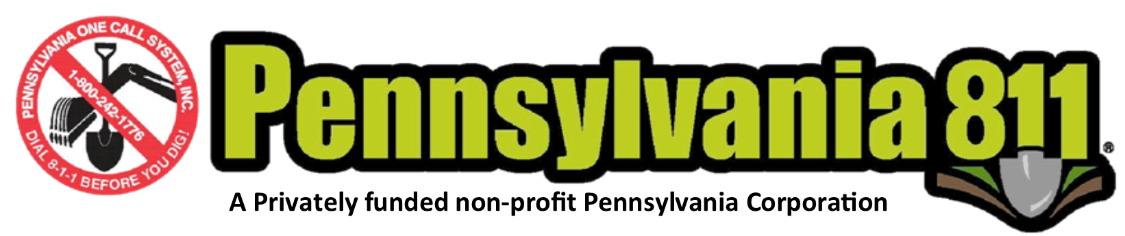
___________________________________________________
(Authorized Signature)

Place Newberry Township Seal here

