News
MARCH

Workforce Development

SEFCEDA will begin having its workforce orientations for the upcoming 2019 Kings Canyon Apprentice Training Program. The orientations will be on the last Wednesday of every month and will be from 9 a.m. - 11a.m. at 3362 E Balch Ave, Fresno CA 93704. If you have any questions please contact Gabriel Lozano at (559) 708-7101 or at marketing@sefceda.org.

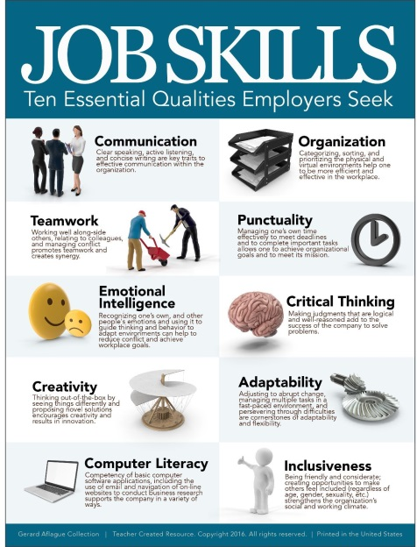

SEFCEDA’s Job Fair

Will have a job fair on May 29th from 9 a.m. till 11 a.m. at SEFCEDA Busines Prosperity Center 3362 E Balch Fresno, CA 93702. A table and two chairs will be provided. You will need to fill out paperwork to participate. Please email Gabriel Lozano, Program Manager at marketing@sefceda.org to receive that paperwork.

SEFCEDA Membership Drive

Dear Friends of SEFCEDA:
As we finish the 1st quarter we would like to thank you for your past support of SEFCEDA.
It is my pleasure to inform you that SEFCEDA continues to improve the quality of life of Southeast Fresno residents, and to promote economic prosperity by expanding opportunities in education, recreation, employment, housing, healthy neighborhoods and entrepreneurship.
As such, I would like to invite you to become a member of SEFCEDA. It is only with the support of the community that we are able to achieve our vision of improving the economic conditions of Southeast Fresno to equal or surpass those of the City of Fresno and the State of California.
The following are our membership categories with associated annual dues:
- Students ($10)
- Southeast Fresno Residents and Employees ($20)
- Community Organization($40)
- Business and Property Owners ($100)
With membership, you will receive:
- A SEFCEDA newsletter
- Recognition as a person or organization that invests in and supports community efforts to improve the quality of life of residents in Southeast Fresno.
You may also support SEFCEDA by becoming a volunteer. We frequently need community members to assist our organization in the capacity of event coordinators, project leaders, phone operators, recruiters, counselors, tutors and other services that help residents.
If you are interested in becoming a member of SEFCEDA, you may mail a check, payable to SEFCEDA, to 3362 E. Balch Fresno 93702.

Or visit our website at www.SEFCEDA.org to submit dues by credit card or PayPal.

Lozano’s Scuttlebutt
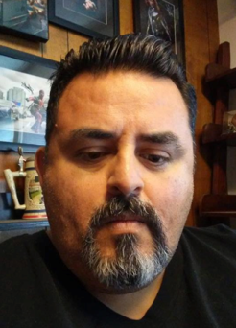
My name is Gabriel Lozano, Program Manager for The Southeast Fresno Community Economic Development Association, Inc. With every newsletter I will add a couple of items that I want to highlight. That being said the first thing I would like to mention is the
office hours are from 9 A.M. until 3:30 P.M.
- We have free internet access and printing
- Resume review
- Word and Excel Training

We would also appreciate it if you like our Facebook page, Southeast Fresno Community Economic Development Association, Inc. this will help you keep in touch with SEFCEDA such as our job fairs, meetings and other activities.
https://www.facebook.com/SEFCEDA/

I continue to serve on the Southeast Fresno Specific Plan. For the last 18 months the Steering Committee has been:

- The purpose of the plan is to draft a strategy on how to develop and improve our existing neighborhoods such as Lane, Calwa and the Kings Canyon/Ventura Corridor.
- The plan will lay the groundwork for improving our neighborhoods, identifying resources and leveraging opportunities for public and private sector investment necessary to help with economic development, transportation, housing, sidewalks, streetlight, safe routes to school, bike lanes, and other revitalization efforts. If you have any questions feel free to contact me at:
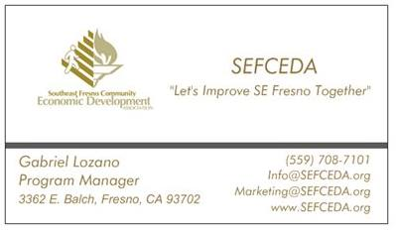

CEO’s Corner

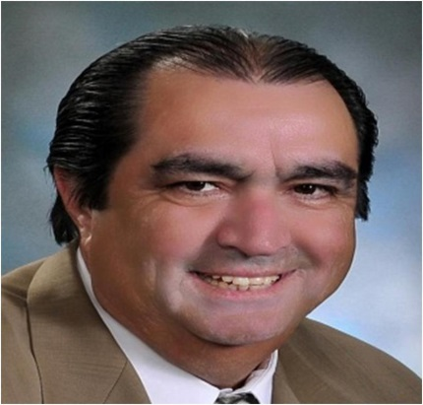

www.joseleonbarraza50@gmail.com and or (559) 301-0695.

Dear Fresno State Friends and Other Community Park Supporters.

This month we met with Jim Schaad, Assistant City Manager, Kristina Chamberlin, Assistant PARCS Director and other City of Fresno officials to review the status of the work associated with the Adopt-A-Park Project. We reported that all cleanup activities have been completed with the assistance of more than 500 volunteers and the markings on tree locations for the tree planting project have been completed by Certified Arborist John Pape. We are currently working on the final details of City review to proceed with the completion of the overall tree planting process. Our deadline to complete this project is June 30, 2019.

YOUR HELP IS NEEDED
Meanwhile we are seeking donations of materials and supplies for the drip irrigation system for 120 trees and a sprinkler system for 60,000 sq. ft.
Please let me know if you know of community minded irrigation system suppliers that we may be able to contact. I can provide a list of the materials and the irrigation system design upon request. Ismael is going to contact CSUF Water Organization to help us contact them.

PROPOSITION 68 GRANT
We are working with Council member Luis Chavez and Mayor Lee Brand's Office to apply for an $8 million Proposition 68 Grant. Details of how a new park would be funded by the City of Fresno in partnership with our community partners and soccer organizations will need to be established. We will keep you in the loop as meetings for this purpose are held. We welcome the assistance of our Fresno State friends in this process. Ismael Herrera has agreed to help us with technical assistance and review the application drafts and others are invited to join in. The deadline for filing for the first round is August 5, 2019.

The Proposition 68 application will be filed by SEFCEDA, which is a (501)c3 non-profit corporation, in partnership with other community groups and the City of Fresno. (Members of the JPA, namely the City of Sanger and Malaga County Water District, are filing their own separate applications and will not be part of our application.)

NEW PARK WEBSITE
In addition to our regular SEFCEDA.org website we are getting ready to launch a new website for parks to be found under the
www.SEFresnoSoccerPark.org. This website will be used for the processing of financial contributions and donation of professional services, materials and supplies.

ONGOING PLANNING FOR 49-ACRE PARK PROJECT

As you are aware, the City of Fresno has provided feedback and comments on City requirements on the concept plan for the entire 49 acres site we submitted back in December, 2018.
This feedback has been very useful as we continue our planning process for the entire 49 acres. When necessary we can get further clarifications.
As part of the Proposition 68 Application development process we are planning to schedule some community meetings which we intend to also use for complying with environmental requirements and completion of additional more detailed park project design work. Fresno State is welcome to be part of this process to the extent you are able to participate, but we will need to seek other professional pro-bono engineering and environmental consultants to make sure the process keeps moving forward.

Please contact me if you have any questions. And we thank all of you for your contributions and help to this process.

Jose Leon-Barraza, CEO
SEFCEDA, Inc.

SEFCEDA Interns

Raymond Avila
Senior Intern
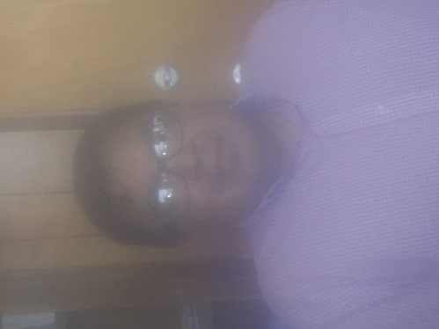

Raymond has volunteered for SEFCEDA for three years.

He has been in charge of projects, data entry, customer service and assistant to the CEO.

Raymond’s long term goals are to finish school and eventually teach music. He spends much time playing the piano for his church and during his free time. Daniel Hagen
UEI Intern

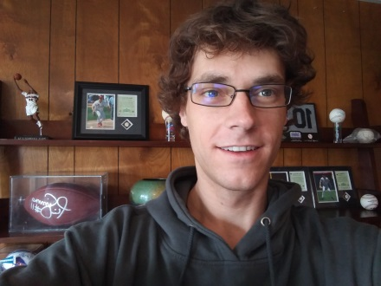

Daniels Internship was for 150 hours he served under the title of Office Assistant.

He assisted our staff with helping maintaining files, entering data and answering phone calls and special projects. His duties also included maintaining the supplies by using First in First out method. While as an intern Daniel was in charge of maintaining SEFCEDA’s social media accounts such as Facebook and Twitter.-
Daniel will use his work experience he received at SEFCEDA along with his schooling at UEI in gaining employment.

SEFCEDA is a proud host site of the AmeriCorps Vista Program.
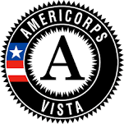

SEFCEDA Organizational Chart
2019 Board of Directors

Itzi Robles, Chair
Catherine Robles, Vice Chair
Joseph Riojas, SR., Treasurer
Sylvia Sanchez, Secretary
DR. Nellie Nedi, Board Member
Charles Vang, Board Member
Andy Hanson-Smith, Board Member

STAFF
Jose Leon-Barraza, CEO
Gabriel Lozano, Program Manager

