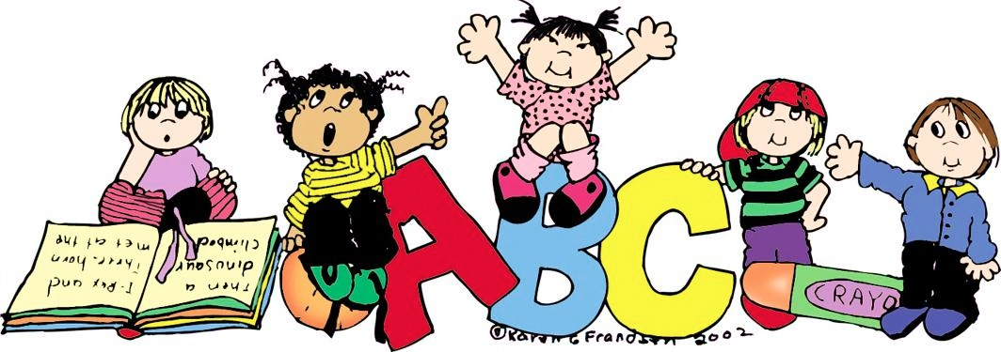

**www.castlebridgepreschool.org**

Parent and Student

Handbook

Students:

* Respect yourself
* Respect the teachers
* Respect your classmates
* Respect the building
* Try your best
* Participate

Parents:

* Respect the teachers
* Respect the Board
* Keep the lines of communication open
* Volunteer and help if and whenever possible
* Continue the teaching at home
* Make payments on time
* Respect the policies the Board has developed

Teachers:

* Respect each child and his/her unique differences
* Love each child and treat them as their own
* Respect the Board
* Be the first line of communication with the parents and the Board
* Teach to the best of their abilities understanding that each child may learn differently
* Have a happy heart and attitude at school

##### Castle Bridge Preschool’s Expectations

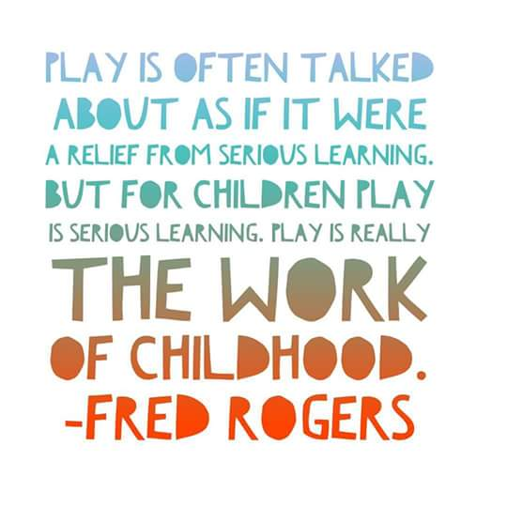



##### Castle Bridge Preschool’s Mission Statement

Striving to engage and challenge children academically, socially, physically, and emotionally in a Christian environment.

**Interested in Helping?**

We are always in need of parent/guardian help and support. Here are a few ways in which you can help your child receive the most out of

Castle Bridge Preschool:

Becoming a Board Member

Writing grants and donation requests

Organizing/planning fundraising activities

Volunteering to teach a special skill

Volunteering to Substituting

Carpooling

2

7



**RHONDA GUNDERT—TEACHER**

**Miss Rhonda** is an avid arts and crafts lover. Many of her beautifully painted rocks can be found around town. Miss Rhonda loves dogs as well and spending time with her grandson. We are so excited to be she will be with us teaching at Castle Bridge Preschool again this year!

**Miss Rhonda 208-206-2391 numbr1mama@yahoo.com**

## Meet OUR LEAD Teacher

## Board Members

**Miss Patti 208-200-8556 jandphammon@cableone.net**

Erin Nazario-- Chairman 206-794-4350

Betty Anderson—Vice Chairman 208-521-3039

Tacey Sanchez—Secretary 208-850-9796

Michelle Hagen--Treasurer 208-541-0096

Kelly P’Pool 208-201-1285

Jenny Helgeson 208-392-7341

If you would like to join the Preschool Board, we would love to have you! Our Board meetings are held on the first Thursday of the month at 11:45am at the Preschool.

**Miss Patti** grew up in a suburb of Chicago.  She moved to Idaho Falls in the early 1980's to teach in District #91.  She taught First grade for a while and then Second grade in the district for 35 years.  She called Longfellow her home for the last years of her teaching for District #91. She retired after the 2014-2015 school year, and began teaching at the Presbyterian Preschool.  She lives in Ammon with her husband, Jim.  Together they have a daughter and a son and an adorable grandson. She is so excited to be with us teaching at Castle Bridge Preschool again this year!

* General Tuition: Monthly tuition is as follows
  + Registration Fee (non- refundable): $50.00 before Sept.1

$75.00 after Sept. 1

* + 4 day (Monday-Thursday): $125.00
  + 3 day (Tuesday-Thursday): $115.00
* Payment: Tuition for enrollment is charged as a monthly fee. The payments are non-refundable and not based on the student’s attendance. Tuition is the same whether a child is absent or not. No adjustments will be made for planned absences or family vacations either.
* Payment Method: Please choose one of these options:
  + Monthly Checks (made payable to Castle Bridge Preschool) should be deposited into the box just inside the door of the classroom.
  + Checks may be mailed to the school, but must be received by the due date.
  + Cash deposits put into an envelope and deposited into the box just inside the door of the classroom.
  + Payment in full (due on the first day of school): if you choose to pay for the entire year, you will receive a 5% discount on the total amount due.
  + Payment in 2 installments (due on the first day of school and the first day back in January): If you choose to pay tuition in two installments, you will receive a 2.5% discount on the total amount.
  + Tuition adjustments may be made for families with multiple children attending the preschool at one time.
  + To make adjustments or payment arrangements not stated in this policy, please do not hesitate to contact the Board Treasurer. She will be happy to work with you. Communication is key.
* Due date: All monthly payments are due by the 10th of the month regardless of whether or not a tuition statement has been received by the parent or guardian.
  + A $25.00 late fee will be charged if payment is not received by the 10th unless arrangements have been made with the Treasurer.
  + If payment is not received or arrangements have not been made by the 15th of any given month, the student will be suspended from school until the balance is paid.
* Pro-rated Tuition: Tuition may be prorated for the very first month a child is enrolled if he or she begins after the beginning of the month. The tuition will be prorated accordingly. This is the only time tuition will be pro-rated.
* Insufficient Funds: Checks that are insufficient will result in a $30.00 charge in addition to any applicable late fees incurred and require replacement in the form of cash, money order, or cashier’s check. If there is a second returned check, all future payments must be made using cash or money order.
* Commitment: Our commitment to the students is for the full school year and we respectfully ask the same from the students and their families. Good communication allows the Board and the teachers to plan accordingly if a family must terminate mid-year. If termination is necessary, please give the preschool 30 days notice or you will be responsible for that month’s tuition. Our budget is based on enrollment, and this will help us in planning and addressing the financial needs of the Preschool.

### Patti Hammon—Lead Teacher

##### Castle Bridge Preschool’s Tuition Policy

6

3

##### Castle Bridge Preschool’s Policy

* Safety: We are a “Safe Schools” establishment. Our teachers are licensed by the city and have had a criminal background check. The preschool does not discriminate on the basis of race, color, national origin, sex, age, beliefs, or disability.
  + Classroom doors remain locked and only the main classroom door is generally opened with the ability to close and lock quickly.
* Visitation: Parents are welcome to visit during school hours, however, if a parent wishes to speak with the teachers about his/her child, arrangements must be made with the teachers outside of school hours.
* Behavior: Students are expected to respect the teachers, the staff, and the other children in the preschool. Teachers will work with parents/guardians to address expressive emotional and behavioral problems.
* Special Needs: Students with special needs that are within our scope of expertise will be accepted, however, we may have to consult with the child’s therapists and specialists if available. Communication between the parents and the teachers is vital. The purpose of this policy is to create a safe and caring environment to facilitate optimum learning. Each child is unique, and each situation is unique, and will be treated as such by all involved.
* Attendance: School is in session Monday-Thursday 9:00-11:30am. Children should attend school regularly and on time. If your child is going to be absent for reasons of illness, travel, or any other, please inform the teachers in advance when possible or before the start of school (illness).
* Illnesses and Head Lice: Please keep your child at home if he/she has any of these symptoms: coughing, sore throat, runny nose, eye infection, fever, rash, diarrhea, swollen glands, earache, or vomiting. If a child begins to feel ill or develops any of these symptoms while at preschool, a parent or guardian will be notified and requested to pick up the student. Please allow 24 hours after any of these symptoms have dissipated before sending your child back to school to avoid infecting others. In the case of head lice, the parents/guardians will be notified and required to pick up their child immediately. He/she will be readmitted upon receiving written verification that proper treatment has been completed.
* Immunizations: As required by law, each child attending preschool must be current on all immunizations or an exemption form must be turned in to the Board. The immunization form must be returned before the start of school.
* Toilet Training: Due to legal and logistical reasons, it is not possible for teachers to assist children with toileting issues. Children must know how to use the toilet and wipe themselves without assistance. We realize accidents happen. Please feel free to send extra clothes with your child to keep in the child’s backpack in case such emergencies happen.
* Emergency/weather alerts: Parents will be notified by text messages if there are any emergencies (such as fire) or closures due to weather.
* **Drop Off/Pick Up:**  Please drop off and pick up your child at the North doors. It is best if you walk your child into the building each morning, as the stairs down to the classrooms can be treacherous at times. Drop-off times are 8:50-9:05am (unless other arrangements with the teacher have been made). Pick Up times are 11:30-11:40. Please be prompt. If someone other than the parent or guardian is picking up your child, please inform the teachers at drop-off with the name of the person responsible for picking up your child that day.
* Clothing: Please be sure to send your child to school in comfortable and washable clothing. It is also important to dress them appropriately for the weather as the children often go outside to play. Please be sure that coats, boots, hats, and gloves are clearly marked. Please no hard-soled shoes or any other shoes that will mark the floor. The gymnasium floor is beautifully maintained, and we would like to respect the gym floor. Flip-flops and open-backed shoes are not recommended as it makes running and playing in the gymnasium and outside difficult.
* Food: Please do not send food with your child unless you have spoken to the teachers and made arrangements. Snack time is scheduled each day. Birthday treats are permitted if previous notice is given to the teachers.
  + Please be sure to list any food allergies on your child’s enrollment form. The Board will purchase daily snacks accordingly.
  + There will be a sign up sheet for students to bring a treat once a week. Please be sure to choose a “letter of the week” snack day and bring enough snacks (starting with that letter) for the entire class.
* Possessions: There is opportunity for your child to bring possessions from home on “show ‘n’ tell” days each week. Any other time is not appropriate for toys from home to come to school. If they do make their way to school, the teacher may ask the child to put it in their backpack, put on the counter in the classroom, or on the shelf in the hallway. If a toy from the preschool makes its way home with your child, please be sure to return it to the school promptly so that other children may enjoy playing with it as well. All toys and equipment belong to the church and are on loan to the preschool.
* Communication: The Board and the teachers value your opinions, suggestions, and questions about all aspects of our program. It is important to keep the lines of communication open. Communication is a 2-way street. If concerns with the preschool arise, the board will notify parents as soon as possible.
* Field Trips: Parents are encouraged to attend filed trips. Liability forms/permission slips will be required for every field trip and transportation to and from field trip locations is the responsibility of the parents/guardians. Parent volunteers and the teachers with verification of current driver’s license and insurance will transport children without an accompanying adult with a signed liability release form.
* Castle Bridge Preschool does not discriminate on the basis of race, color, national origin, sex, age, beliefs, or disability.

4

5