* **Name:**
* **Date:**
* **SBA #:**
* **Topic:** Specific heat capacity
* **Title:** Finding the specific heat capacity by the method of mixtures
* **Aim:** To determine the specific heat capacity of a metal by using the method of mixtures technique
* **Equation(s):**EHwater  = mwater  × cwater × ΔTwater  
  EHmetal  = mmetal  × cmetal × ΔTmetal  
    
  hence when: EHwater = EHmetalthen:   
    
  mmetal × cmetal × Δ*θ*metal = mwater  × cwater × Δ*θ*water   
    
  therefore:  
  cmetal = (mwater × cwater  × Δ*θ*water) ÷ (mmetal × Δ*θ*metal)   
    
  where:  
  cwater is 4.2 Jg-1oC-1 which is a constant  
    
  please note that:  
  **m** means mass in grams since the value for **cwater** being used has units of grams in it, **Δθ** means change in temperature with units of **oC** or **K** and ***c*** means specific heat capacity with units of **Jg-1oC-1**
* **Apparatus/Materials:** top pan balance, thermometer, measuring cylinder, Styrofoam cup, metal, Bunsen burner, beaker , tongs and approximately 200 g of water
* **Method:**1. Record the mass of the metal in grams.  
    
  2. Heat the solid in 100 g of boiling water for 10 minutes and once the time has elapsed record the temperature of the boiled water as the ***initial temperature of the metal solid***.  
    
  3. Meanwhile, using a measuring cylinder obtain approximately 100 cm3 of water then find its mass in grams.  
    
  4. Fill a polystyrene cup with the 100 cm3 of water and using a thermometer record the temperature of the ***water as*** ***initial temperature***.  
    
  4. Once ten minutes of boiling have elapsed, quickly and carefully transfer the solid to the Styrofoam cup containing the 100 g of water.   
    
  5. Place a thermometer within the same Styrofoam cup containing the water and hot metal and record the temperature of the water measured as ***final temperature*** of both the **block** and **the water** once the reading on the thermometer’s scale becomes constant.   
    
  6. Record all observations and data within an appropriate table.
* **Observations:***Describe what you saw here. This shouldn’t be more than three to four lines.*
* **Diagram: (Draw a 2-D representation of your apparatus)**

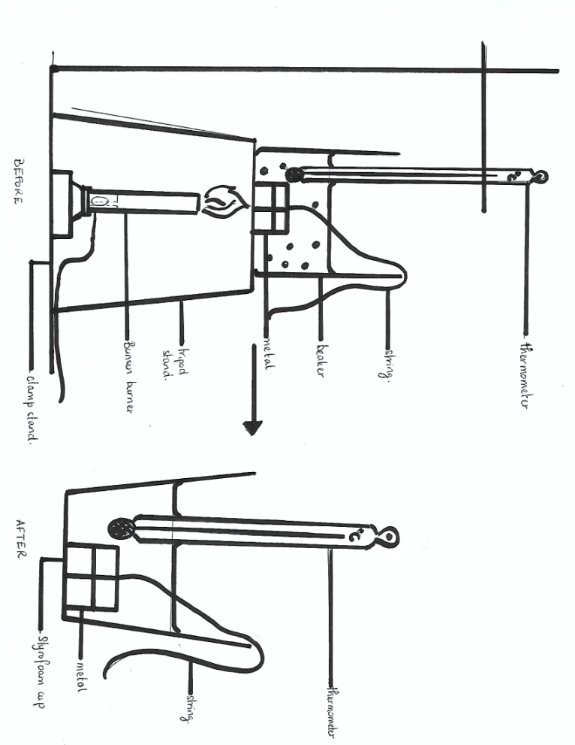DIAGRAM SHOWING HOW LAB WAS EXECUTED TO DETERMINE THE SPECIFIC HEAT CAPACITY OF A METAL

* **Calculations:**1. Type of metal used: ________   
    
  2. Mass of metal: ________g  
    
  3. Volume of water : **_______** cm3   
     
   Actual mass of water: _______g  
    
  4. Initial Temperature of metal after being boiled: ______oC  
    
  5. Final Temperature of metal after being placed in Styrofoam cup : _____oC  
    
  6. Δ*θ* of metal (***show working***): _____________________ oC  
    
  7. Temperature of water in Styrofoam cup before adding the hot metal: _____oC  
    
  8. Temperature of water in Styrofoam cup after hot metal  
  has been added to it: _____oC  
    
  9. Δ*θ* of water (***show working***): ___________________________________ oC  
    
  10. Using the specific heat capacity of water: **4.2 J/goC**determine the heat the water gained if:  
    
  EHheatgainedbywater = mH2O × cH2O × ΔTH2O   
    
  ________________________________________________________________ J  
    
  11. Literature value of specific heat capacity of metal: __________J/goC   
    
  12. Calculated specific heat capacity of metal if heat lost from metal was gained by water (***show working***) where:  
    
  EHheatgainedbywater = EHheatlostbymetal  
    
  :. cmetal = EHheatgainedbywater ÷ (mmetal × ΔTmetal )  
    
    
  _______________________________________________________________ J/goC  
    
  13. % Difference of metal’s specific heat capacity (***show working***):   
    
  [ |Actual value – Calculated value| ÷ ((Actual value + Calculated Value) ÷ 2)] × 100  
    
  ____________________________________________________________________  
    
    
  _________________________________________________________________ %

Data and Results:

**TABLE 1 SHOWING THE RESULTS OBTAINED FROM THE METHOD OF MIXTURES**

|  |  |  |
| --- | --- | --- |
| **Measurements** | **Type of metal  ………………..** | **Water** |
| **Mass (g)** |  |  |
| **Final Temperature (oC)** |  |  |
| **Initial Temperature (oC)** |  |  |
| **Temperature change, Δθ (oC)** |  |  |
| **Literature value for the metal’s specific heat capacity  (Jg-1oC-1)** |  | 4.2 |
| **Calculated value for metal’s specific heat capacity (Jg-1oC-1)** |  | × |

**TABLE 2 SHOWING THE LITERATURE VALUES FOR THE SPECIFIC HEAT CAPACITIES OF VARIOUS METALS**

|  |  |
| --- | --- |
| Metal | Specific Heat Capacity (Jg-1oC-1) |
| Copper | 0.377 |
| Brass | 0.380 – 0.402 |
| Steel | 0.502 |
| Iron | 0.450 |

* Discussion: (***Use the questions below as a guide for writing the discussion in prose format.***)  
    
  **Paragraph 1:**  
  Define specific heat capacity.  
    
  **Paragraph 2:**  
  1. What was the experimentally determined value for the specific heat capacity of the metal used?  
    
  2. Were the results in question 1 very close to the accepted literature value for the specific heat capacity of the metal? Whether yes or no, explain the results.
* Limitation: (***State one thing that could have caused the lab to go wrong and could not have been helped/fixed at that particular point in time?***)
* Precautions:  
  1. Hot glassware and objects were handled with thongs  
    
  2. ?
* Reflections: (***Provide an overview of how this lab is or can be used in everyday applications.***)
* Conclusion: (***The conclusion should reflect the aim or purpose of executing the lab.***)  
  In conclusion …….

**Analysis and Interpretation – Finding the Specific Heat  
Capacity by the Method of Mixtures**Student’s ability to:  
(a) make accurate calculations;  
* ΔT of metal complete with correct units /2  
* ΔT of water complete with correct units /2  
* Calculated EH of water complete with correct units /2   
* Calculated specific heat capacity of metal complete with   
units /2  
* Calculated % difference between actual value and   
calculated value of specific heat capacity of metal,  
complete with units /1  
  
(c) Evaluates from data  
 (including sources of error)  
 *See discussion section for*  
 Explanation of results: /8  
* Given (1)  
* Sensible (1)  
* Thorough (2)  
 or  
 Partial (1)  
* Comparisons or Trends   
 mentioned (2)  
* Limitation or Source of Error:  
(i) Given (1)  
(ii) Plausible (1)  
(iii) None given (0)  
  
(f) Draws a conclusion  
 justified by data /1  
 **Total: /18**

**Manipulation/Measurement**a. Student’s ability to handle scientific equipment competently.  
The list of equipment is:  
(i) Bunsen burner;  
* Close air hole /1  
* Light match /1  
* Turn on gas /1  
(iv) measuring cylinder;  
* measuring cylinder set on a flat surface /1  
* Height of liquid read below the meniscus /1  
(v) thermometer;  
* Handled with care by letting it lie flat when  
 not in use /1  
* Clamped/held in middle of the liquid that  
is above a flame /1  
 **Total: /7**