* **Name:**
* **Date:**
* **SBA:**
* **Topic:**  Specific latent heat of fusion
* **Title:** Specific latent heat of fusion of ice
* **Aim:** To determine the specific latent heat of fusion of ice by allowing it to melt in water
* **Equations:  
    
  If**   
  EHheat given off by water = EHheat taken in by ice **and**EH heat given off by water = mwater × cwater × ΔTwater **and** EH heat taken in by ice = mice × ΔTice  
  **then**mwater × cwater × ΔTwater = mice l*f*icewhere***l****f*ice  = mwater × cwater × ΔTwater ÷ mice

***please note that*:**  
**EH** means heat gained or heat lost with units of **J  
m** means mass with units of **kg  
c** means specific heat capacity with units of **Jkg-1oC-1** or**Jg-1K-1**  
**Δ*T* or Δ*θ*** means temperature change with units of **oC** or **K** and ***lf*** means specific latent heat of fusion with units of **Jkg-1** or **Jg-1**

* **Apparatus/Materials:** top pan balance/electronic scale, vacuum flask, ice cubes, 100cm3 of water, measuring cylinder, Styrofoam cup, thermometer
* **Method:**   
  1. As a precautionary measure, ***tare*** out a top pan balance and place a measuring cylinder on top of it.  
    
  2. Fill the measuring cylinder with approximately 100 cm3 of water and record the mass of the water within it.  
    
  3. Pour all 100 cm3 of the water from the measuring cylinder into a Styrofoam cup and take its temperature. Record it as the initial temperature of water.  
    
  4. Place a Petri dish or beaker upon the top-pan balance and press the tare button.   
    
  5. Obtain some ice cubes and find their mass by placing them into the Petri dish. (***A Petri-dish or beaker is used to find out the mass of the ice to avoid loss of mass as it will melt naturally.)***  
  6. Transfer the ice cubes into the Styrofoam cup containing the water and record the temperature of the icy water once it has equilibrated.  
    
  7. Repeat the entire lab one more time.  
    
  8. Record all data onto the worksheet and into the data table provided.

* **Observations: (*Write what affected any of your five senses here. This section should not be more than three lines and less than one.*)**
* **Diagram: 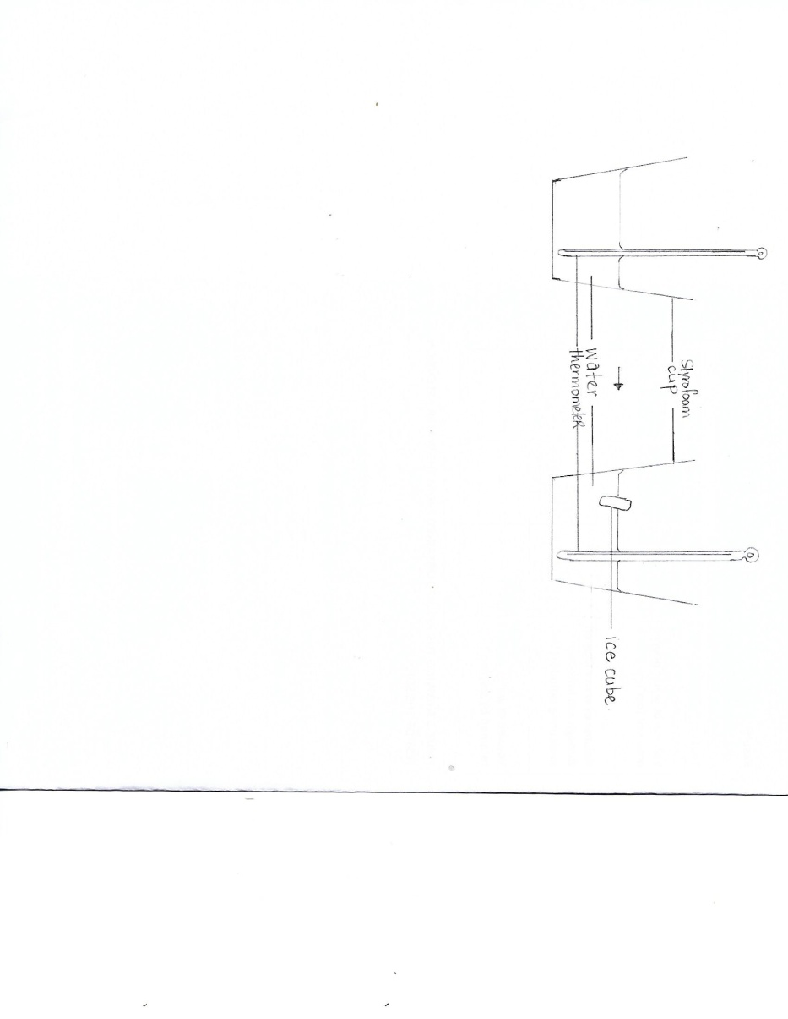DIAGRAM SHOWING HOW LAB WAS EXECUTED** **TO DETERMINE THE SPECIFIC LATENT HEAT OF FUSION OF AN ICE CUBE OF WATER.**
* **Calculations:**1. Volume of water: _____________ cm3  
    
  2. Mass of water: ______________ g  
    
  3. Specific heat capacity of water, **4.2 J/goC**4. Final temperature of water in Styrofoam cup: __________ oC   
    
  5. Initial temperature of water in Styrofoam cup: __________ oC  
    
  6. ΔTH2O of water: __________ oC  
    
  7. Heat given off by water:   
    
  EHheatgivenoffbywater = mH2O × cH2O × ΔTH2O  
  ___________________________________________________ J  
     
  8. Mass of ice (***including the parts that melted)***: ___________ g  
    
  9. Calculated value for the specific latent heat of fusion of ice if:  
    
  EHwater = EHice  then mH2O × cH2O × ΔTH2O = mice lf(ice)  
    
  where lf(ice) = (mH2O × cH2O × ΔTH2O) ÷ mice___________________________________________________ J/g10. Actual value for the specific latent heat of ice, **340 J/g**
* 11. % difference of specific latent heat of ice if:  
    
  [|Actual value – Calculated value| ÷ ((Actual value + Calculated value) ÷ 2)] × 100   
   **______________________________________________________  
    
  ______________________________________________________  
    
  ___________________________________________________ %**
* **Data and Results  
    
  Table showing the results collected to obtain the calculated value for the latent heat of fusion of ice**

|  |  |  |
| --- | --- | --- |
| Date recorded | Trial 1 | Trial 2 |
| Mass of water (g) |  |  |
| Final Temperature of water (oC) |  |  |
| Initial Temperature of water (oC) |  |  |
| ΔT of water (oC) |  |  |
| Heat given off by water (J) |  |  |
| Heat taken in by ice (J) |  |  |
| Mass of ice (g) |  |  |
| Calculated specific latent heat of ice (Jg-1) |  |  |
| Actual specific latent heat of fusion of ice (Jg-1) | 340 | |
| % Difference of calculated value and actual value of specific latent heat of fusion of ice |  |  |

* **Discussion:  
  Paragraph 1**  
  1. What is latent heat?  
  2. Define specific latent heat of fusion?  
  3. Explain why there is no heat loss during specific latent heat of fusion.  
    
  **Paragraph 2**  
  1. Compare your calculated results with the actual results for the specific latent heat of fusion for ice.   
  2. Did both, one or none of the trials produce any favourable results?  
  2. State at least one possible limitation that may have materialized during the practical.
* **Precautions:**  
  1. All glassware were handled with care.  
    
  2.
* **Reflections:**  
  *\*relate your lab to how it can be used in everyday life. Why do you need to know about latent heat?*
* **Conclusion:**  
  *\*relate it to your aim and state your calculated value for specific latent heat of fusion.*

**Analysis and Interpretation  
Specific Latent Heat of Fusion of Ice**Student’s ability to:  
(a) make accurate calculations:  
* ΔT of water complete  
 with correct units /**2** * Calculated EH of water  
 complete with correct units /**2**   
* Calculated mlf of ice   
complete with correct units /**2**  
 * Calculated % difference  
between actual value and  
 calculated value of specific  
latent heat of fusion of ice /**2**  
  
(c) Evaluates from data  
 (including sources of error)  
 *See discussion section for*  
 Explanation of results: **/8**  
* Given (1)  
* Sensible (1)  
* Thorough (2)  
 or  
 Partial (1)  
* Comparisons or Trends   
 mentioned (2)  
* Limitation or Source of Error:  
(i) Given (1)  
(ii) Plausible (1)  
(iii) None given (0)  
  
(f) Draws a conclusion  
 justified by data **/1**  
  
**Total: /17**