* **Name:**
* **Date:**
* **SBA:** #
* **Topic:** Ray optics
* **Title: Reflection of light**
* **Aim:** To prove that the two laws of reflection are true
* **Apparatus/Materials:** blank paper, pencil, protractor, ruler, opaque piece of paper slit, torch light/flashlight
* **Method:**1. Using a ray boy the apparatus was set up as demonstrated.  
  2. Three incident rays were drawn using a pencil.  
  3. On incident ray 1 a ray of light was focused and its reflected ray was observed and marked off.  
  4. The lab was repeated twice for the other two incident rays.  
  5. All observations and results were recorded.
* **Observations:** Describe what you saw here.
* **Diagram: (Insert the plain paper with your data on it here)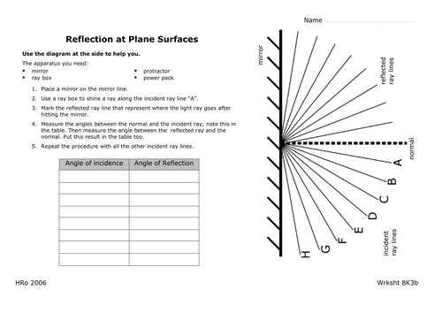 DIAGRAM SHOWING HOW LAB WAS EXECUTED**
* **Data and Results:  
    
  Table of incidence rays and their corresponding angles of reflection**

|  |  |  |
| --- | --- | --- |
| **Trial** | **Measured angle of incident ray** | **Measured angle of reflected ray** |
| **1** |  |  |
| **2** |  |  |
| **3** |  |  |

* **Discussion:**1. What is light and how does it travel?  
  2. How does light behave on reflective surfaces?  
  3. State the two laws of reflection.  
  4. Did your experiment prove them true? Why?  
  5. On an irregular surface why does light seem to diffuse?   
  6. State a limitation here
* **Precautions:  
  1.  
    
  2.**
* **Reflections:**
* **Conclusion: (What did you conclude)**  
  In conclusion…..

**Measurement and Manipulation – Reflection of Light  
  
\***Drawing and lining up a mirror along the mirror plane /2  
  
*Drawing the normal perpendicular to the mirror plane /1  
  
*Drawing & measuring the incident angles correctly /2  
  
* Properly aligning a single ray of light along the prior  
measured incident angle /2  
  
*Correctly locating, drawing and measuring the  
reflected ray /3  
  
**Total: /10**