* Name:
* Date:
* SBA: #
* Topic: Ray optics
* Title: Refraction of light
* Aim:   
  1. To prove that light bends once it passes from air to glass   
  2. To determine the refractive  
  index of glass.  
  3. To determine the speed of light in glass
* Apparatus/Materials: blank paper, pencil, protractor, ruler, opaque piece of paper with slit, torch light/flashlight,  
  block of glass
* Method:  
  1. The apparatus was set up as shown.  
  2. Five readings for the incident ray, θ1, were taken and subsequently  
  the refracted ray, θ2 were recorded.  
  3. All data was recorded within a table.  
  4. The results were plotted on a graph of sinθ1 against sinθ2 and the refractive index of the glass was determined via its slope.  
  5. The results were then used to determine the speed of light through the graph.
* Observations: (*Describe what you saw here.*)
* Diagram: (*Insert the plain paper with your data on it here*)  
   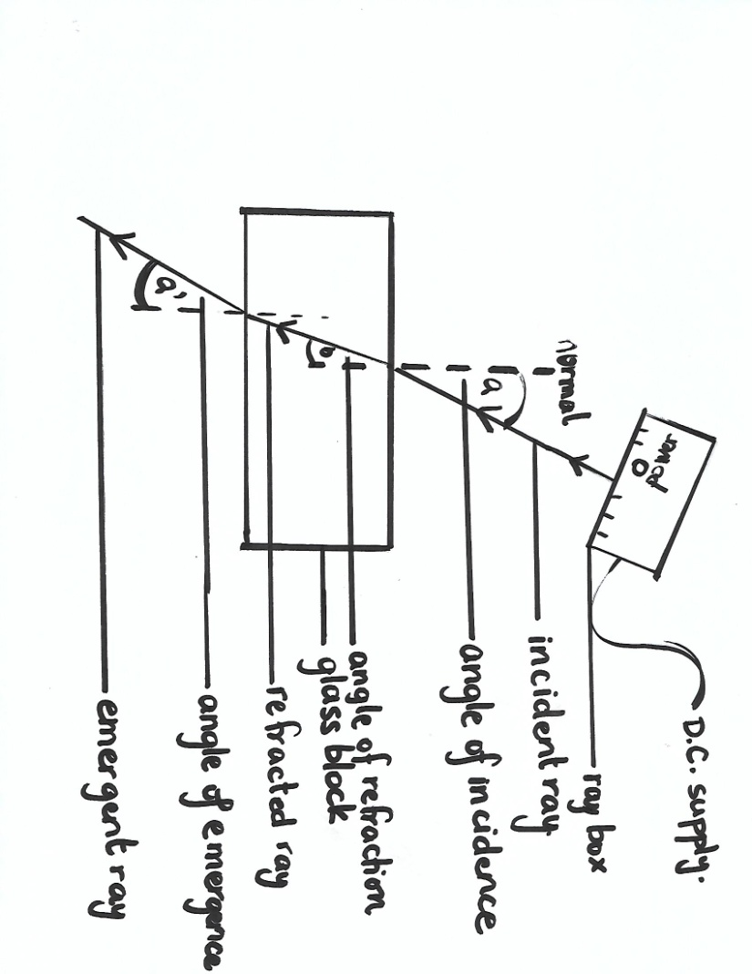  
  DIAGRAM SHOWING HOW THE LAB WAS EXECUTED
* Calculations: (*Show an example of all calculations performed in this section*)  
  1. Experimentally determined refractive index (*n*) = sin θ1 ÷ sin θ2    
    
  2. speed of light in glass (*v*)  
  = (3 × 108 m/s ÷ experimentally determined refractive index)  
    
  3. % difference = |actual – calcd| ÷ ((actual + calcd)/2) × 100
* **Data and Results:  
  Table 1 showing ……………………………… (*give an appropriate title*)**

|  |  |  |  |  |
| --- | --- | --- | --- | --- |
| **Trial** | **Measured angle of incident ray θ1** | **Measured angle of refracted ray θ2** | **sin θ1** | **sin θ2** |
| **1** |  |  |  |  |
| **2** |  |  |  |  |
| **3** |  |  |  |  |
| **4** |  |  |  |  |
| **5** |  |  |  |  |

**Experimentally determined refractive index of glass determined from slope of graph ________**

* **Discussion:**1. What is light?  
  2. What is the speed of light and how is its speed affected by entering denser mediums?  
  3. State the two laws of refraction.   
  4. Write the equation for Snell’s law.   
  5. Did your experiment follow the laws of refraction well?   
  6. What was your calculated refractive index of glass?   
  7. Does your calculated refractive index of glass mirror the accepted literature value for the refractive index of glass which is 1.5?  
  8. For your answer above in question 7 provide an explanation whether it does or does not.  
  9. Provide a limitation for this lab.
* **Precautions: (*Did you wear your goggles or a lab coat or some gloves? What did you do to protect yourself? Did you avoid parallalax?*)**
* **Reflections: (How may this lab be applied to everyday life?)**
* **Conclusion: (What have you concluded)***In conclusion…..*

**Observation/Recording/Reporting (ORR)   
Refraction of Light  
(a) Recording** a. Student’s ability to record observations and   
to collect and organise data; observations and   
data may be recorded in:  
(i) Prose  
Written description of observations  
in the correct tense /1  
(ii) Table  
Appropriate headings /1  
Title given /1  
(iii) Graph  
* Title for graph /1  
* Title axes labelled for  
 both x and y /2  
* Correct scales /2  
* Accurate plotting:  
All points plotted correctly /5  
Every point incorrectly plotted  
minus one point  
* Fine points used /1  
* Best fit line drawn /1  
  
(b) Reporting  
Student’s ability to prepare a comprehensive  
written report on their assignments using the   
following format:  
(i) Date (date of experiment) /1  
(ii) Aim (what is to be  
accomplished by doing the  
experiment /1  
(iii) Apparatus and Materials  
(all equipment and materials  
used in the experiment must  
be listed) /1  
(iv) Method/Experimental  
Procedure (step by step  
procedure written in past   
tense) /2  
  
Total: /20

**Measurement and Manipulation  
Refraction of Light  
\***Tracing out the block /1  
  
*Correctly drawing the normal  
 perpendicular to the block /1  
  
*Correctly drawing and measuring  
and incident ray towards  
the normal /2  
  
*Correctly locating, drawing and  
 measuring the emergent ray /3  
  
*Correctly locating, drawing and  
 measuring the refracted ray /3  
  
*Correctly indicates where θ1 and  
 θ 2 are /2  
  
* Indicates which ray is the:  
incident ray /1  
  
refracted ray /1  
  
emergent ray /1  
  
**Total: /15**