**Name:   
  
Date:   
  
SBA:**   
  
**Topic:** Static and current electricity  
  
**Title:** Resistance  
  
**Aim:** To determine the resistance of a bulb in a series circuit  
  
**Equation**:   
  
R = V/I  
  
Where R means resistance with units of ohms, Ω; V means voltage with units of volts, V and I means current with units of amperes, A  
  
**Apparatus/Materials:**  power source, connecting wires, one light bulb and an ammeter   
  
**Method: (*Rewrite this method in past tense*)  
1.** Set up a series circuit using a power source, ammeter and a light bulb as demonstrated on page ____.   
2.Adjust the voltage at 1 V and record the amount of current flowing throughout the circuit.  
3. Repeat step 2 four more times at 2V, 3V, 4V and 5V..  
4. Using the results obtained plot a graph of current against time and determine its slope, R.  
5. To determine the resistance of the bulb find the inverse of the slope by dividing 1 by the slope where resistance = 1/slope.  
  
**Observations:  
(*Describe what you noticed here.*)  
  
  
  
  
  
Diagram:**

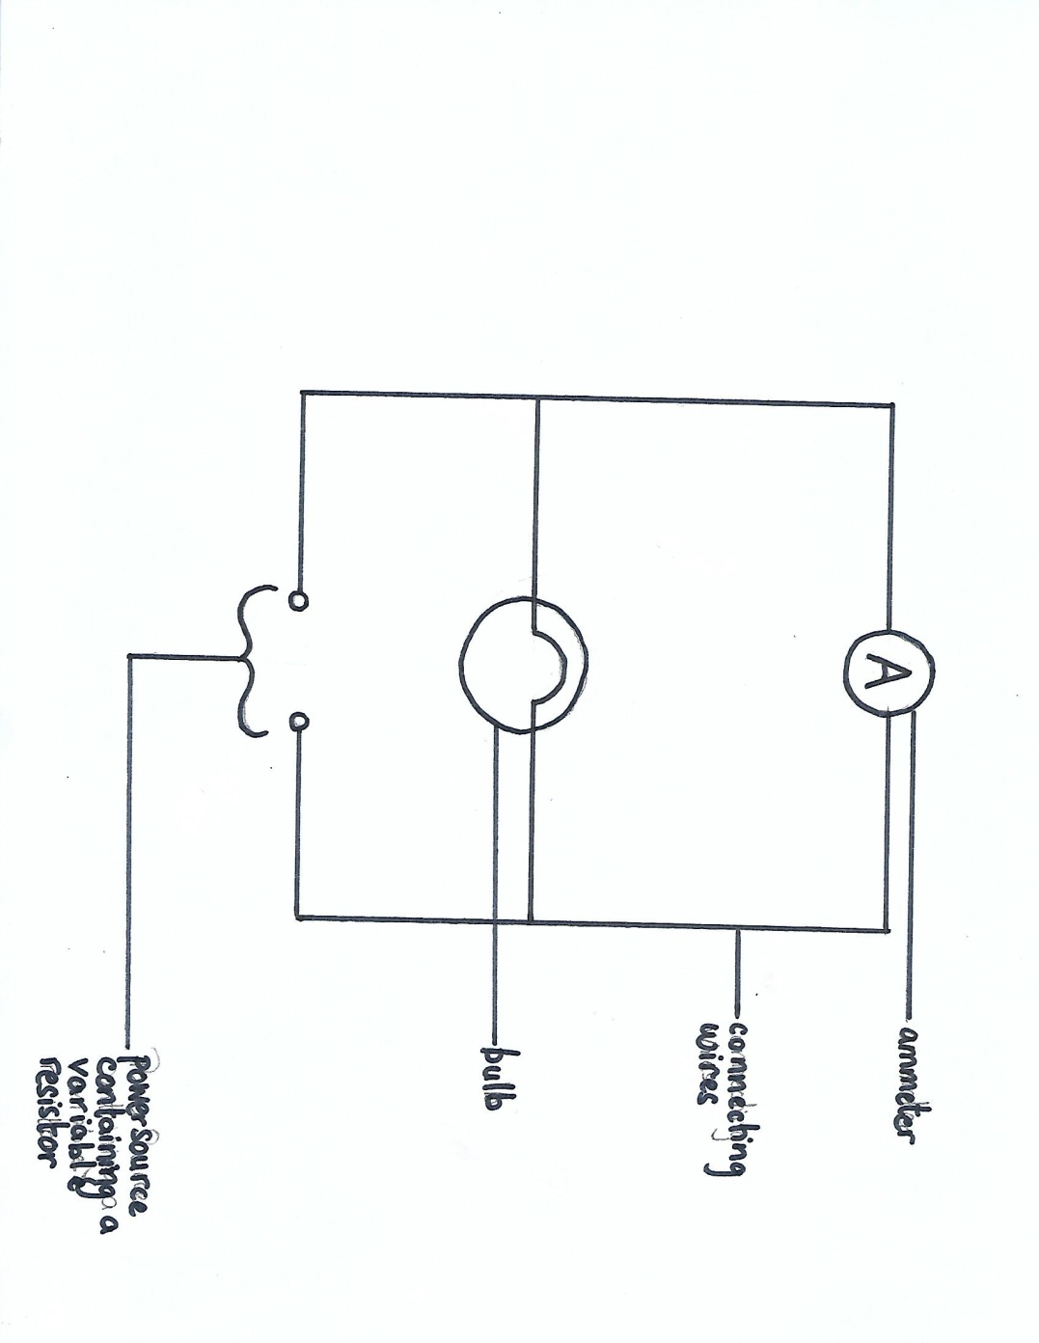

**DIAGRAM SHOWING HOW LAB WAS EXECUTED**

**Data and Results:  
  
Table 1 showing ……..**

|  |  |
| --- | --- |
| Voltage (V) | Amperes (A) |
|  |  |
|  |  |
|  |  |
|  |  |
|  |  |
|  |  |

**Calculations: (*Show ALL calculation(s) performed*)**1. slope of graph, ***S*** = = OR   
2. Average resistance across bulb = $\frac{1}{S}$ Ω

**Discussion: (*Use these questions as guidelines for writing your discussion in paragraph form*)  
Paragraph 1:**Define resistance giving its unit.  
 **Paragraph 2:**Using your graph explain how altering voltage affects current as well as the behaviour of the intensity of the light produced from the bulb.   
  
**Paragraph 3:**  
Provide a possible limitation of this lab.  
 **Precautions:  
1.  
  
2.  
  
  
Reflection: (*How does this lab apply to everyday life?*)  
*I now know why…..*  
  
Conclusion:   
*In conclusion …***

**Measurement and Manipulation –   
IV relationships**

1. Following instructions /1  
  
2. Uses basic laboratory equipment correctly /4  
power source (1)  
wires (1)  
ammeter (1)  
and bulb (1)  
  
3. Sets up electrical circuit correctly /1  
  
4. Uses electrical circuit correctly /1  
  
5. Prepares material for observation or  
investigation correctly /1  
  
6. Student’s ability to take accurate   
measurements /1  
  
7. Student’s ability to use appropriate units /1

**Total: /10**

**Observation & Recording – IV relationships**a. Student’s ability to record observations and   
to collect and organise data; observations and   
data may be recorded in:  
  
(i) Prose  
Written description of observations in the correct  
tense /1  
(ii) Table  
Appropriate headings /1  
Title given /1  
(iii) Graph  
* Title for graph /1  
* Title axes labelled for both x and y /2  
* Correct scales /2  
* Accurate plotting: /5  
All points plotted correctly (5)  
1 -2 points plotted incorrectly (4)  
3 -4 points plotted incorrectly (3)  
5 -6 points plotted incorrectly (2)  
7- 8 points plotted incorrectly (0)  
* Fine points used /1  
* Best fit line drawn /1  
  
(b) Reporting  
Student’s ability to prepare a comprehensive  
written report on their assignments using the   
following format:  
(i) Date (date of experiment) /1  
(ii) Aim (what is to be accomplished by  
doing the experiment /1  
(iii) Apparatus and Materials (all equipment  
and materials  
used in the experiment must be listed) /1  
(iv) Method/Experimental Procedure (step by  
step procedure written in past tense) /2  
  
**Total: /20**