**Name:**

**Date:**

**SBA:**   
  
**Topic: The atom   
  
Title: Simulating radioactive decay**  
  
**Aim:** To simulate radioactive decay by determining the half life of a dice’s probability to land with the six face exposed.   
  
**Apparatus/Materials:** 50 – 100 dice, beaker  
  
**Method:**1. Obtain at least 50 – 100 dice.   
  
2. Place them into a beaker.  
  
3. Record this initial count of dice as ‘***un-decayed nuclei***’, and designate this ‘throw’ as throw zero (0).  
  
4. Shake the beaker of dice and after shaking the container thoroughly, pour the dice over a wide area such as a table-top.   
  
5. Remove all of the ‘***decayed nuclei***’ (*dice that have landed with the six face exposed*).   
  
6. Count and record the number of ‘***un-decayed nuclei***’ (*dice that did not landed with their six face up*) as well as the throw number in an appropriate table.  
  
7. Remove the ‘***decayed nuclei***’ to one side and put the ‘***undecayed nuclei***’ back into the beaker.  
  
8. Repeat steps 2 - 7 for about 15 throws or until all dice ‘***decay***’.  
  
9. Draw a graph of number of un-decayed nuclei versus number of throws to determine the half life of the dice.   
O**bservations:  
Describe what you see here.**

**Diagram:  
  
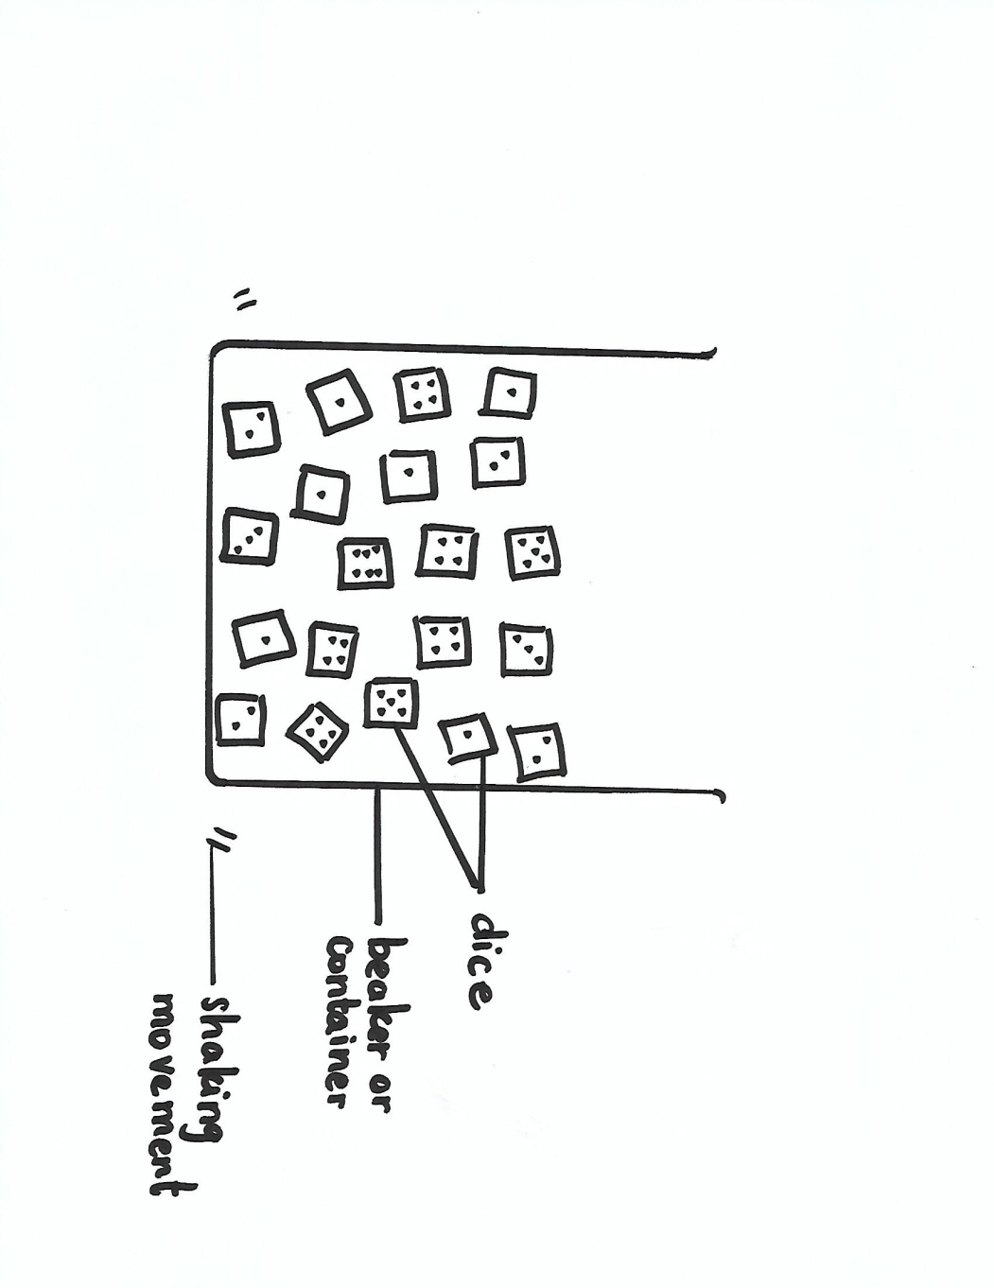**DIAGRAM SHOWING HOW LAB WAS EXECUTED TO DETERMINE THE HALF LIFE OF DICE

**Data and Results:  
Table showing….(complete the title of this table)**

|  |  |
| --- | --- |
| **Number of times thrown** | **Number of un-decayed nuclei** |
| **1** | **100** |
| **2** |  |
| **3** |  |
| **|4** |  |
| **5…** |  |

1. Plot a graph of number of ‘***un-decayed nuclei***’ against ‘***times thrown***’.  
  
2. Using the graph in step 1, determine the ‘half-life’ of the matchsticks’ ‘decay’ process by considering:  
a. 25 as the initial number of ‘un-decayed nuclei’,  
b. 12.5 as the initial number of ‘un-decayed nuclei’.  
c. 6.25 as the initial number of ‘un-decayed nuclei’.

**Calculations:   
  
Half –life at 50 un-decayed nuclei left: ______________ throws  
  
Half – life at 25 un-decayed nuclei left: ______________ throws  
  
Half – life at 12.5 un-decayed nuclei left: _______________ throws  
  
Average half – life of dice: (show your working) ________________________ throws**

**Discussion:   
(Use the following questions to guide you when writing up your discussion. Do not use pronouns. Answer in complete sentences. Do NOT write out the questions. Use indented or block paragraphing)  
  
Paragraph 1**: Define Radioactivity  
  
**Paragraph 2**:   
Explain your results. What was the experimentally determined half life of the dice?   
Is radioactive decay a random process?  
Does throwing the dice mimic radioactive decay?  
  
**Paragraph 3**: State any limitation that was met or could have been met.  
  
  
**Precautions:  
  
  
  
Reflections: How does this lab apply to life? (You may write in first person and you may use pronouns here)**

**Conclusions: (What is your conclusion?)  
In conclusion…..**

* **Observation/Recording/Reporting (ORR)  
  Simulating radioactive decay  
  (a) Recording**Student’s ability to record observations and to collect and  
  organize data; observations and data may be recorded in:  
  (i) Prose  
  Written description of observations in the correct tense. /**1**  
  (ii) Table  
  Appropriate headings  **/1**  
  Title given **/1**  
  (iii) Graph

* Title for graph  **/1** * Title axes labeled for both x and y **/2**  
 * Correct scales **/2** * Accurate plotting:  
 All points plotted correctly  **/5**  
 1 – 2 points plotted incorrectly **(4)**  
 3 – 4 points plotted incorrectly **(3)**  
 4 – 5 points plotted incorrectly **(2)**  
 5 – 6 points plotted incorrectly **(1)**  
 7 points or more plotted incorrectly **(0)**  
 * Fine points used  **/1**  
 * Best fit line/curve **/1**  
  
**(b) Reporting**Student’s ability to prepare a comprehensive written report on  
their assignments using the format  
(i) Date (date of experiment) **/1**  
(ii) Aim (what is to be accomplished by doing the   
experiment) /**1**  
(iii) Apparatus and Materials (all equipment and   
materials used in the experiment must be listed) **/1**  
(iv) Method/Experimental Procedure (step by   
step procedure written in the past tense) /**2  
  
Total: /20**

**Analysis and Interpretation (AI)**Simulating radioactive decay  
**(a) Recording**Student’s ability to make accurate calculations for:  
* determining the half life of the matchsticks :  
 extrapolates three times /3  
 calculates the average half-life correctly w/ units /2  
  
**(c) Evaluates from data (including sources of error)**See discussion section  
Explanation of results: /5  
* Given (1)  
* Sensible (1)   
* Thorough (2)  
* Partial (1)   
* Comparisons or Trends mentioned (1)  
* Limitation or Source of Error: /2  
(i) Given (1)  
(ii) Plausible (1)  
  
**(f) Draws a conclusion justified by data:**  /2  
* Given (1)  
* Plausible (1)  
 **Total: /14**