Name:   
  
Date:

SBA: #  
  
Topic: Measurement and Units  
  
Title: Density  
  
Aim: To determine the density of a pebble  
  
Equation(s):  
1. density (g/cm3) = mass (g) ÷ volume (cm3)  
  
2. relative density = density of object (g/cm3) ÷ density of water (g/cm3)  
  
density of water: 1 g/cm3  
  
Apparatus and Materials: measuring cylinder, approximately 50 mL of water, top pan balance, pebble  
  
Method: **(REWRITE IN PAST TENSE)**  
1. Determine the mass, in grams, of a pebble using a top pan balance.  
  
2. Fill a measuring cylinder with approximately 50 mL of water and record this as the initial volume of water, V*i*.  
  
3. Slide the pebble down the side of the measuring cylinder to avoid loss of water and note the new volume as the final volume of water, V*f*.  
  
4. Using the experimentally determined mass and volume of the pebble determine its density and relative density.  
  
5. Repeat steps 1 – 4 two more times.  
  
6. Record all data within a suitable table.  
  
  
Observations: **(FILL IN WHAT YOU SAW, SMELLED ETC….)**

Diagram:

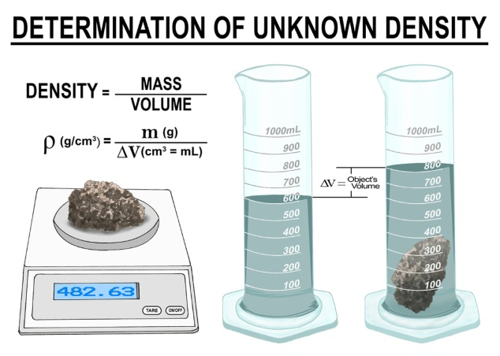  
  
DIAGRAM SHOWING HOW LAB WAS EXECUTED

Data and Results: **(FILL IN THE TABLE WITH YOUR DATA)**  
  
Results obtained to determine the density of a pebble

|  |
| --- |
| **Measurements** |
| **Results** |
| Mass of pebble (g) |  |
| Final volume of water (cm3) |  |
| Initial volume of water (cm3) |  |
| Volume of pebble (cm3) |  |
| Density of pebble (g/cm3) |  |
| Relative density of pebble |  |

Calculations: **(FILL IN THE NUMBERS)**  
  
  
Volume of pebble (cm3) = Final volume of H2O (cm3) – Initial volume of H2O (cm3)  
  
Density of pebble = mass of pebble (g) ÷ volume of pebble (cm3)  
  
Relative density of pebble = density of pebble (g/cm3) ÷ density of water (g/cm3)

Discussion: (**DISCUSS YOUR FINDINGS HERE**)  
**Paragraph 1:**  
1. What is density  
  
**Paragraph 2:**  
1. How does the density of an object affect the way it behaves in a fluid?  
  
2. Did the pebble float or sink? Explain why.  
  
3. What was the density of the pebble?  
  
4. What is the density of water? Explain why your pebble sank or floated based on your results.

Limitation: **(WHAT COULD HAVE LIMITED THIS EXPERIMENT?)**

Precautions:  
1.  
2.  
  
Reflections: **(DO NOT REWRITE THIS REFLECTION PRODUCE YOUR OWN)**  
I have a greater understanding for why big cruise ships are able to float on sea water. They displace the same amount of water as their weight. Plus the way ships are built enables them to float as air is trapped within their hulls.  
  
Conclusion: