* Name:
* Date:
* SBA:
* Topic: Acceleration of a Pendulum
* Title: Periodicity
* Aim:   
   1. To observe how differing the length of a pendulum affects the square of its period.  
   2. To determine the acceleration of a pendulum, g, due to gravity
* Equations:  
   1. **T2/*l* =**  **slope = Δy ÷ Δx = (y1 – y2) ÷ (x1 – x2)2. g = (4π2) ÷ slope** *Where g = acceleration due to gravity in metres per second (ms-1), = 3.14, l = length in metres (m), T = time/period in seconds (s)*
* Materials/Apparatus: metre rule, mass, clamp stand, timer or stop watch, protractor
* Method:  
  1. Set up the apparatus as demonstrated below.  
  2. Using a measuring cylinder cut at least 80 cm of string.  
  3. Tie the string onto a mass to make a pendulum.  
  4. Affix the pendulum to the clamp stand and shorten it to 70 cm.  
  5. Measure an amplitude of about 40o – 50o .  
  6. Let the pendulum go and record the time it takes to allow it to oscillate 5 times.  
  7. Repeat steps 4 – 6 with a 60 cm, 50 cm, 40 cm, 30 cm, 20 cm and 10 cm string.  
  8. Construct a graph of period squared (s2) against length of pendulum (m).
* Observations: (*Write what you saw here*)
* Diagram:

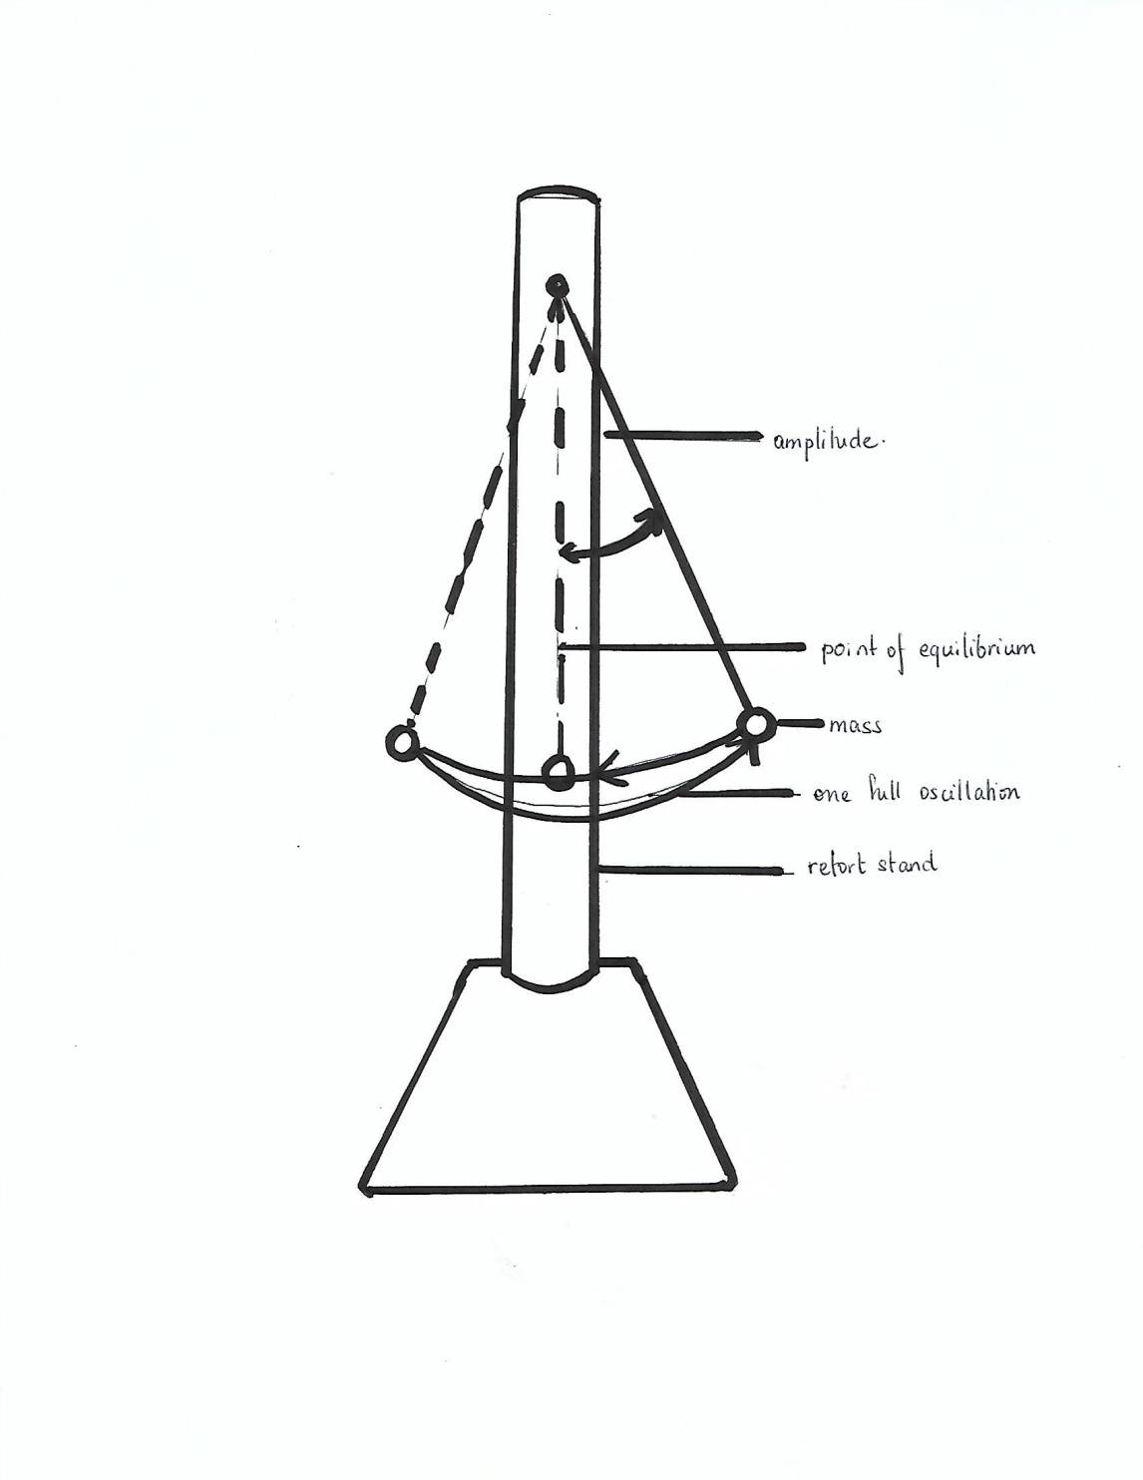

DIAGRAM SHOWING HOW LAB WAS EXECUTED TO DETERMINE THE ACCELERATION OF A PENDULUM

* Data and Results:

TABLE SHOWING THE TIME IT TAKES FOR A PENDULUM TO OSCILLATE AT AN ANGLE OF 40O USING THE SAME MASS A VARYING LENGTHS

|  |  |  |  |  |  |  |
| --- | --- | --- | --- | --- | --- | --- |
| Length of pendulum (m) | Time it takes for 5 oscillations to transpire (s) | | | Average time of 5 oscillations (s) | Period/Time it takes for one oscillation (s) | Time Squared or Period Squared (s2) |
|  | Trial 1 | Trial 2 | Trial 3 |  |  |  |
|  |  |  |  |  |  |  |
|  |  |  |  |  |  |  |
|  |  |  |  |  |  |  |
|  |  |  |  |  |  |  |
|  |  |  |  |  |  |  |
|  |  |  |  |  |  |  |

* Calculations:  
    
  1. Average time for 5 oscillations = A + B + C = D **÷** 3  
    
  2. Period/Time it takes for 1 oscillation to transpire = (D÷ 3) ÷ 5 = E  
    
  3. Square period, T2 = E × E  
    
  4. Slope = (y1 – y2) / (x1 – x2)  
    
  5. Acceleration of the bob = (4π2) ÷ slope

* Discussion:  
  **Paragraph 1**What is a pendulum?  
    
  **Paragraph 2**What affects the period of a pendulum?  
  Discuss the results based on your graph and what you obtained from the experiment.
* Limitation:  
  1.
* Precautions:  
  1.   
  2.
* Reflections:
* Conclusion:

**Measurement and Manipulation – Periodicity**1. Follows instructions /3

(excellent – 3, good – 2, poor – 1)  
  
2. Uses basic laboratory equipment correctly:  
* Avoids parallax when using the metre rule /1  
* Operates the timer on the phone or stop watch  
 properly /1  
* Understands how to use clamp stand /1  
  
3. Prepares material for observation or investigation correctly:  
* Measures string correctly /1  
* Attached string to the clamp stand properly /1  
* Adjusts string between change of length properly /1  
* Measures and maintains the same amplitude  
 throughout the lab /1  
  
Total: /10

**Observation & Recording – Periodicity** a. Student’s ability to record observations and   
to collect and organise data; observations and   
data may be recorded in:  
(i) Prose  
Written description of observations  
in the correct tense /1  
(ii) Table  
Appropriate headings /1  
Title given /1  
(iii) Graph  
* Title for graph /1  
* Title axes labelled for  
 both x and y /2  
* Correct scales /2  
* Accurate plotting:  
All points plotted correctly /5  
Every point incorrectly plotted  
minus one point  
* Fine points used /1  
* Best fit line drawn /1  
  
(b) Reporting  
Student’s ability to prepare a comprehensive  
written report on their assignments using the   
following format:  
(i) Date (*date of experiment*) /1  
(ii) Aim (*what is to be  
accomplished by doing the  
experiment*) /1  
(iii) Apparatus and Materials  
(*all equipment and materials  
used in the experiment must  
be listed*) /1  
(iv) Method/Experimental  
Procedure (*step by step  
procedure written in past   
tense*) /2  
  
Total: /20