* Name:
* Date:
* SBA:
* Topic: Forces in Motion
* Title: Falling Bodies
* Equations: s = (at2) ÷ 2  
    
  where *s* means distance or height in meters, **m**, *a* means acceleration in meters per second, **ms-2** and *t* means period or time in seconds, **s**
* Aim: To determine the standard height of a door by timing how long it takes for a ball to fall from the top of it to the floor
* Materials and Apparatus: stop watch, ball, door, metre stick or measuring tape
* Method:  
  1. Using a stool, drop a ball from the top of the door frame to the floor.   
  2. Record the time it takes for the ball to drop and land.  
  3. Repeat this about 5 – 10 times.  
  4. Record all observations and results in appropriate sections and tables.
* Observations:
* Diagram:

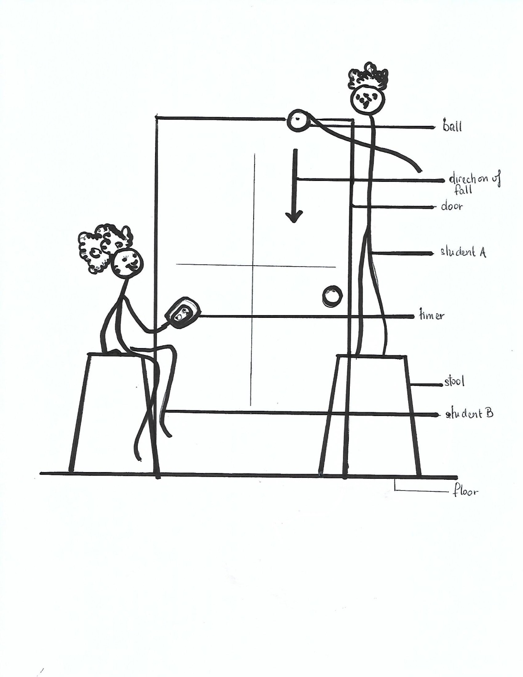

DIAGRAM SHOWING HOW LAB WAS EXECUTED TO DETERMINE THE HEIGHT OF A DOOR BY TIMING A BALL’S FALL FROM THE TOP OF ITS FRAME

* Calculations:  
    
  a. Actual height of door: __________ m  
    
  b. Acceleration of ball: __________ m/s2  
    
  c. Average time ball took to fall (*show full working*): _________________________________________ s  
    
  d. Calculated Height of door, *s*:   
    
  s = (at2) ÷ 2 = __________ m  
    
  e. % Difference = [(a – d) / ((a+d)/2) ] × 100 = _________ %
* Results:

|  |  |
| --- | --- |
| Drops | Time (s) |
| 1 |  |
| 2 |  |
| 3 |  |
| 4 |  |
| 5 |  |
| 6 |  |
| 7 |  |
| 8 |  |
| 9 |  |
| 10 |  |
| Average Time |  |

TABLE 1 SHOWING THE RESULTS OBTAINED FROM THE LAB

* Discussion:  
  Paragraph 1  
  What is gravity?   
  What type of force is it and how does it affect bodies?  
    
  Paragraph 2  
  How can timing a ball determine the height of a door?  
  What was the average time?  
  How close was it to the actual value? Mention the % difference.
* Limitation:
* Precautions:  
  1.  
    
  2.
* Reflections:
* Conclusion:

**Analysis and Interpretation  
Forces in Motion**(a) Makes accurate calculations  
i. Height of door with correct units /2  
ii. Average time with correct units /2  
iii. % difference with correct units /2  
  
(c) Evaluates from data  
 (including sources of error)  
 *See discussion section for*  
 Explanation of results: /8  
* Given (1)  
* Sensible (1)  
* Thorough (2)  
 or  
 Partial (1)  
* Comparisons or Trends   
 mentioned (2)  
* Limitation or Source of Error:  
(i) Given (1)  
(ii) Plausible (1)  
(iii) None given (0)  
  
(f) Draws a conclusion  
 justified by data /1  
  
Total /15