**Name:  
  
Date:   
  
SBA:** #  
  
**Topic:** Weights and Springs  
  
**Title: Hooke’s law**  
**Aim:** To determine the spring constant of a spring  
  
Equation(s):  
  
W = mg  
where: W = weight in newtons, N; m = mass in kilograms, kg and g = gravity in newtons per kilograms, N/kg  
  
F = kx   
where: F = force in newtons, N; k = spring’s constant or stiffness N/m; x = extension of spring in metres, m.  
  
Gradient/Slope = Δ y ÷ Δx = (*y1 – y2*) ÷ (*x1 – x2*)   
  
1N = 100 g 1 N = 0.1 kg   
  
**Apparatus/Materials:** 6 – 10 five, ten, twenty or one hundred gram masses, a spring balance, a retort stand, a metre stick or ruler  
  
**Method:**1. Set up the apparatus as shown.  
2. First, using a ruler, note the original length of the spring in meters and place the reading in the first row titled, ‘Length’.  
3. Hang one of the masses onto the spring balance and note its mass and extension.  
4. Add the rest of your masses on successively noting the extension each time.  
5. Record all observations and results into an appropriate table.  
6. Construct a graph of extension, m against load, N.  
7. Determine the gradient of the graph (gradient = extension/load = Δy/Δ x)  
8. Determine the spring’s constant k by using the equation: k = 1/gradient  
  
 **Observations: (*Describe what you see here*)**

* **Diagram:**

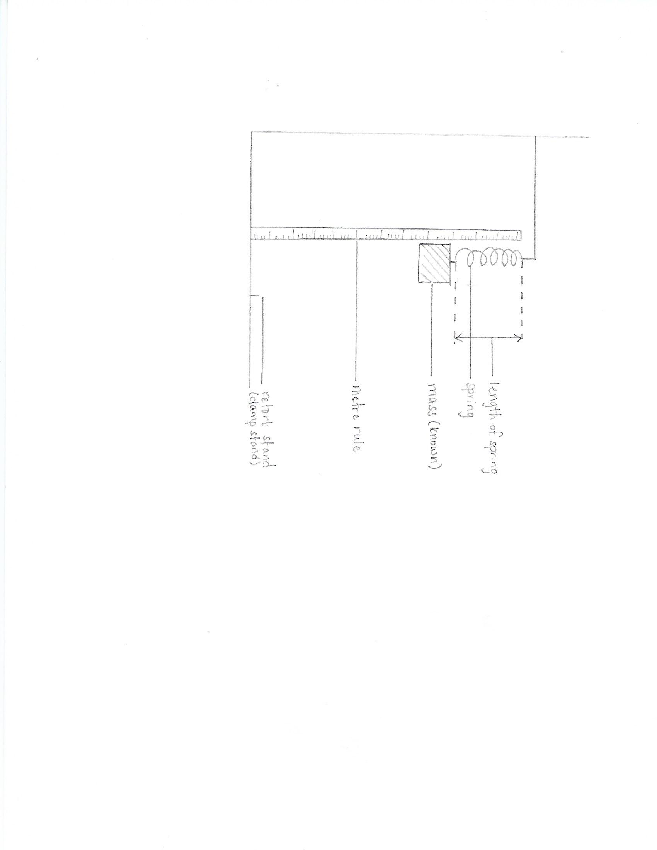  
DIAGRAM SHOWING HOW THE LAB WAS EXECUTED

* **Calculations: (Show ALL working. DO NOT FORGET YOUR UNITS)**1.Gradient/Slope = Δ y ÷ Δx = (*y1 – y2*) ÷ (*x1 – x2*)2. Spring constant = 1 ÷ slope
* **Data and Results:**Table showing the extension of the spring each time 100 g masses were added to it

|  |  |  |  |
| --- | --- | --- | --- |
| **Mass (kg)** | **Load (N)** | **Length (m)** | **Extension (m)** |
| 0.0 | 0 |  | 0 |
| 0.1 |  |  |  |
| 0.2 |  |  |  |
| 0.3 |  |  |  |
| 0.4 |  |  |  |
| 0.5 |  |  |  |

* **Discussion:**1. What is Hooke’s law?  
  2. What is termed as the elastic limit?  
  3. Determine if the spring you used reached its elastic limit.  
  4. What was the calculated spring constant?  
  5. State any possible limitation(s) that may have been experienced during this lab.
* **Precautions:**1.  
    
    
  2.
* **Reflection:***\*How can this lab be applied to daily life?  
  * How has this lab impacted your understanding of springs?*
* **Conclusion:**  *\* Refer to the aim of this lab and state the calculated value of the spring’s constant.*

**Observation & Recording – Hooke’s Law** a. Student’s ability to record observations and   
to collect and organise data; observations and   
data may be recorded in:  
(i) Prose  
Written description of observations  
in the correct tense /1  
(ii) Table  
Appropriate headings /1  
Title given /1  
(iii) Graph  
* Title for graph /1  
* Title axes labelled for  
 both x and y /2  
* Correct scales /2  
* Accurate plotting:  
All points plotted correctly /5  
Every point incorrectly plotted  
minus one point  
* Fine points used /1  
* Best fit line drawn /1  
  
(b) Reporting  
Student’s ability to prepare a comprehensive  
written report on their assignments using the   
following format:  
(i) Date (date of experiment) /1  
(ii) Aim (what is to be  
accomplished by doing the  
experiment /1  
(iii) Apparatus and Materials  
(all equipment and materials  
used in the experiment must  
be listed) /1  
(iv) Method/Experimental  
Procedure (step by step  
procedure written in past   
tense) /2  
 **Total: /20**

**Analysis and Interpretation – Hooke’s Law**Student’s ability to:  
(a) make accurate calculations for:  
* extension of spring /6   
 6 or more points correctly  
 plotted (6)   
 *For every incorrect point plotted  
 deduct one point*  
* Slope of graph Δy ÷ Δx  
 complete with correct units /2  
* Stiffness of spring complete  
 with correct units /2   
  
(c) Evaluates from data  
 (including sources of error)  
 *See discussion section for*  
 Explanation of results: /8  
* Given (1)

* Sensible (1)  
* Thorough (2)   
 or  
 Partial (1)  
* Comparisons or Trends   
 mentioned (2)  
* Limitation or Source of Error:  
(i) Given (1)  
(ii) Plausible (1)  
(iii) None given (0)  
  
(f) Draws a conclusion  
 justified by data   
Given /1  
Plausible /1  
  
**Total: /20**