 Franconia Heritage Banquet
& Conference Center
508 Harleysville Pike, Unit A, Telford, PA 18969
215-721-8900
www.franconiaheritagebcc.com
janet@franconiaheritage.com

LUNCHEON MENU 2026
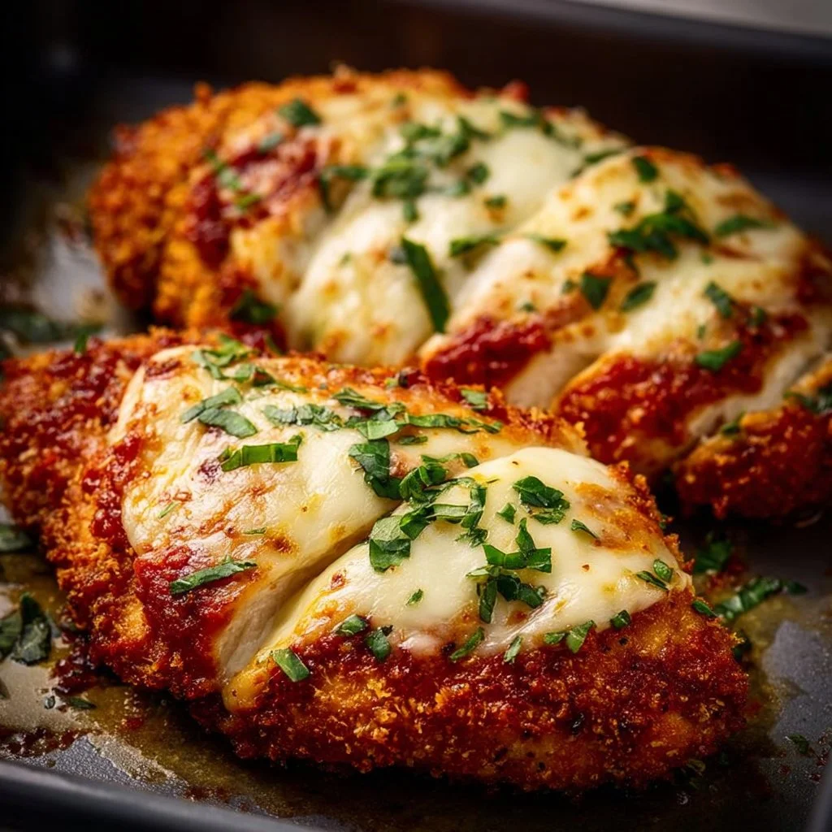
Banquet Luncheon Selections
25 people minimum
No to-go food permitted to be taken from buffets

Plated Luncheon $29.99 per person
Choice of One or Two Entrees (must specify how many of each entrée with final head count)
Choice of Two Vegetables
Choice of One Salad
Dinner Rolls and Butter
Choice of One Dessert
Coffee, Hot Tea, Iced Tea & Ice Water

Cold Buffet Package $32 person
Meat & Cheese Tray (choose 3 meats and 2 cheeses)
Choice of Two Salads
Assorted Sandwich Breads and Rolls
Vegetable Tray with Ranch Dip
Chips, Pickles & Olives
Lettuce, Tomato and Onion Tray
Assorted Desserts on Dessert Table
Fresh Fruit Tray on Dessert Table
Coffee, Hot Tea, Iced Tea & Ice Water on Beverage Table

Hot & Cold Buffet Package $35.50 per person
Choice of One Hot Entrée
Choice of Two Hot Vegetables
Meat & Cheese Tray (choose 2 meats and 2 cheeses)
Choice of One Salad
Assorted Sandwich Breads and Rolls
Vegetable Tray with Ranch Dip
Lettuce, Tomato and Onion Tray
Chips, Pickles & Olives
Assorted Desserts on Dessert Table
Fresh Fruit Tray on Dessert Table
Coffee, Hot Tea, Iced Tea & Ice Water on Beverage Table

Hot Buffet Package $33.50 per person
Choice of Two Entrees
Choice of Three Vegetables
Choice of One Salad
Dinner Rolls and Butter
Assorted Desserts on Dessert Table
Fresh Fruit Tray on Dessert Table
Coffee, Hot Tea, Iced Tea & Ice Water on Beverage Table

Extra entrée +$5 per person
Extra vegetable +$3 per person

Banquet Luncheon Selections

Entrees:

Beef Brisket topped with natural brown sauce (+$1.25 per person)
Hot Sliced Roast Beef in Gravy for Sandwiches (+$1.25 per person)
Honey Baked Ham with house-made pineapple sauce
Grilled Chicken Breast with rotisserie seasoning
Oven Roasted Chicken Breast in house-made gravy
Crispy Southern Chicken Tenders with BBQ Dipping Sauce
Chicken Marsala in a mushroom Marsala wine sauce
Chicken Francaise egg dipped, sauteed and covered in lemon butter with diced tomatoes, onions and parsley
Fried Chicken Parmesan topped with marinara sauce and mozzarella
Chicken Stir Fry with Rice
Roast Turkey in house-made gravy

Cheese Ravioli with roasted tomato and garlic sauce
Stuffed Shells in house made Italian Sauce
Baked Ziti
Broiled Haddock in a lemon butter sauce
Glazed Salmon

Salads:

Caesar-Romaine lettuce, Romano cheese, croutons with our Caesar Dressing
House -Romaine and iceberg lettuce, carrots, red cabbage, tomatoes, and cucumbers
served with your choice of two dressings (French, Thousand Island, Ranch,
Lemon Vinaigrette, Balsamic Vinaigrette, Italian or House (our version of Catalina)
Mixed Greens with Grape Tomato, Feta Cheese and house made Italian Dressing
Spinach Salad with Bacon Crumbles, Egg, Parmesan and Ranch Dressing
Macaroni Salad
Pasta Salad
Cole Slaw
Potato Salad

Franconia Heritage Banquet & Conference Center
508 Harleysville Pike, Unit A, Telford, PA 18969
215-721-8900
www.franconiaheritagebcc.com
janet@franconiaheritage.com

Vegetables:
Homemade Mashed Potatoes with Gravy on the Side
Red Skin Sour Cream Mashed Potatoes
Au Gratin Potatoes
Red Potatoes with Parsley Butter
Creamy Scalloped Potatoes
Bread Stuffing with Gravy on the Side
Macaroni & Cheese
Three Cheese Cavatappi Pasta
Cavatappi Pasta with Spring Vegetables in a garlic olive oil sauce
White Rice in a Garlic Herb Seasoning
Broccoli with Cheese Sauce
Broccoli with Red Peppers sauteed in Butter
Cauliflower in Cheese Sauce
Glazed Carrots
Green Beans with Red Peppers and Onion in a Light Butter Sauce
Green Beans Almondine
Green Bean and Cauliflower Saute with Garlic and Olive Oil
Steamed House Mix – Broccoli, Cauliflower and Carrots
Buttered Corn

Cold Meats: Cheeses:
Baked Ham American
Roast Beef Swiss
Roast Turkey Provolone
Sliced Chicken Breast Cheddar
Chicken Salad
Tuna Salad

Desserts (sit down only):
Homemade Apple Crumb Pie
New York Style Cheesecake (add strawberries in glaze +$1 per person)
Chocolate Torte Cheesecake
Raspberry Cheese Pie
Cherry Cheese Pie
Peach Crisp Pie
Chocolate Mousse Pie
Red Velvet Cake
Carrot Cake
Homemade Brownie with Vanilla Ice Cream
Vanilla Ice Cream with a Sugar Cookie

Franconia Heritage Banquet & Conference Center
508 Harleysville Pike, Unit A, Telford, PA 18969
215-721-8900
www.franconiaheritagebcc.com
janet@franconiaheritage.com

Finger Food Buffet
$30.50 per person
25 people minimum
No to-go food is permitted to be taken from buffets

Assorted Salad Croissants – chicken salad, tuna salad and egg salad

Assorted Sliced Wraps – Dijon Ham & Swiss, Chicken Ranch & Mild Cheddar and Fresh Vegetable with White Cheddar. All with Fresh Spinach and Tomato

Cheese Cube Tray - Cheddar, Swiss, & Provolone

Caesar Salad

Pickles, Olives & Chips

Fresh Fruit Tray

Assorted Cookie & Bar Dessert Tray

Coffee, Hot Tea, Iced Tea, Lemonade and Ice Water on Beverage Table

Franconia Heritage Banquet & Conference Center
508 Harleysville Pike, Unit A, Telford, PA 18969
215-721-8900
www.franconiaheritagebcc.com
janet@franconiaheritage.com

Included in Luncheon Prices:
Room Rental for up to four hours plus one hour for set up/decorating
Linen Tablecloths
Linen Napkins
Podium & Mic as available if requested in advance
Screen and AV Cart as available if requested in advance
Registration Table if requested in advance
Display Tables if requested in advance

Additional Banquet Luncheon Selections

Beverages:
Pitchers of Sweet Tea or Lemonade $8.25 each
Canned Soda $1.75 each
Bottled Water $1.50 each

Luncheon Compliments
Assorted Mini Danish (30 pieces) $31.99 per tray
Assorted Dessert Bars (50 pieces) $49.99 per tray
Assorted Cookies (50 pieces) $49.99 per tray
Fresh Fruit Tray $44.99 per tray
Vegetable Tray with Ranch Dip $40.25 per tray

Equipment Rentals (upon availability)
Flip Chart with Markers $20
White Board with Markers No Charge as available
65” Wireless Monitor $40
Projector Rental with 135” Screen $50
120” Screen No Charge
Wireless Internet No Charge
Dance Floor Rental $250

Franconia Heritage Banquet & Conference Center
508 Harleysville Pike, Unit A, Telford, PA 18969
215-721-8900
www.franconiaheritagebcc.com
janet@franconiaheritage.com

BANQUET INFORMATION

Deposits and Payment Schedule
Deposits are required to hold your scheduled date and time of event.
A contract must be completed to reserve a banquet room. The non-refundable deposit amount is 20% of the estimated total for your menu selection or the amount listed on your contract. If no deposit is received, Franconia Heritage has the option to reserve the room to another party.
Full payment is required prior to the event. Tax-exempt forms must be on file with us before final payment of the event.
We accept Cash, Check, Master Card, Visa, Discover & American Express.
Guest Count and Menu Deadlines
When you book the date with us, you must give us your best estimate as to the number of guests planning to attend. We will then reserve a room for you with appropriate space for your guests.
The guaranteed final count is required one week prior to your event. This is the minimum number of guests that you will be charged for. If more than the guaranteed final count attends, you will be charged for the greater number of guests plus a 25% premium for the extra guests.
Your menu is required no later than 14 days prior to your event date. Any menu received after this time may be charged a 20% premium.
From time to time, some items may not be available from our suppliers. Franconia Heritage reserves the right to make substitutions.
Price Guarantee
We will guarantee that the total price per person will not exceed 5% per calendar year.
Gratuity and Sales Tax
20% gratuity and 6% Pennsylvania Sales Tax will be added to all prices.
Children’s pricing
Children 3 years old and younger are free. Children ages 4-10 are half price.
Bar Glassware
All BYOB events will incur a charge of $1.50 per person.
NO OUTSIDE FOOD IS PERMITTED
Franconia Heritage Banquet & Conference Center
508 Harleysville Pike, Unit A, Telford, PA 18969
215-721-8900
www.franconiaheritagebcc.com
janet@franconiaheritage.com

