 Franconia Heritage Banquet
& Conference Center
508 Harleysville Pike, Unit A, Telford, PA 18969
215-721-8900
www.franconiaheritagebcc.com
janet@franconiaheritage.com

COnference PACKAGES 2026
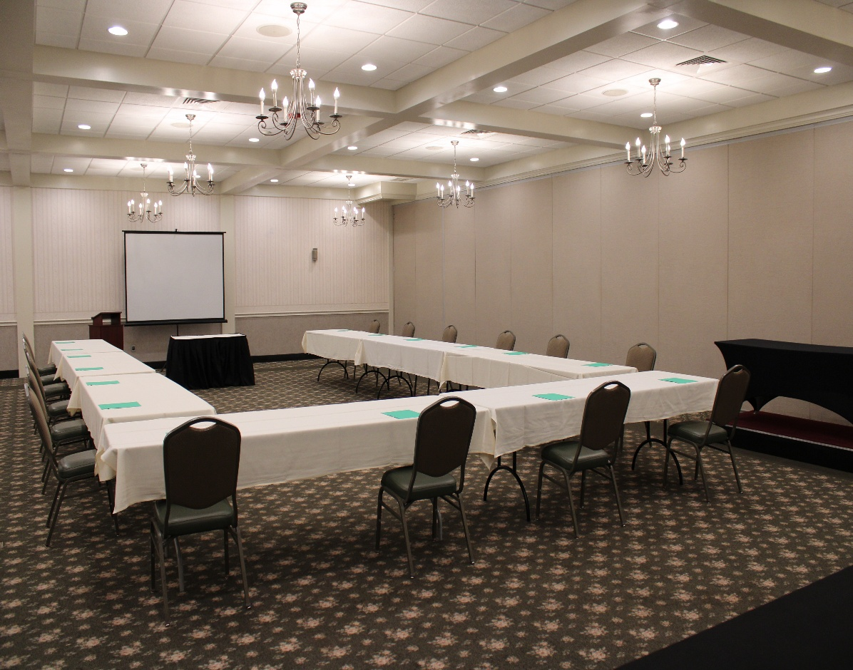

Corporate Menus $50.50 per person
20 people minimum

Room Rental of $250 will be charged if minimum is not met
No to-go food is permitted to be taken from buffets

Continental Breakfast

Fresh Fruit
Assorted Homemade Mini Danish
Assorted Doughnuts
Bagels with Cream Cheese, Butter & Jelly
Orange Juice, Coffee, Hot Tea, Ice Water , Hot Chocolate (winter season)
Oatmeal with Milk, Brown Sugar & Raisins +$2.99

Lunch Buffet Option #1:

Choice of Two Hot Entrees
Choice of Four Sides
Dinner Rolls and Butter
Coffee, Hot Tea, Iced Tea & Ice Water on Beverage Table

Lunch Buffet Option #2:

Cold Tray – Choice of Three Meats and Two Cheeses
Choice of Three Sides
Assorted Sandwich Rolls and Breads
Chips, Pickles & Olives
Appropriate Condiments
Coffee, Hot Tea, Iced Tea & Ice Water on Beverage Table

Afternoon Snack – Choose one:

Assorted Desserts with Fresh Fruit Tray
OR
Fresh Vegetables with Dip and Cheese & Crackers

Franconia Heritage Banquet & Conference Center
508 Harleysville Pike, Unit A, Telford, PA 18969
215-721-8900
www.franconiaheritagebcc.com
janet@franconiaheritage.com

Conference Package Selections
Hot Entrees:
Beef Brisket in Natural au Jus (+$1.25 per person)
Hot Sliced Roast Beef in Gravy for Sandwiches (+$1.25 per person)
Make your own Cheesesteaks with Sandwich Rolls (+$1.25 per person)
Steakburger with Fried Onions
Meatballs in Italian Tomato Sauce with Sandwich Rolls
Pulled BBQ Pork with Sandwich Rolls
Sweet Sausage, Peppers & Onions with Sandwich Rolls
Oven Roasted Chicken Breast in House-Made Gravy
Grilled Chicken Breast in Rotisserie Seasoning
Breaded Chicken Tenders with BBQ Dipping Sauce
Fried Chicken Parmesan
Chicken Marsala
Chicken Stir Fry with Rice
Roast Turkey in House-Made Gravy
Baked Ziti
Cheese Ravioli with roasted tomato and garlic sauce
Stuffed Shells in house made Italian sauce

Sides:
Macaroni & Cheese
Glazed Carrots
Mashed Potatoes with Gravy
Red Potatoes with Parsley Butter
Buttered Broccoli
Red Skin Sour Cream Mashed Potatoes
Three Cheese Cavatappi Pasta
Cavatappi Pasta with Spring Vegetables in a Garlic Olive Oil Sauce
White Rice in a Garlic Herb Seasoning
Buttered Corn
Buttered Green Beans
Broccoli in Cheese Sauce
Steamed Broccoli, Cauliflower & Carrots
Caesar Salad
Spinach Salad—Bacon, Egg & Parmesan with Ranch Dressing
House Tossed Salad with Ranch & Italian Dressings
Mixed Greens, Grape Tomatoes & Feta Cheese in house made Italian Dressing
Macaroni Salad
Cole Slaw
Potato Salad
Pasta Salad
Extra entrée +$5 per person
Extra salad or vegetable +$3 per person

Cold Meats: Cheeses:
Baked Ham American
Roast Beef Swiss
Roast Turkey Provolone
Sliced Chicken Breast Cheddar
Chicken Salad
Tuna Salad

Included in Prices:
Room Rental up to 8 hours
Linen Tablecloths
Linen Napkins
Podium & Mic as available if requested in advance
Screen and AV Cart as available if requested in advance
Registration Table if requested in advance
Display Tables if requested in advance

Additional Corporate Selections

Beverages:
Pitchers of Lemonade or Sweet Tea $8.25each
Canned Soda $1.75 each
Bottled Water $1.50 each

Accompaniments:
Assorted Dessert Bars (50 pieces) $49.99 per tray
Assorted Cookies (50 pieces) $49.99 per tray
Fresh Fruit Tray $44.99 per tray
Vegetable Tray with Ranch Dip $40.25 per tray

Equipment Rentals (upon availability)
Flip Chart with Markers $20 as available
White Board with Markers As available
55” Wireless Monitor $40
Projector Rental with 135” Screen $50
120” Screen No Charge
Wireless Internet No Charge

BANQUET INFORMATION

Deposits and Payment Schedule
Deposits are required to hold your scheduled date and time of event.
A contract must be completed to reserve a banquet room. The non-refundable deposit amount is 20% of the estimated total for your menu selection or the amount listed on your contract. If no deposit is received, Franconia Heritage has the option to reserve the room to another party.
Full payment is required prior to the event. Tax-exempt forms must be on file with us before final payment of the event.
We accept Cash, Check, Master Card, Visa, Discover & American Express.

Guest Count and Menu Deadlines
When you book the date with us, you must give us your best estimate as to the number of guests planning to attend. We will then reserve a room for you with appropriate space for your guests.
The guaranteed final count is required one week prior to your event. This is the minimum number of guests that you will be charged for. If more than the guaranteed final count attends, you will be charged for the greater number of guests plus a 25% premium for the extra guests.
Your menu is required no later than 14 days prior to your event date. Any menu received after this time may be charged a 20% premium.
From time to time, some items may not be available from our suppliers. Franconia Heritage reserves the right to make substitutions.

Price Guarantee
We will guarantee that the total price per person will not exceed 5% for each calendar year
.
Gratuity and Sales Tax
20% gratuity and 6% Pennsylvania Sales Tax will be added to all prices. Minimum Gratuity $200

NO OUTSIDE FOOD IS PERMITTED

Franconia Heritage Banquet & Conference Center
508 Harleysville Pike, Unit A, Telford, PA 18969
215-721-8900
www.franconiaheritagebcc.com
janet@franconiaheritage.com

