Franconia Heritage Banquet
& Conference Center
508 Harleysville Pike, Unit A, Telford, PA 18969
215-721-8900
www.franconiaheritagebcc.com
janet@franconiaheritage.com

BREAKFAST MENU 2026
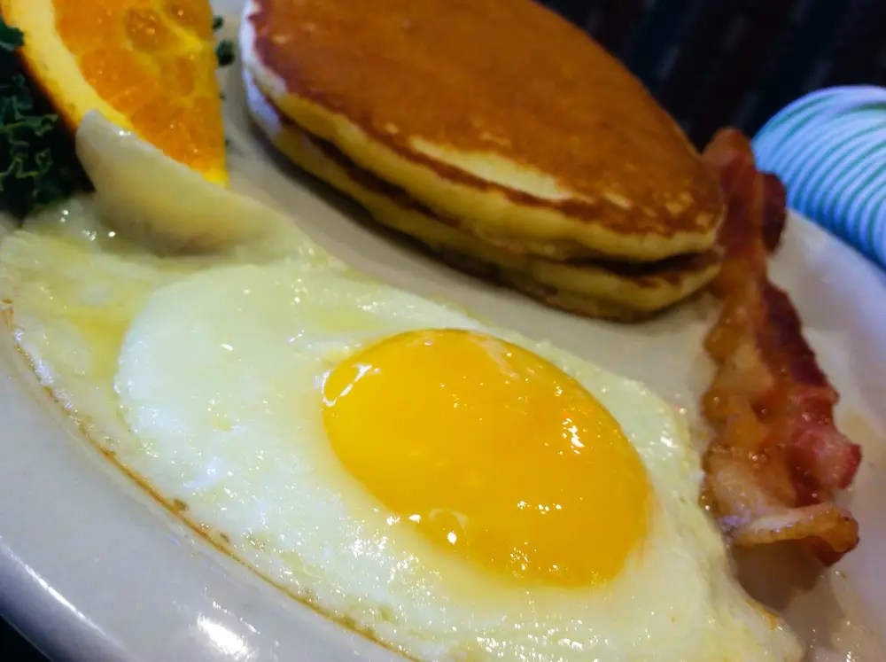
Franconia Heritage Banquet & Conference Center
Breakfast Selections
25 people minimum – please note no to-go food to be taken from buffets

Continental Breakfast $14.99 Per Person
If after 10 am, add $2 per person
If under 50 people, add $250 room rental fee (up to four hours)

Fresh Fruit
Assorted House Made Mini Danish
Assorted Doughnuts
Yogurt with Granola
Orange Juice, Coffee, Hot Tea, Ice Water

To add oatmeal with milk, brown sugar & raisins +$2.99 per person

All-You-Can-Eat Breakfast Buffet $24.75 Per Person
If breakfast is being served after 11 am, add $3 per person
Includes 4 hour room rental

Select Six Items:
Scrambled Eggs
Egg & Cheese Scramble
Over Easy Eggs (50 people or less)
Egg & Cheese Frittata (specify with or without meat)

Sliced Home Fries
Shredded Hash Browns
Tater Tots
Irish Hash Browns with Onions & Parsley
Country Style Potatoes (diced)

Cream Dried Beef with Toast
Sausage Gravy
Bacon
Turkey Bacon
Sausage Patties
Sausage Links
Ham
Scrapple
Pork Roll

Pancakes
French Toast
Oatmeal with Milk, Brown Sugar & Raisins
Yogurt with Granola

Includes:
Assorted Pastries OR Shoofly Pie & Funny Cake
Butter, Jelly, Syrup, Warm Biscuits, Fresh Fruit
Orange Juice, Coffee, Hot Tea, Hot Chocolate (winter season), Ice Water

Included in Breakfast Prices:
Linen Tablecloths
Linen Napkins
Podium & Mic as available if requested in advance
Screen and AV Cart as available if requested in advance
White Board or Easels as available if requested in advance
Registration Table if requested in advance
Display Tables if requested in advance
Four Hour Room Rental plus one hour for set up/decorating

Additional Banquet Breakfast Selections

Beverages:
Pitchers of Iced Tea, Sweet Tea or Lemonade $8.25 each
Carafe of Coffee $12.99 each
Pitcher of Orange Juice $13.25 each
Canned Soda $1.75 each
Bottled Water $1.50 each

Breakfast Compliments
Bagels with Cream Cheese (10 bagels in half) $30.50 per tray
Half Tray $25.25
Assorted Doughnuts $1.50 each piece
Mini Cinnamon Buns (30 pieces) $31.99 per tray
Assorted Mini Danish (30 pieces) $31.99 per tray
Assorted Dessert Bars (50 pieces) $49.99 per tray
Assorted Cookies (50 pieces) $49.99 per tray
Fresh Fruit (5 lbs) $44.99 per tray

Equipment Rentals (upon availability)
Flip Chart with Markers $20 as available
White Board with Markers No Charge
55” Wireless Monitor $40 as available
Projector Rental with 135” Screen $50
120” Screen No Charge
Wireless Internet No Charge

BANQUET INFORMATION

Deposits and Payment Schedule
Deposits are required to hold your scheduled date and time of event.
A contract must be completed to reserve a banquet room. The non-refundable deposit amount is 20% of the estimated total for your menu selection or the amount listed on your contract. If no deposit is received, Franconia Heritage has the option to reserve the room to another party.
Full payment is required prior to the event. Tax-exempt forms must be on file with us before final payment of the event.
We accept Cash, Check, Master Card, Visa, Discover & American Express.
Guest Count and Menu Deadlines
When you book the date with us, you must give us your best estimate as to the number of guests planning to attend. We will then reserve a room for you with appropriate space for your guests.
The guaranteed final count is required one week prior to your event. This is the minimum number of guests that you will be charged for. If more than the guaranteed final count attends, you will be charged for the greater number of guests plus a 25% premium for the extra guests.
Your menu is required no later than 14 days prior to your event date. Any menu received after this time may be charged a 20% premium.
From time to time, some items may not be available from our suppliers. Franconia Heritage reserves the right to make substitutions.
Price Guarantee
We will guarantee that the total price per person will not exceed 5% for each calendar year.
Gratuity and Sales Tax
20% gratuity and 6% Pennsylvania Sales Tax will be added to all prices. Minimum gratuity is $125
Children’s pricing
Children 3 years old or younger are free. Children ages 4-10 are half price.
Bar Glassware
All BYOB events will incur a charge of $1.50 per person.
NO OUTSIDE FOOD IS PERMITTED
Franconia Heritage Banquet & Conference Center
508 Harleysville Pike, Unit A, Telford, PA 18969
215-721-8900
www.franconiaheritagebcc.com

