 Franconia Heritage Banquet
& Conference Center
508 Harleysville Pike, Unit A, Telford, PA 18969
215-721-8900
www.franconiaheritagebcc.com
janet@franconiaheritage.com

FUNERAL menu 2026
D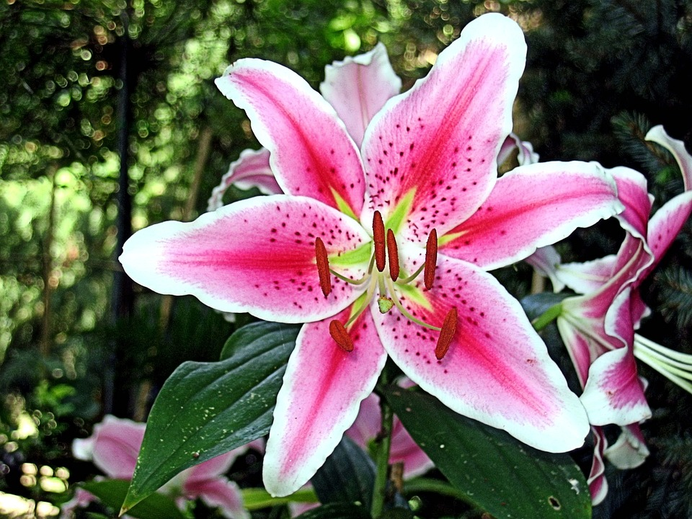

Funeral Selections
25 people minimum
No to-go food permitted to be taken from buffets

Please add $5.99 per person if food is served 4 pm or later

Hot Buffet Package $34.75 Per Person (25-40 guests)
$33.75 Per Person (41-60 guests)
$32.75 Per Person (61-80 guests)
$31.75 Per Person (over 80 guests)

Includes: House Salad or Caesar Salad
Choice of Two Entrees
Choice of Four Vegetables
Dinner Rolls with Butter
Assorted Desserts
Fresh Fruit Tray
Beverage Table of Coffee, Hot Tea,
Unsweetened Iced Tea, and Ice Water

Franconia Heritage Banquet & Conference Center
508 Harleysville Pike, Unit A, Telford, PA 18969
215-721-8900
www.franconiaheritagebcc.com
janet@franconiaheritage.com

Funeral Luncheon Selections
25 people minimum
No to-go food permitted to be taken from buffets

Please add $5.99 per person if food is served 4 pm or later

Cold Buffet Package $32.75 Per Person (25-40 guests)
$31.75 Per Person (41-60 guests)
$30.75 Per Person (61-80 guests)
$29.75 Per Person (over 80 guests)

Includes: Meat & Cheese Tray (choose 3 meats & 2 cheeses)
Choice of Two Salads
Assorted Sandwich Breads and Rolls
Vegetable Tray with Ranch Dip
Chips, Pickles and Olives
Lettuce, Tomato & Onion Tray
Assorted Desserts
Fresh Fruit Tray
Beverage Table of Coffee, Hot Tea,
Unsweetened Iced Tea, and Ice Water

Cold & Hot Buffet Package $37.99 Per Person (25-40 guests)
$36.99 Per Person (41-60 guests)
$35.99 Per Person (61-80 guests)
$34.99 Per Person (over 80 guests)

Includes: Meat & Cheese Tray (choose 2 meats & 2 cheeses)
Choice of One Salad
Choice of One Hot Entrée
Choice of Two Hot Vegetable
Assorted Sandwich Breads and Rolls
Vegetable Tray with Ranch Dip
Chips, Pickles and Olives
Lettuce, Tomato & Onion Tray
Assorted Desserts
Fresh Fruit Tray
Beverage Table of Coffee, Hot Tea,
Unsweetened Iced Tea, and Ice Water

Franconia Heritage Banquet & Conference Center
508 Harleysville Pike, Unit A, Telford, PA 18969
215-721-8900
www.franconiaheritagebcc.com
janet@franconiaheritage.com
Hot Entrees:
Honey Baked Ham with House-Made Pineapple Sauce
Beef Brisket in Natural Au Jus (+$1.25 per person)
Hot Sliced Roast Beef in gravy for Sandwiches (+$1.25 per person)
Meatballs in Italian Tomato Sauce with Sandwich Rolls
Oven Roasted Chicken Breast in House-Made Gravy
Grilled Chicken Breast in Rotisserie Seasoning
Fried Chicken Parmesan
Chicken Marsala
Chicken Stir Fry with Rice
Roast Turkey in House-Made Gravy
Baked Ziti
Cheese Ravioli in our roasted tomato and garlic sauce
Stuffed Shells in our house Italian sauce

Vegetables:
Macaroni & Cheese Red Skin Sour Cream Mashed Potatoes
Bread Stuffing with Gravy Glazed Carrots
Mashed Potatoes with Gravy Buttered Corn
Scalloped Potatoes Buttered Green Beans
Au Gratin Potatoes Steamed Broccoli, Cauliflower & Carrots
Red Potatoes with Parsley Butter Buttered Broccoli
Three Cheese Cavatappi Pasta

Salads:
Caesar Salad
House Tossed Salad with Ranch & Italian Dressings
Macaroni Salad
Cole Slaw
Potato Salad
Pasta Salad

Cold Meats: Cheeses:
Baked Ham American
Roast Beef Swiss
Roast Turkey Provolone
Sliced Chicken Breast Cheddar
Chicken Salad
Tuna Salad

Extra entrée +$5 per person
Extra vegetable +$3 per person

Included in Price:

Room Rental for up to three hours
Linen Tablecloths
Linen Napkins
Silk Centerpieces
Podium & Mic as available if requested in advance
Screen and AV Cart as available if requested in advance
Table for Pictures and/or Flowers if requested in advance

Beverages:
Canned Soda $1.75 each
Bottled Water $1.50 each

Accompaniments:
Fresh Fruit Tray $44.99 per tray
Vegetable Tray with Ranch Dip $40.25 per tray

Equipment Rentals (upon availability)
Flip Chart with Markers $20 as available
White Board with Markers As available
65” Wireless Monitor $40
Projector Rental with 135” Screen $50
120” Screen No Charge
Wireless Internet No Charge

Franconia Heritage Banquet & Conference Center
508 Harleysville Pike, Unit A, Telford, PA 18969
215-721-8900
www.franconiaheritagebcc.com
janet@franconiaheritage.com

BANQUET INFORMATION

Deposits and Payment Schedule

Deposits may be required to hold your scheduled date and time of event.
A contract must be completed and signed for all BYOB events
Full payment is required on the event date. Tax-exempt forms must be on file with us before final payment of the event.
We accept Cash, Check, Master Card, Visa, Discover & American Express.

Guest Count and Menu Deadlines:

When you book the date with us, you must give us your best estimate as to the range of the number of guests planning to attend. (25 to 40 guests, 41 to 60 guests, 61 to 80 or over 80 guests) We will then reserve a room for you with appropriate space for your guests.

The minimum number of guests you will pay for would be the lowest number of the range that you choose when reserving your event. We will prepare for the highest number of the range that you give us. If more guests than anticipated arrive, we will do our best to accommodate them, while the per person cost will remain the same as the range that you originally chose.
From time to time, some items may not be available from our suppliers. Franconia Heritage reserves the right to make substitutions.

Gratuity and Sales Tax
20% gratuity and 6% Pennsylvania Sales Tax will be added to all prices.

Bar Glassware
All BYOB events will incur a charge of $1.50 per person and a Banquet Contract must be signed in advance.
NO OUTSIDE FOOD IS PERMITTED

Franconia Heritage Banquet & Conference Center
508 Harleysville Pike, Unit A, Telford, PA 18969
215-721-8900
www.franconiaheritagebcc.com
janet@franconiaheritage.com

