 Franconia Heritage Banquet
& Conference Center
508 Harleysville Pike, Unit A, Telford, PA 18969
215-721-8900
www.franconiaheritagebcc.com
janet@franconiaheritage.com

APPETIZER MENU 2026
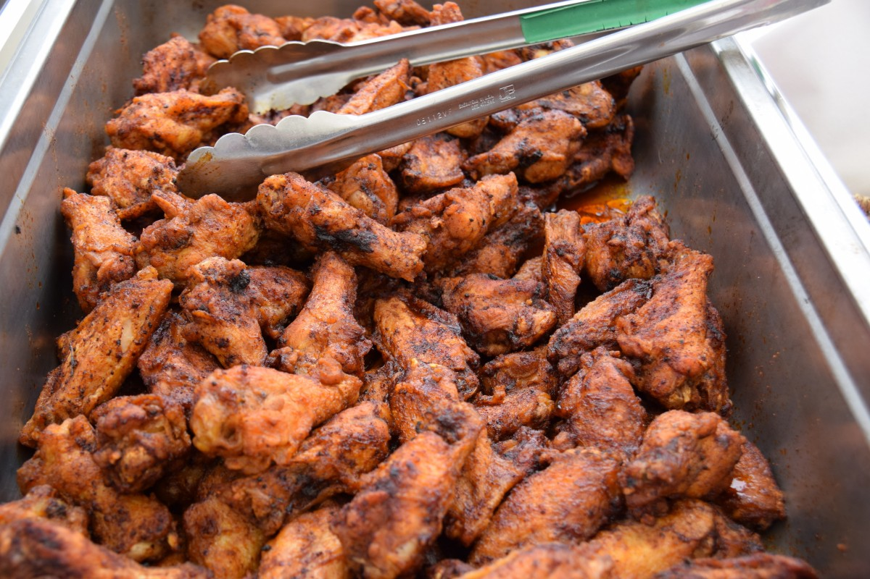

Banquet Appetizer Selections

Appetizer Selections served buffet style

Assorted Fresh Vegetables with Ranch Dip (6 lbs) $40.25

Fresh Fruit Tray (5 lbs) $44.99
Wedges of Cantaloupe, Honeydew, Watermelon, Pineapple & Strawberries

Cheese & Crackers (3 lbs) $44.99
Cubed Cheddar, Provolone Triangles and Swiss Cheese with
assorted Crackers and Mustard

Croissanwiches (24 pieces assorted) $46.99
Chicken salad, Tuna salad, and Egg salad

Assorted Sliced Wraps (30 sliced assorted) $44.50
Dijon Ham & Swiss, Chicken Ranch with Mild Cheddar and Fresh Vegetable with White Cheddar Cheese. All with Fresh Spinach and Tomato

Cocktail Sandwiches (24 pieces assorted) $44.50
Corned Beef & Swiss with Mustard; Turkey, Lettuce & Tomato with Mayo; Ham & Provolone with Seasoned Olive Oil & Lettuce

(continued next page)

Appetizer Selections by the piece (minimum 50 pieces of each selection)

Shrimp Cocktail $1.75 per piece
served with cocktail sauce

Shrimp Scampi $1.25 per piece
sautéed in a garlic butter sauce

Breaded Butterfly Shrimp $1.25 per piece
served with cocktail sauce

Smoked Bacon wrapped Chicken $1.50 per piece

Breaded Chicken Tenders $1.25 per piece
served with Barbecue Sauce

Chicken Wings $1.50 per piece
specify mild, hot honey or bbq

Sweet & Sour Meatballs $.95 per piece

Mozzarella Sticks $1.25 per piece
served with marinara dipping sauce

Franks in a Blanket $.95 per piece
served with mustard dipping sauce

Empanadas (50 pieces minimum each flavor) $1.50 per piece
Choose from Chili Burger, Cheese Steak, Pulled Pork or Chicken with Tomatoes & Peppers

Fresh Mini Spring Rolls (48 pieces minimum each flavor) $1.25 per piece
Choose from Caprese (fresh basil, fresh mozzarella, tomato, olive oil & balsamic vinegar), Veggies with White Cheddar & Ranch, Shrimp Salad or Chicken Salad

Assorted Dessert Bars (50 pieces) $49.99

Assorted Cookies (50 pieces) $49.99

Beverages:
Beverage Table, Coffee,Hot Tea, Iced Tea $5.99 per person
Canned Soda $1.75 each
Bottled Water $1.50 each

Equipment Rentals (upon availability)
Flip Chart with Markers $20 as available
White Board with Markers As available
55” Wireless Monitor $40
Projector Rental with 135” Screen $50
120” Screen No Charge
Wireless Internet No Charge

BANQUET INFORMATION

Deposits and Payment Schedule
Deposits are required to hold your scheduled date and time of event.
A contract must be completed to reserve a banquet room. The non-refundable deposit amount is 20% of the estimated total for your menu selection or the amount listed on your contract. If no deposit is received, Franconia Heritage has the option to reserve the room to another party.
Full payment is required prior to the event. Tax-exempt forms must be on file with us before final payment of the event.
We accept Cash, Check, Master Card, Visa, Discover & American Express.
Guest Count and Menu Deadlines
When you book the date with us, you must give us your best estimate as to the number of guests planning to attend. We will then suggest a room for you with appropriate space for your guests.
The guaranteed final menu with quantities is required at least two weeks prior to the event. Any changes made after this time may be charged a 25% premium.
From time to time, some items may not be available from our suppliers. Franconia Heritage reserves the right to make substitutions.
Price Guarantee
We will guarantee that the food and beverages prices will not exceed 5% for each calendar year
Gratuity and Sales Tax
20% gratuity and 6% Pennsylvania Sales Tax will be added to all prices. For small groups, a minimum gratuity may be imposed.
Bar Glassware
All BYOB events will incur a charge of $1.50 per person
Appetizers are priced to be added to a lunch or dinner package. If no lunch or dinner package is ordered, there will be a room rental charge (four hours plus one hour for set up/decorating) as follows:
North Rooms (up to 90 guests) $600
South Rooms (up to 180 guests) $750
North & South Rooms (up to 350 guests) $1200
Each additional hour over 4 hours add $200

NO OUTSIDE FOOD IS PERMITTED

