 Franconia Heritage Banquet
& Conference Center
508 Harleysville Pike, Unit A, Telford, PA 18969
215-721-8900
www.franconiaheritagebcc.com
janet@franconiaheritage.com

DINNER MENUS 2026

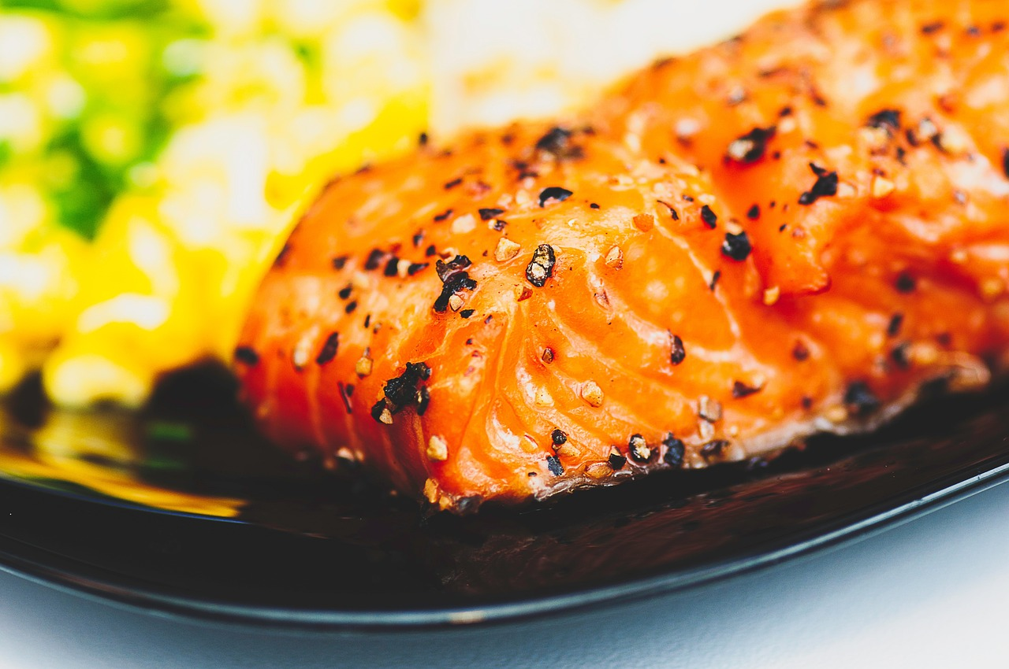

Banquet Dinner Buffets
25 people minimum
No to-go food permitted to be taken from buffets

Twin Buffet $43.75 per person

Choice of Two Entrees
Choice of Three Vegetables
Soup or Salad
Dinner Rolls and Butter
Choice of Two Desserts on Dessert Table
Coffee, Hot Tea, Iced Tea on Beverage Table

Trio Buffet $46.25 per person

Choice of Three Entrees
Choice of Four Vegetables
Soup or Salad
Dinner Rolls and Butter
Choice of Two Desserts on Dessert Table
Coffee, Hot Tea, Iced Tea on Beverage Table

Quartet Buffet $50.50 per person

Choice of Four Entrees
Choice of Four Vegetables
Soup or Salad
Dinner Rolls and Butter
Choice of Two Desserts on Dessert Table
Coffee, Hot Tea, Iced Tea on Beverage Table

Add an extra entrée for $5 per person
Add an extra vegetable for $3 per person

Franconia Heritage Banquet & Conference Center
508 Harleysville Pike, Unit A, Telford, PA 18969
215-721-8900
www.franconiaheritagebcc.com
janet@franconiaheritage.com

Banquet Plated Dinners
25 people minimum

Sit Down Dinner $41.50 per person

Choice of One or Two Entrees (please specify how many of each when giving head count)
Choice of Three Vegetables
Choice of One Salad
Dinner Rolls and Butter
Choice of One Dessert
Coffee, Hot Tea, Iced

Add an extra entrée for $5 per person
Add an extra vegetable for $3 per person

Franconia Heritage Banquet & Conference Center
508 Harleysville Pike, Unit A, Telford, PA 18969
215-721-8900
www.franconiaheritagebcc.com
janet@franconiaheritage.com

Banquet Dinner Selections
Entrees:

Beef Roast in house-made gravy (+$1.25 per person)
Tender Filet with Bearnaise Sauce on the side (+$1.25 per person)
Beef Brisket topped with natural brown sauce (+$1.25 per person)
Honey Baked Ham in house-made pineapple sauce
Pork Rib-Eye with a dry rub of Tuscan seasonings
Pork Tenderloin with a Sweet & Sour Chili Glaze
Grilled Chicken Breast with rotisserie seasoning
Oven Roasted Chicken Breast in house-made gravy
Crispy Southern Chicken Tenders with BBQ Dipping Sauce
Chicken Marsala in a mushroom Marsala wine sauce
Chicken Stir Fry with Rice
Chicken Cordon Bleu (stuffed with ham & Swiss) baked with a crumb topping
Chicken Caprese with tomato, fresh mozzarella, fresh basil in a red wine balsamic sauce
Chicken Francaise egg & flour dipped, sauteed and covered in lemon butter with diced tomatoes, onions and parsley
Stuffed Chicken Breast with bread stuffing in a sage cream sauce
Fried Chicken Parmesan topped with marinara sauce and mozzarella
Roast Turkey in house-made gravy

Cheese Ravioli in a roasted tomato and garlic butter sauce
Stuffed Shells in Marinara Sauce
Baked Ziti

Broiled Haddock in a lemon butter sauce
Broiled Flounder in a lemon butter sauce
Crab Stuffed Flounder in a Mornay sauce
Glazed Salmon

Franconia Heritage Banquet & Conference Center
508 Harleysville Pike, Unit A, Telford, PA 18969
215-721-8900
www.franconiaheritagebcc.com
janet@franconiaheritage.com

Salads:

Caesar-Romaine lettuce, Romano cheese, croutons with our Caesar Dressing
House -Romaine and iceberg lettuce, carrots, red cabbage, tomatoes, and cucumbers
served with your choice of two dressings (French, Thousand Island, Ranch,
Balsamic Vinaigrette, Italian or House – our version of Catalina)
Mixed Greens with Grape Tomatoes, Feta Cheese & House Made Italian Dressing
Spinach Salad-Bacon Crumbles, Egg, Parmesan Cheese with Ranch Dressing

Vegetables:
Au Gratin Potatoes
Homemade Mashed Potatoes with Gravy on the Side
Red Skin Sour Cream Mashed Potatoes
Red Potatoes with Parsley Butter
Creamy Scalloped Potatoes
Three Cheese Cavatappi Pasta
Cavatappi Pasta with Spring Vegetables in a Garlic Olive Oil Sauce
White Rice in a Garlic Herb Seasoning
Broccoli with Cheese Sauce
Broccoli Florets sauteed in Butter
Cauliflower in Cheese Sauce
Glazed Carrots
Green Beans with Red Peppers and Onion in a Light Butter Sauce
Green Beans Almondine
Green Bean and Cauliflower Sauté with Garlic and Olive Oil
Steamed House Mix – Broccoli, Cauliflower and Carrots
Buttered Corn

Franconia Heritage Banquet & Conference Center
508 Harleysville Pike, Unit A, Telford, PA 18969
215-721-8900
www.franconiaheritagebcc.com
janet@franconiaheritage.com

Desserts:
Homemade Apple Crumb Pie
New York Style Cheesecake (add strawberries in glaze +$1 per person)
Chocolate Torte Cheesecake
Raspberry Cheese Pie
Cherry Cheese Pie
Peach Crisp Pie
Chocolate Mousse Pie
Red Velvet Cake
Carrot Cake
Homemade Brownie with Vanilla Ice Cream – Sit Down Only
Vanilla Ice Cream with a Sugar Cookie and Whipped Cream – Sit Down Only

Additional Banquet Dinner Options

Beverages:
Pitchers Lemonade or Sweet Tea $8.25 each
Carafes of Coffee on guest tables $12.99 each
Canned Soda $1.75 each
Bottled Water $1.50 each
Assorted Cookies – 50 pieces $49.99 per tray
Assorted Dessert Bars – 50 pieces $49.99 per tray

Included in Dinner Prices:
Room Rental for up to four hours plus one hour to set up/decorate
Linen Tablecloths
Linen Napkins
Podium & Mic as available if requested in advance
Screen and AV Cart as available if requested in advance
Registration Table if requested in advance
Display Tables if requested in advance

Equipment Rentals (upon availability)
Flip Chart with Markers $20 as available
White Board with Markers No Charge as available
55” Wireless Monitor $40 as available
Projector Rental with 135” Screen $50 as available
120” Screen No Charge as available
Wireless Internet No Charge
Dance Floor Rental $250 as available

Appetizer Selections served buffet style

Assorted Cheese & Fruit Display with crackers $3.99 per person
Assorted Fresh Vegetables with Ranch Dip (6lbs) $40.25
Cheese & Crackers (3 lbs) with Mustard Dip $44.99
Fresh Fruit Tray 5 lbs $44.99

Appetizer Selections by the piece (minimum 50 pieces of each selection)

Shrimp Cocktail $1.75 per piece
served with cocktail sauce

Shrimp Scampi $1.25 per piece
sautéed in a garlic butter sauce

Breaded Butterfly Shrimp $1.25 per piece
served with cocktail sauce

Smoked Bacon wrapped Chicken $1.50 per piece

Breaded Chicken Tenders $1.25 per piece
served with Barbecue Sauce

Chicken Wings $1.50 per piece
specify mild, hot honey or bbq

Sweet & Sour Meatballs $.95 per piece

Mozzarella Sticks $1.25 per piece
served with marinara dipping sauce

Franks in a Blanket $.95 per piece
served with mustard dipping sauce

Empanadas (50 pieces minimum each flavor) $1.50 per piece
Choose from Chili Burger, Cheese Steak, Pulled Pork or Chicken with Tomatoes & Peppers

Fresh Cold Mini Spring Rolls (48 pieces minimum each flavor) $1.25 per piece
Choose from Caprese (fresh basil, fresh mozzarella, tomato, olive oil & balsamic vinegar), Veggies with White Cheddar & Ranch, Shrimp Salad or Chicken Salad

BANQUET INFORMATION

Deposits and Payment Schedule
Deposits are required to hold your scheduled date and time of event.
A contract must be completed to reserve a banquet room. The non-refundable deposit amount is 20% of the estimated total for your menu selection or the amount listed on your contract. If no deposit is received, Franconia Heritage has the option to reserve the room to another party.
Full payment is required prior to the event. Tax-exempt forms must be on file with us before final payment of the event.
We accept Cash, Check, Master Card, Visa, Discover & American Express.
Guest Count and Menu Deadlines
When you book the date with us, you must give us your best estimate as to the number of guests planning to attend. We will then reserve a room for you with appropriate space for your guests.
The guaranteed final count is required one week prior to your event. This is the minimum number of guests that you will be charged for. If more than the guaranteed final count attends, you will be charged for the greater number of guests plus a 25% premium for the extra guests.
Your menu is required no later than 14 days prior to your event date. Any menu received after this time may be charged a 20% premium.
From time to time, some items may not be available from our suppliers. Franconia Heritage reserves the right to make substitutions.
Price Guarantee
We will guarantee that the total price per person will not exceed 5% per calendar year
Gratuity and Sales Tax
20% gratuity and 6% Pennsylvania Sales Tax will be added to all prices.
Children’s pricing
Children 3 years old and younger are free. Children ages 4-10 are half price.
Bar Glassware
All BYOB events will incur a charge of $1.50 per person.
NO OUTSIDE FOOD IS PERMITTED
Franconia Heritage Banquet & Conference Center
508 Harleysville Pike, Unit A, Telford, PA 18969
215-721-8900
www.franconiaheritagebcc.com
janet@franconiaheritage.com

