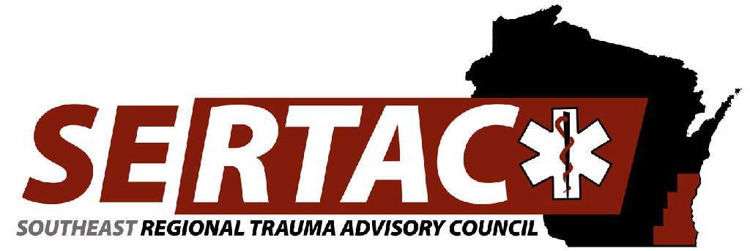
General Meeting
September 18, 2018 1:30 PM to 3:30 PM
CMH

- New Members: (1:30PM-1:35PM)
  - Welcome, Introductions and approval of Minutes
  - Completed – attendance taken and introductions done

- Subcommittee Breakout Session and Report out (1:35PM-2:20PM)
  - PI Committee – Fall activation processes, and surveys coming up
  - Medical Oversight Committee – Ketamine in Kids and pre-hospital protocols with SERTAC taking a stance and endorsing the preferred methods, Other project is spine immobilization – what is our stance and readdress what population needs education
  - Education Committee – SERTAC conference discussion, ideas for 2018-19 courses – simulation, MCI, TCC, TEEX,
  - Injury Prevention Committee – look at 2 pathways for intervention – National speaker for next SERTAC conference and looking at water safety (life jacket station, signage)

- Subcommittee Reports (see notes above) (23:20PM-2:30PM)
  - PI Committee
  - Medical Oversight Committee
  - Education Committee
  - Injury Prevention Committee

- Executive Council Updates (2:30PM-2:40PM)
  - General Updates/Fiscal – still in the black;
  - ATS Trauma Program Manager Course – just got a bill however the class was last year

- RTAC Coordinator Update (2:45PM-3:00PM)
  - State Update – Tom just returning and getting feet wet. Meeting was cancelled for the state in September
  - SERTAC Conference – 63 signed up, we really need a push for it, please send it out to everyone, request Caitlin send it out, 29 still in process but not counting as have not paid
- New Business
  - Please add to the website subcommittee files to post minutes, agendas,
  - Email Tom Thrash and Karen Keys documents
  - Can we have a working documents secure folder for each subcommittee
  - Website new address: www.sertacwi.com
  - Could we incorporate something for Trauma Medical Directors in future conference
    - Suzanne Martens willing to teach the course
    - Need re-education/education for all

**Trauma coordinators meeting following the General meeting **

Next Meeting:
November 20, 2018 13:30PM-16:30PM
Community Conference Room 1
8700 W. Watertown Plank Rd.
Wauwatosa, WI 53226

