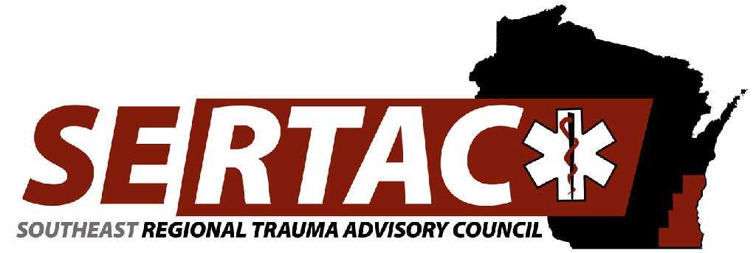
General Meeting
September 18, 2018 1:30 PM to 3:30 PM
CMH

- New Members: (1:30PM-1:35PM)
  - Welcome, Introductions and approval of Minutes

- Subcommittee Breakout Session (1:35PM-2:20PM)
  - PI Committee
  - Medical Oversight Committee
  - Education Committee
  - Injury Prevention Committee

- Subcommittee Reports (23:20PM-2:30PM)
  - PI Committee
  - Medical Oversight Committee
  - Education Committee
  - Injury Prevention Committee

- Executive Council Updates (2:30PM-2:40PM)
  - General Updates/Fiscal
  - ATS Trauma Program Manager Course

- RTAC Coordinator Update (2:45PM-3:00PM)
  - State Update
  - SERTAC Conference
- New Business

**Trauma coordinators meeting following the General meeting **

Next Meeting:
November 20, 2018 13:30PM-16:30PM
Community Conference Room 1
8700 W. Watertown Plank Rd.
Wauwatosa, WI 53226

