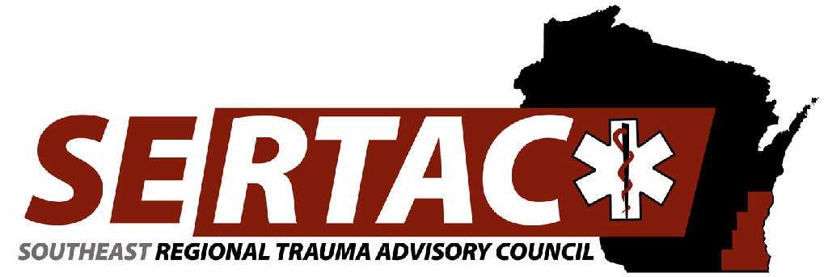
General Meeting
May 21st, 2019 1:30 PM to 3:30 PM
WAC
8700 W Watertown Plank Rd
Wauwatosa, WI 53226

- New Members:
  - Welcome, Introductions and approval of Minutes
    - Ann Marson
    - Tom Hass
BE SURE TO SIGN IN (1:30PM-1:45PM)

- Subcommittee Breakout Session (1:45PM-2:30PM)
  - PI Committee
  - Medical Oversight Committee
  - Education Committee
  - Injury Prevention Committee

- Subcommittee Reports (2:30PM-2:45PM)
  - PI Committee
    - Trauma coordinator tool kit, looking at components and teams to put it together
    - Site review process and reviewed the questions; what facilities have and the needs
  - Medical Oversight Committee
    - Solidify action plan for the region
    - Creating a survey to our EMS Medical Directors and TMD as well as EMS teams
        - What do you need
        - How do we get you to participate more
        - Expectations of MOS
        - Free text for open conversation
    - What are the needs of the region, how can we support you better, guidelines that are best practice and evidence based
    - Share guidelines and place a SERTAC version on our site for reference
    - Goal is to have contact information and survey completed by next meeting
    - Anyone who would like to add questions to survey reach out to Chris Dodgion, MD at cdodgion@mcw.edu
  - Education Committee
    - Optimal Course Update – July 12 – 34 people signed up from variety of specialties, if others in hospital want to attend we will sponsor more people and more than 2 from each facility – please contact Kristin Braun by June 1 (kbraun@chw.edu)
    - What educational offerings for the future – burns
    - New changes from STB – what are the changes in teaching the course (cleaned up the course and a lot less slides, less bloody slides)
  - Injury Prevention Committee
    - Falls App – ready to roll out very soon – Dave Taylor has approved SERTAC to use and purchase on our own – Hartford FD and West Bend FD will move forward with the app and then will disseminate to region after trial. – App can go on phone, tablet, Toughbook
    - Finalized fall prevention bags – keychain flashlight, fall prevention education, will provide to those that are providing education

- Executive Council Updates (2:45PM-3:00PM)
  - General Updates/Fiscal
    - Optimal Course covered
    - Financials – granted an additional $2,000 for use by state. Currently have $29,663. Using money for Optimal course 50% of remaining budget, purchase additional STB kit replacement supplies and an additional training kit, purchased the falls app, Grant to Aurora for STB kits for MPS – balance at next meeting will discuss how to spend remaining funds
    - If you have a STB training kit – you must submit a roster or the kit will be reallocated as numbers are needed

- RTAC Coordinator Update (3:00PM-3:15 PM)
  - State Update
    - STAC meeting June 19th @ Alliance Center
    - Changing the way regional funding is provided
    - ImageTrend now has the hospital feedback loop where you can provide feedback to EMS – they don’t know unless you tell them you are using it
    - Website is being updated but could take up to 6 months to be corrected
    - NERTAC – looking for a new RTAC coordinator
  - SERTAC Conference
    - At the Ingleside: 10/17 & 10/18
    - Adding Invisible Trauma to the pre-con – will cover cost of the room and a snack
    - Flyer will be coming out in next several weeks
    - Registration link is up and able to be signed up for: www.regonline.com/sertaccuttingedgeintrauma2019
- New Business (3:15PM – 3:30 PM)
  - ELECTIONS:
    - Secretary

    - EMS Urban Rep
        - Rick Boeshaar
    - PI Chair
        - Tom Hass
    - Injury Prevention Chair
        - Shana Lebanowski
    - Treasurer
        - Karen Keys (voted and approved)
    - Education Chair
        - Kristin Braun (voted and approved)
    - Trauma Coordinators/Registry Chair
        - Lisa Heinz (voted and approved)
  - Bylaws – elections should be done in June but now we do nominations in May, elections in July and September start in position

**Trauma coordinators meeting following the General meeting **

Next Meeting:
July 16, 2019 13:30PM-15:30PM
Community Conference Room 1
8700 W. Watertown Plank Rd.
Wauwatosa, WI 53226

