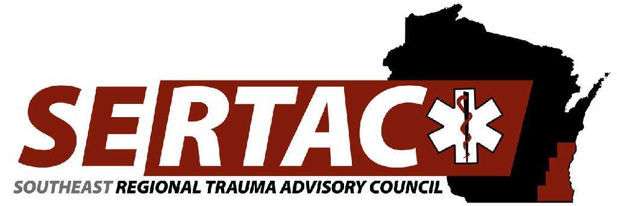
General Meeting
November 19th, 2019 1:30 PM to 3:30 PM
WAC
8700 W Watertown Plank Rd
Wauwatosa, WI 53226

- New Members:
  - Welcome, Introductions and approval of Minutes
BE SURE TO SIGN IN (1:30PM-1:45PM)

- Subcommittee Breakout Session (1:45PM-2:30PM)
  - PI Committee
  - Medical Oversight Committee
  - Education Committee
  - Injury Prevention Committee

- Subcommittee Reports (2:30PM-2:45PM)
  - PI Committee
    - Continued work on the TC Tool Kit, looking for input from committee members
  - Medical Oversight Committee
    - Completed the survey and relayed the results, not working to use the results to create and action plan
  - Education Committee
    - Reviewed the conference, discussed working with another RTAC to hold AAAM class
  - Injury Prevention Committee
    - Falls App
    - Purchased trinkets for kits for pub ed.

- Executive Council Updates (2:45PM-3:00PM)
  - General Updates/Fiscal

- RTAC Coordinator Update (3:00PM-3:15 PM)
  - State Update
    - Upcoming Stac Meeting Dec 4 at Alliant energy center
    - Discussed a change in data to State Registry and why that may be, could be due to hip fractures and a change in uploading to 60 days
    - RTAC Coordinators discussed a statewide trauma activation criteria, will discuss at STAC
    - Discussed the DHS 118 changes
  - SERTAC Conference
    - Was reviewed by ED Committee
- New Business (3:15PM – 3:30 PM)
  - Walk In Items
    - NONE

**Trauma coordinators meeting following the General meeting **

Next Meeting:
January 21st, 2020 13:30PM-15:30PM
Community Conference Room 1
8700 W. Watertown Plank Rd.
Wauwatosa, WI 53226

