**February 16th, 2021 (1:30-2:45 PM) - Zoom: Virtual Meeting Only**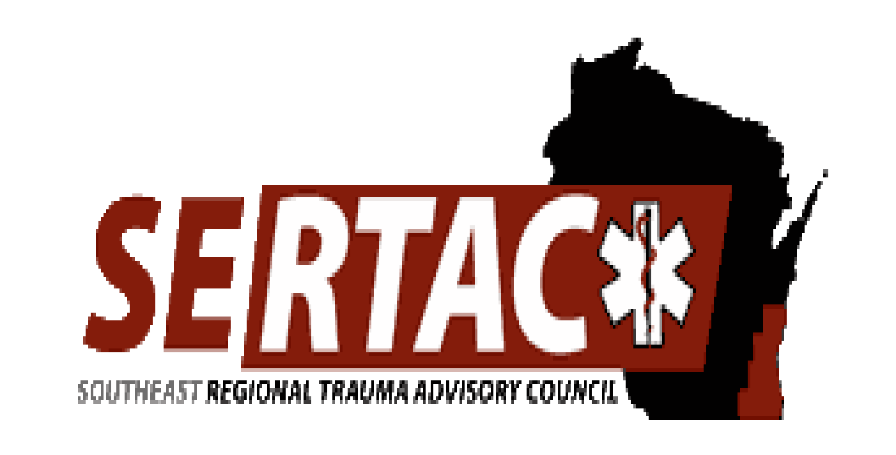

**SERTAC GENERAL MEETING**

**MEETING MINUTES**

**SERTAC CHAIR:** Lisa Hass-Peters  **SERTAC COORDINATOR:** Tom Thrash

**Welcome and Introductions by Lisa Hass-Peters**

Erica Kain Project Leader for EMSC - Mission, improve pediatric care prehospital and hospital settings.

* Federally funded and markers for performance indicators for care of children. Nation Resources available for process improvement of pediatric emergency care.
* Presentation Provided to the general membership on overview of EMSC, and pediatric readiness. According to studies: the higher your readiness score on the review, the lower your inpatient pediatric mortality rate.
* Also meets the ACS Peds criteria. 6 categories, 43 questions, total score possible is 100. 2013-2014 survey scores of the State average score 67/100 ; SE average 64/100.
* [ekane@chw.org](mailto:ekane@chw.org) is available for all questions and able to help review your hospital’s past score.

**Subcommittee Breakout Sessions:**

The subcommittees divided into breakout groups for 30 minutes:

**Subcommittee Reports:**

**PI Committee:** (Tom Hass)

* PI indicators education completed by Education committee. Working on the ED PI indicators next.
* Tom’s Hass has accepted a new position, and will be leaving his PI Chair position. Now taking applications and recommendations for new chair.

**Medical Oversight Committee:** (Jessica Lancaster)

Ketamine:

Jessica Lancaster create a flow sheet for ketamine dosing. Shared with the group for review. Discussion around changing doses, easiest way to communicate it without making a large amount of paperwork between analgesia versus procedural sedation versus induction versus agitation.

Spinal Motion Restriction:

-Finalized the SMR decision tree to hand out to SERTAC EMS agencies

- Powerpoint reviewed by the committee.

Pending: Imaging guidelines for outside hospitals prior to trauma transfers.

Also taking other recommendations from group at this time.

**Education Committee:** (Kristin Braun)

* AAAM course will be in 2021 - PreConference.
* TCAR will be hosting soon, more communication to come.
* Conference planning underway, on schedule for October 2021, sub committee meetings taking place.

**Injury Prevention:**

* New team lead needed for this group

**EXECUTIVE COUNCIL UPDATE:**

* Karen provided a treasury update. Budget will be created once the budget amount is received and finalized.
* Please send Lisa Hass Peters/ Lisa Heinz concerns ATLS for summary before March 3rd’s Stac meeting.

**RTAC COORDINATOR UPDATE:**

* No updates at this time, no RTAC Coordinator meeting has taken place since last EC meeting.
* Caitlin Washburn has left position, standing in is Jessica Link Reeve.
* March 3rd is next STAC meeting, invites have started to go out, Mandy Walsh sent out.
* Stac was only doing virtual, starting to do in person for level 1 and 2. Other reviews are starting to take place in person. Hopefully, starting to slowly move towards in person visits.
* Section Chief position open and interviewing.
* UV lights and mask fit testing started for EMS.
* Dr Collella shared the new scope of practice and protocols
* Life Jacket motor board, and demoing patient tracking software.
* North is working on online conference (April) and introducing patient tracking.
* Also working on falls app in various locations.

State Updates:

* Recruiting for CRC members
* Interview for epidemiologist, state trauma coordinator,
* Covid funding, UV lights
* DHS110 (EMS Scope and protocols)
* BIOSpacial reports
* Life jacket loaner boards under discussion

The meeting adjourned at 2:35 PM, and the **Trauma Coordinators Meeting** followed.

**Next meeting is Tuesday April 20th, 2021 at 1:30-3:30pm**