**April 20, 2021 (1:30-2:45 PM) - Zoom: Virtual Meeting Only**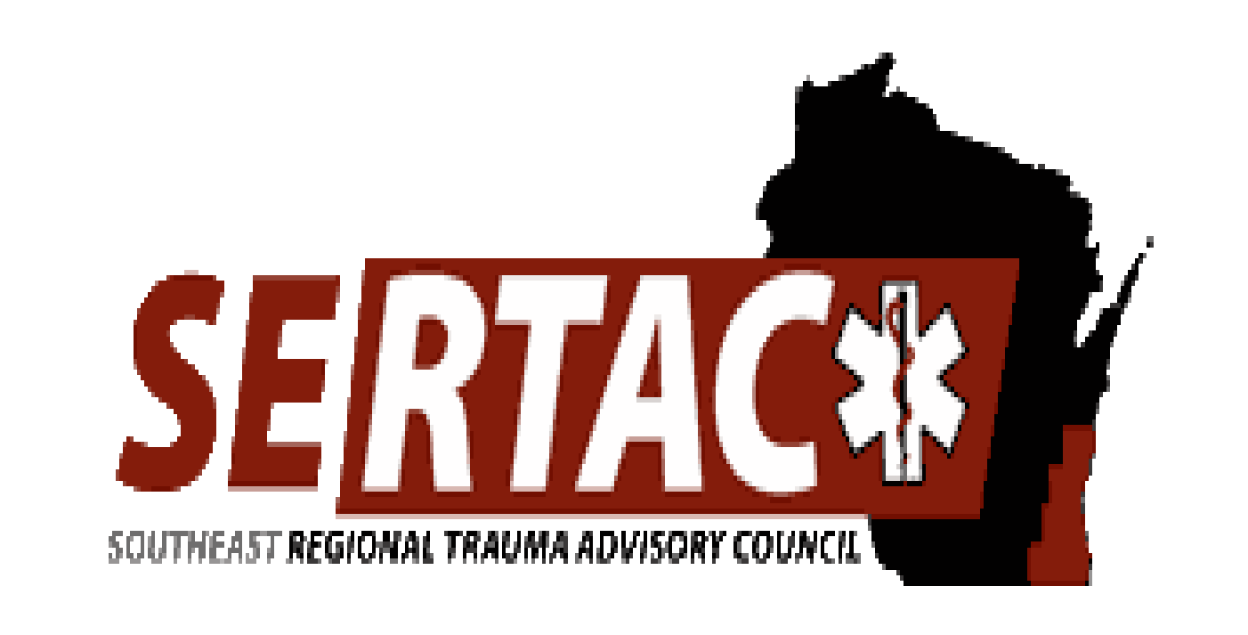

**SERTAC GENERAL MEETING**

**MEETING MINUTES**

**SERTAC CHAIR: Lisa Hass Peters SERTAC COORDINATOR:** Tom Thrash

**Welcome and Introductions by Lisa Heinz**

* Intro of Guest Speaker Jay Deppe
* Jay did a talk about when the rescuer becomes the patient and how that feels and how it affected him

**Subcommittee Breakout Sessions:**

The subcommittees divided into breakout groups for 45 minutes:

**Subcommittee Reports:**

**PI Committee:** (Tom Hass)

Discussed Geriatric Palliative Care Consulting

Discussed any Hospitals that have upcoming Surveys

Discussed DHS 118 and the changes and that Cinda Warner is doing a training the end of April which will be on Zoom for SERTAC then uploaded to the SERTAC website

Also mentioned pediatric guidelines that will hopefully be approved by STAC and available soon

**Medical Oversight Committee:** (Dr Kunkel

-Completed a Spinal Motion Restriction Presentation

-trauma imaging- reaching out to hospital radiology dept, IT, ED/trauma depts to help figure out current imaging guidelines for trauma, what we can get at referring hospitals, improve imaging transmission between hospitals and health systems to decrease repeat imaging

-Working on a Ketamine dosing chart and a position statement on ketamine use

Watching the use of Toradol by EMS

**Education Committee:** (Kristin Braun)

* AAAM course will be in 2021 – Sept 20 & 21
* In regards to Med Oversight and imaging, Children’s, Children’s Marshfield and UW have worked together to create a framework for Ped Imaging Guidelines, which is part of new DHS 118 and will report back to the State TQIP group
* Discussed the AAAM course which will be offered by SERTAC on Sept 20 21
* Discussed the ATS Registry course which will be June 24 25 and covered by SERTAC

**Injury Prevention:**

* New team lead needed for this group

**Conference Committee**

- Filling in presenters

Save the date coming soon

**EXECUTIVE COUNCIL UPDATE:**

* Approved the ATS Registry Course
* South Central RTAC has 2 openings for that course on May 13 14 – contact Tom if interested
* We were notified by ANIK that they are dropping all RTACs as fiscal Agent, We started talking with HERC 7 to have them cover our financial agent needs
* New State positions announced
  + Trauma Coordinator Margaret Finco
  + Data Coordinator Katy Prather
* MCW is hosting an Advanced Haz Mat Life Support Class in May, contact Tom if interested, depending on finances SERTAC may be able to help with cost to attend.

Grants

Partial grant to Flight for Life for PPE, Partial Grant to Town of Sheboygan Falls FD for Trauma Supplies/Gear, Full grant to MCW/Froedtert for additional Stop the Bleed Kits

**RTAC COORDINATOR UPDATE:**

Nothing to report

The meeting adjourned at 2:45 PM, and the **Trauma Coordinators Meeting** followed.

**Next meeting is Tuesday June 15, 2021 at 1:30-3:30pm**