**June 15th, 2021 (1:30-2:45 PM) - Zoom: Virtual Meeting Only**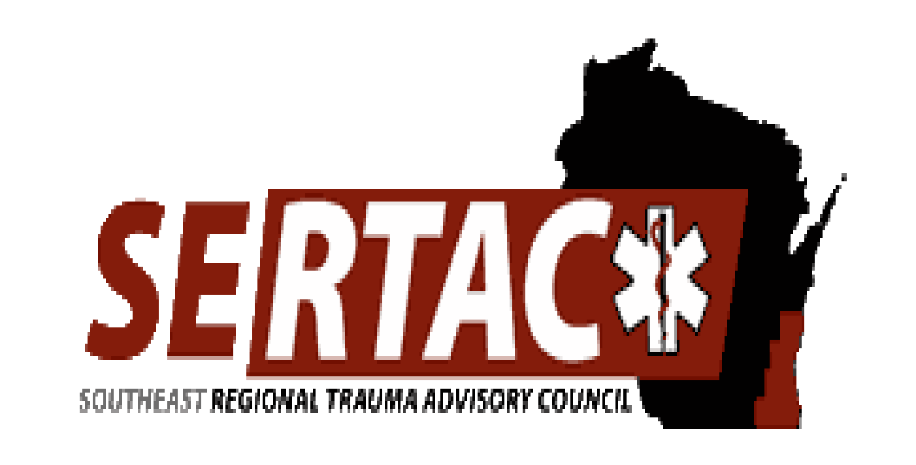

**SERTAC GENERAL MEETING**

**MEETING MINUTES**

**SERTAC CHAIR : Kelli Anderson**  **SERTAC COORDINATOR:** Tom Thrash

**Welcome and Introductions by Kelli Anderson**

* Kelli did a presentation on the upcoming elections for the Executive Council

**Subcommittee Breakout Sessions:**

The subcommittees divided into breakout groups for 30 minutes:

**Subcommittee Reports:**

**PI Committee:** (Tom Hass)

* Talked about the chair position be up for election – no takers
* Talked about the importance of staying up to date with PRQ’s and for everyone to watch Cinda Warner’s presentation on DHS 118 which is on the SERTAC website
* ED Guidelines is now on the website for everyone to review
* New Project is going to look at ED length of stay with delayed transfer to a higher level of care
* Also talked about the new DHS 118 and what is needed for additional documents in regards to pediatric burns

**Medical Oversight Committee:** (Dr Martens)

Ketamine:

Dosing chart needs to be finalized.

Spinal Motion Restriction:

-Dr Kunkel made a presentation – Tom needs to cut it to make it fit on the website

Pending: Imaging guidelines for outside hospitals prior to trauma transfers.

Also taking other recommendations from group at this time.

Use of Toradol by EMS – want to keep an eye on the use by EMS

**Education Committee:** (Kristin Braun)

* AAAM course will be in 2021 – Sep 20 &21 at Brookfield Conf Center Cost covered by SERTAC unless you sign up and don’t attend then the individual that signed up will be responsible to pay SERTAC $750
* Trauma Registry course is set for virtual and has 20 people signed up.

**Injury Prevention:**

* New team lead needed for this group

**EXECUTIVE COUNCIL UPDATE:**

* Discussed the elections

**RTAC COORDINATOR UPDATE:**

* No May meeting due to new people in STATE positions
* Margaret Finco is the new State Trauma Coordinator
* Katy Prather is the new Data Coordinator
* DHS 118 goes into effect Oct 1, 2021
* The state website is live with DHS 118 updates and FAQ’s
* EMS C has a new pediatric readiness assessment open until July 1 and there are up to 184 PECC’s in the state now
* Amanda Bates is the new EMS Section Chief
* EMS is working on releasing statewide protocols
* Trauma Registry will have new monthly reports coming soon
* BIospatial can do monthly reports, see Tom for more info if you want these reports

**NOMINATIONS**

Trauma Coordinators

Wendy Golonski by Lisa Heinz 2nd by Tom Hass, no other nominations, unanimous ballet by Lisa Heinz, 2nd by Tom Hass, Passed

Injury Prevention

No nominations

Vice Chair

No Nominations

Treasurer

No Nominations

Performance Improvement

Tom Hass by Karen Keys 2nd by Rick Boeshaar no other nominations, unanimous ballot by Dr Martens 2nd by Rick B, Passed

Urban EMS Rep

Rick Boeshaar by Matt Pinsoneault 2nd by Kristin Braun, no other nominations, unanimous ballot by Tom Hass 2nd by Dr Martens, Passed

Education

Kristin Braun by Rick Boeshaar 2nd by Karen Keys, no other nominations, unanimous ballot by Kelli Anderson 2nd by Rick Boeshaar, Passed

The meeting adjourned at 2:35 PM, and the **Trauma Coordinators Meeting** followed.

**Next meeting is Tuesday August 17, 2021 at 1:30-3:30pm**