**August 17, 2021 (1:30-2:45 PM) - Zoom: Virtual Meeting Only**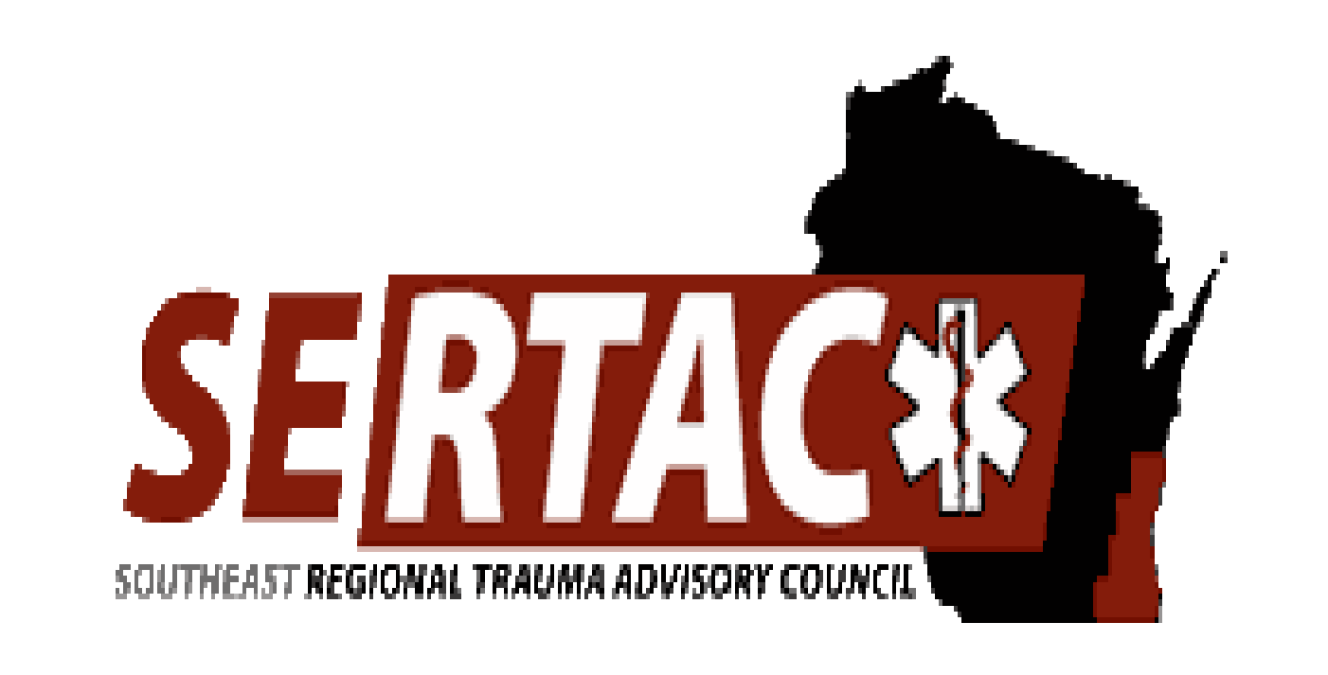

**SERTAC GENERAL MEETING**

**MEETING MINUTES**

**SERTAC CHAIR: Kelli Anderson SERTAC COORDINATOR:** Tom Thrash

**Welcome and Introductions by Kelli Anderson**

* Approval of Minutes
* Coordinator Update
  + Talked about Helicopter usage and incidents, has been referred to STAC
  + State EMSC has a new program manager – Brittany Farrell, she will be running the pediatric readiness. And we (SERTAC) will be updating the regional trauma plan, after STAC approves a new template.

**Subcommittee Breakout Sessions:**

The subcommittees divided into breakout groups for 45 minutes:

**Subcommittee Reports:**

**PI Committee:** (Kelly Faymoville St Agnes)

Discussed greater than 3 hour transfers for last 2 months, whether there was anything we could do about LOS

Discussed difference between Total LOS and to decision to transfer. Total LOS difficulties are bed availability and transportation issues which in most cases cannot be helped.

Agreed importance to watch total length, but may be able to change more if focus on decision to transfer time

Discussed differences between criticality of ed to ed transfers vs. direct admit times.

Also mentioned pediatric guidelines that will hopefully be approved by STAC and available soon

**Medical Oversight Committee:** (Jessica Lancaster)

-completed ketamine dosing tool, position statement, summary card

-trauma imaging- reaching out to hospital radiology dept, IT, ED/trauma depts to help figure out current imaging guidelines for trauma, what we can get at referring hospitals, improve imaging transmission between hospitals and health systems to decrease repeat imaging

**Education Committee:** (Kristin Braun)

* AAAM course will be in 2021 – Sept 20 & 21
* Conference planning underway, on schedule for October 2021, sub committee meetings taking place.
* Trauma Registry course in June- was a success and all great feedback.
* TCAR- look into for 2022 and if there are additional funds left over in 2021 .

**Injury Prevention:**

* New team lead needed for this group

**EXECUTIVE COUNCIL UPDATE:**

* Karen provided a treasury update. Budget is done. Karen is done, Ginger will be new treasurer, Thanks to Karen for all her work over the years

**RTAC COORDINATOR UPDATE:**

Was done at top of meeting

The meeting adjourned at 2:45 PM, and the **Trauma Coordinators Meeting** followed.

**Next meeting is Tuesday October 20th, 2021 at 1:30-3:30pm**