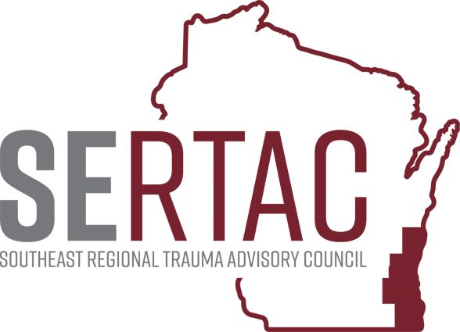April 19th, 2022 (1:30-2:45 PM) - VIA ZOOM

SERTAC GENERAL MEETING
MEETING MINUTES

SERTAC CHAIR: Keli Anderson SERTAC COORDINATOR: Tom Thrash

Welcome and Introductions by Keli Anderson

Guest Speaker – Shaun Piller (Chair of WI Air Ambulance Committee)

Data Reports – Tom Thrash SERTAC Coordinator

Subcommittee Breakout Sessions:
The subcommittees divided into breakout groups for 30 minutes:

Subcommittee Reports:
PI Committee: Reviewed the PRC Ped Trauma Filters and are asked to have questions for Ginger Knapp regarding Image Trend for next meeting

Medical Oversight Committee: Working to better share imaging prior to pt tranfers

Education Committee: Working with Med Oversight to share position statements

Injury Prevention: Close to completing the magnet. Agreed to the Radio Add on Trauma Awareness that Tom will read for Trauma Week in May.

Conference: Will be held on Oct 14th at Brookfield Conf Center. Thanks to those that completed the needs survey for the conference. Looking for vendors or sponsors.

RTAC COORDINATOR UPDATE:
EXECUTIVE COUNCIL UPDATE: Now working with Scholz Law Firm to complete the 501c3 process. Reviewing Grants that are coming in. Updating the By Laws with help of the Law Firm

The meeting adjourned at 2:45 PM, and the Trauma Coordinators Meeting followed.

