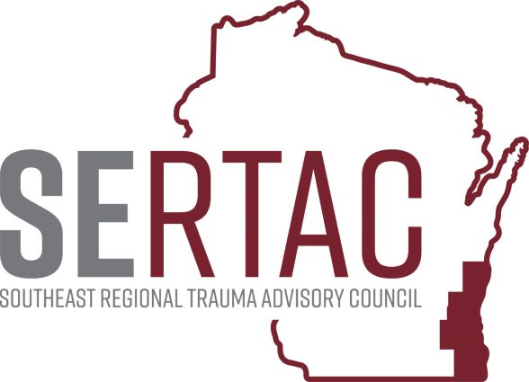
April 18, 2023 (1:30-2:45 PM) - VIA ZOOM

SERTAC GENERAL MEETING
MEETING MINUTES

SERTAC CHAIR: Dr Tom Engel SERTAC COORDINATOR: Tom Thrash

Welcome and Introductions by Tom Thrash

Guest Speaker – Lexi Brand – State DHS Trauma – RN Consultant

Data Reports – Tom Thrash SERTAC Coordinator

Subcommittee Breakout Sessions:
The subcommittees divided into breakout groups for 60 minutes:

Subcommittee Reports:
PI Committee: Reviewed the IP and ED Indicators and updated. Motion made by Alissa from Aurora Sheboygan and 2nd by Amber from Aurora Washington County to approve the ED indicator – no discussion – Motion PASSED UNANIMOUSLY Motion by Alissa from Aurora Sheboygan and 2nd by Wendy from Aurora St Luke’s to approve the In-Patient Indicator document - No discussion – Motion Passed UNANAMOUSLY
They also discussed some recent site reviews.

Medical Oversight Committee: Dr Beckman not present – they reviewed adding anticoagulation to the GLF for Geriatric

Education Committee: Future Education Goals for Region. TPM class is full and will be in May.

Injury Prevention: Kenny Asselin for WBFD was there and will work to get more people to the SERTAC IP, mostly from community risk reduction of area Fire Departments. Also discussed how to evaluate the use of the toolkits.

Conference: Will be Nov 9 at Brookfield, working to finalize the speaker list. Now working to get sponsors.

HERC: Has carryover funding that will purchase MCI Walk Kits for the region as well as cleaning supplies for long term health. Will have several trainings coming in prep for the RNC.

RTAC COORDINATOR UPDATE: Announced Lexi Brand as a contract Nurse Consultant
EXECUTIVE COUNCIL UPDATE:
We have over $31,000 to spend. Will purchase more IP toolkits and fund a booth at the ENA conference in May

b. EMS for Children Update – see Matts Report
c. EMS
i. Renewals are open.
ii. Amanda Bates has resigned as Chief.
iii. FAP and Flex dollars are in process.
iv. EMS MCI Plan is still in revision, hoping for a draft in June.
d. STAC
i. GIS Map update has been submitted trying to do it quarterly.
ii. Site reviews – some good and some not good
iii. Discussion on changes to hospitals for trauma classification and when to notify Coordinators, decided to notify of all changes.
iv. TCAA course was held, and everyone got a seat
v. TOPIC course is soon and everyone who applied will get a seat.
e. Data
i. Working on 2022 Annual Report
ii. Have had lots of data requests.

The meeting adjourned at 2:45 PM, and the Trauma Coordinators Meeting followed.

