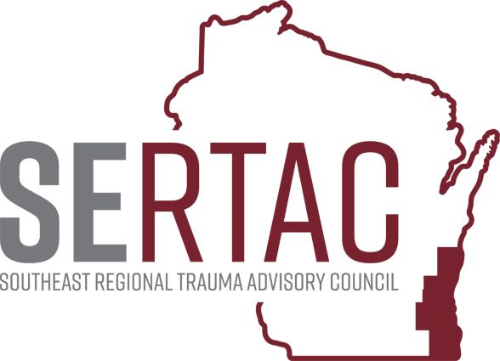Feb15, 2022 (1:30-2:45 PM) - VIA ZOOM

SERTAC GENERAL MEETING
MEETING MINUTES

SERTAC CHAIR: Keli Anderson SERTAC COORDINATOR: Tom Thrash

Welcome and Introductions by Keli Anderson

Guest Speaker – Kristin Braun – Ped Imaging Guidelines

Data Reports – Tom Thrash SERTAC Coordinator

Subcommittee Breakout Sessions:
The subcommittees divided into breakout groups for 30 minutes:

Subcommittee Reports:
PI Committee: Discussion about PI Initiatives, and site surveys and deficiencies that are happening in the region. ED Specific like open fracture antibiotic, GSW for ortho, and tele neurology, and use of O+ blood for mass transfusion. Ginger Knapp talked about the PI Tab in Image Trend, more to come on this topic.

Medical Oversight Committee: Message from Dr Kunkel about Blood Shortages

Education Committee: Future Education Goals for Region, going to send out a survey to SERTAC. All Funds for this year are used up. Looking at an STN TPM Course or Topic Course for next fiscal Year.

Injury Prevention: Need to identify community falls risks, how to make connections between resources. Looking at using Printed Materials to help bridge that gap. Going to create a magnet for falls and home safe info to place on a fridge. Working on pricing and a mock up for the magnet.

Conference: Will be held on Oct 14th at Brookfield Conf Center. Thanks to those that completed the needs survey for the conference. Looking for vendors or sponsors.

RTAC COORDINATOR UPDATE: EMSC – implementation guide for ped readiness. Has a training on human trafficking which is on the EMSC Website. STATE EMS has hired Dan Williams as Rural EMS Coordinator, interviews for Community EMS Coordinator. Hired several other positions within the EMS Office. Still doing Townhall Listening Sessions. FAP money should have been sent out. State EMS Office will re start the numbered memos again. Discussion about diversion again, and how when hospitals go on diversion causes issues with EMS. Discussed the blood shortage issue.
EXECUTIVE COUNCIL UPDATE: Pushing ahead with Scholz Law Firm to complete the 501c3 process. Regional Plan Assessment has been completed with little input from Region 7.

Walk in Items: Keli – reminder to do the Grant Application and send out to whoever may be interested.

The meeting adjourned at 2:15 PM, and the Trauma Coordinators Meeting followed.

