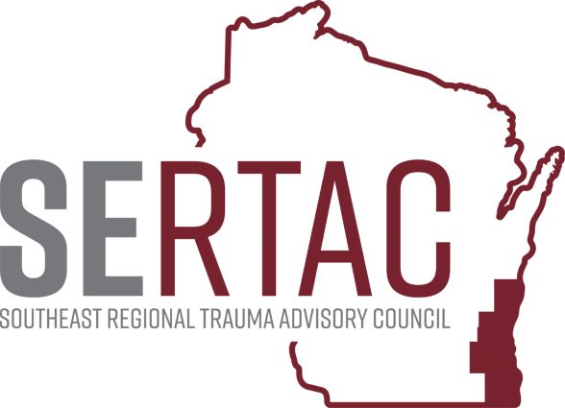June 21st, 2022 (1:30-2:45 PM) - VIA ZOOM

SERTAC GENERAL MEETING
MEETING MINUTES

SERTAC CHAIR: Keli Anderson SERTAC COORDINATOR: Tom Thrash

Welcome and Introductions by Keli Anderson

Guest Speaker – Ginger Knapp – Image Trend Reports

Data Reports – Tom Thrash SERTAC Coordinator

Subcommittee Breakout Sessions:
The subcommittees divided into breakout groups for 30 minutes:

Subcommittee Reports:
PI Committee: Looked at under triage for our region. The state showed a chart that made Reg 7 look bad, we think its bad data in that chart. Reviewed the NIFTI Criteria. Looking at how to validate the over/under triage reports.

Medical Oversight Committee: Reviewed the National Field Triage Guidelines. Dr Kunkel had to leave but we discussed imaging of trauma patients and sharing the images, this is stuck with some IT Departments.

Education Committee: Reviewing the Survey results, looking at hosting a virtual TPM course. Looking at interest in the STN E-Library for SERTAC, Lisa Heinz will get more details. This would be in the next fiscal year.

Injury Prevention: Magnets are printed and finalized, we have 3000 and looking to share with TC’s and EMS in the region. Can be picked up at the conference in Oct as well. Talked about making tool kits for fall prevention, folders with lots of information. Goals for next year is to build up the website and the tool kits.

Conference: Registration will open July1st. Oct 14 at Brookfield Conf Center. Presenters are set.

RTAC COORDINATOR UPDATE: EMSC Surge Plan Webinar will be tomorrow. Child Passenger Safety Training is on WI Train. No info from the PECC meeting. Waiting for the Ped Readiness survey results. State EMS Office has new people that are hired. EMS Flex Grant is now open. RTAC Coordinators contracts are open and under review.
EXECUTIVE COUNCIL UPDATE: Fiscal update by Ginger - New By Laws were sent out that were approved by the Executive Council. By Laws are almost identical to South Central RTAC. Need a simple majority to approve the By-Laws as approved by the EC. Motion Made by Kelly Faymoville from St Agnes, 2nd by Lisa Heinze Aurora Summit. Motion passed unanimously. 501c3 application is done and everything should be sent off to the federal government. Starting July 1, we will be our own fiscal agent.

The meeting adjourned at 2:45 PM, and the Trauma Coordinators Meeting followed.

