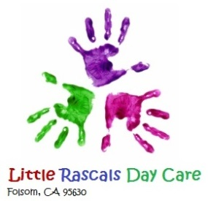

Parent Provider Agreement
I agree to enroll my child__________________ In Little Rascals Daycare beginning on _____________.
I have received and read the provider agreement and I __________________ agree to comply with rules and regulations outlined in the “Rules and Regulations” Document.
Daycare fees are as follows: Weekly or Bi-weekly. My payment will be for _________ days a week.
Payment obligations are based on days agreed to not on actual hours attended. There are no refunds and or credits for attending partial days or weeks. There are no refunds for deposits for any reason.
Thank you for choosing Little Rascals Daycare and myself. I hope to make your years here at Little Rascals Daycare an educational, fun and memorable time.
Sincerely,
Teacher Michelle Jones

_________________________________________ Date_____________

Parent signature: ___________________________ date: ______________
Sincerely, Little Rascals Daycare and Michelle

