Vintique Resale LLC Consignment Contract – STORE COPY 2021 Season
10254 Water St. (Hwy 42) Ephraim, WI 54211 vintiqueresale.com
(920) 854-8060
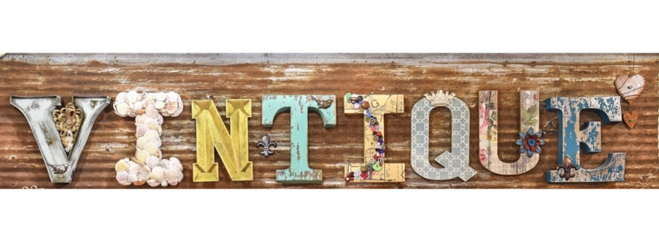

We appreciate the opportunity to sell your items and find new homes for them!
Below are some consignment guidelines to ensure the best possible outcome:

Merchandise Info: Our space is limited, so we are selective about pieces that we take in. Sending pictures (from multiple angles) with a description (including age, any damage, and special details) will increase the likelihood of selection. We would also appreciate a “ballpark” price range suggestion to make sure that we are the right avenue for you before you agree to consign. Please email bholm@vintiqueresale.com for inquiries.

Merchandise Pricing: Management will determine the selling price of each item based on factors including condition, age, damage, popularity, and demand. Consignors will have access to an online login to see the price of each item, when it sells, and available payout balance.

Split: 50/50. Vintique Resale LLC agrees to pay the consignor 50% of the final sale price. We maintain the right to adjust prices through promotions, coupons, and/or management’s discretion at any time during the term of this contract. If an item remains on the floor beyond 60 days, it is likely that the price will be reduced in a final effort to sell.

Responsibility: Vintique Resale LLC will do its best to care for your items, however we are not responsible for damage to or theft of items.

Photography Rights: Vintique Resale LLC reserves the right to photograph merchandise and use on website, promotional materials, and/or social media platforms.

Payout to Consignors: Checks will be sent to the address on file by the 10th of each month for the previous month of sales. Checks will only be sent if a consignor’s payout is $50 or over. At any time, you may come to pick up your balance or use as store credit. Please note: cash will only be issued for payouts totaling less than $25.

Contract Term: 90 days from the date your item is entered into our inventory. During the first 60 days, Vintique Resale LLC has the exclusive right to sale of that item. Items may not be retrieved before 60 days. Items may be picked up between 60 and 90 days.

Unsold items MUST be picked up on/by day 90 OR they will be donated to a local charity. Please elect and initial an option below:

_______ I will pick up my unsold item(s):

between ________________ (60 days) and _______________ (90 days).
I understand that if my item(s) are not picked up by day 90, they will be donated.

OR

______ Vintique Resale LLC has my permission to donate my unsold item(s) on:

_______________ (90 days).

Phone #: ________________________________

Email: __________________________________________________________________
ϒ Include me in exclusive monthly newsletters with sneak peeks, VIP promos & more!

Mailing Address:

Street: ___________________________________________________________________

City, State, Zip: ____________________________________________________________

Winter Mailing Address (if different):

Street: ___________________________________________________________________

City, State, Zip: ____________________________________________________________

Dates of Residency: ____________________________

Name (PRINT): ______________________________________

Consignor Signature: __________________________________ Date: _______________

Vintique Resale LLC Consignment Contract – CUSTOMER COPY 2021 Season
10254 Water St. (Hwy 42) Ephraim, WI 54211 vintiqueresale.com
(920) 854-8060

We appreciate the opportunity to sell your items and find new homes for them!
Below are some consignment guidelines to ensure the best possible outcome:

Merchandise Info: Our space is limited, so we are selective about pieces that we take in. Sending pictures (from multiple angles) with a description (including age, any damage, and special details) will increase the likelihood of selection. We would also appreciate a “ballpark” price range suggestion to make sure that we are the right avenue for you before you agree to consign. Please email bholm@vintiqueresale.com for inquiries.

Merchandise Pricing: Management will determine the selling price of each item based on factors including condition, age, damage, popularity, and demand. Consignors will have access to an online login to see the price of each item, when it sells, and available payout balance.

Split: 50/50. Vintique Resale LLC agrees to pay the consignor 50% of the final sale price. We maintain the right to adjust prices through promotions, coupons, and/or management’s discretion at any time during the term of this contract. If an item remains on the floor beyond 60 days, it is likely that the price will be reduced in a final effort to sell.

Responsibility: Vintique Resale LLC will do its best to care for your items, however we are not responsible for damage to or theft of items.

Photography Rights: Vintique Resale LLC reserves the right to photograph merchandise and use on website, promotional materials, and/or social media platforms.

Payout to Consignors: Checks will be sent to the address on file by the 10th of each month for the previous month of sales. Checks will only be sent if a consignor’s payout is $50 or over. At any time, you may come to pick up your balance or use as store credit. Please note: cash will only be issued for payouts totaling less than $25.

Contract Term: 90 days from the date your item is entered into our inventory. During the first 60 days, Vintique Resale LLC has the exclusive right to sale of that item. Items may not be retrieved before 60 days. Items may be picked up between 60 and 90 days.

Unsold items MUST be picked up on/by day 90 OR they will be donated to a local charity. Please elect and initial an option below:

_______ I will pick up my unsold item(s):

between ________________ (60 days) and _______________ (90 days).
I understand that if my item(s) are not picked up by day 90, they will be donated.

OR

______ Vintique Resale LLC has my permission to donate my unsold item(s) on:

_______________ (90 days).

Items To Be Consigned:

