PUBLIC AUCTION
  - SATURDAY, OCTOBER 24, 2026
Starting at 9:30 a.m.
Location: 4690 East Hwy. H Stoutland, MO 65567
Directions: From Hwy 7 just North of Richland, take Hwy H 2.7 miles to the sale site.
\

Household
Desks
Rugs
3 Cushion Sofa
2 Recliners
Rocker Recliner
Hamilton Beach Microwave
Osterizer blender
Nutribullet
Alaron Regulator Clock
Towels/wash cloths
Corningware
Pyrex bowls
Kitchen Table w/4 chairs
Sofa table
Air Cleaner (hepa)
2 Blond wood bar stools
Magazine racks
Full Size Bed
Dresser w/mirrored hutch& nightstands (2) Matching desk w/hutch
Wardrobe & tall chest
Queen bed, HB, FB, frame
China Hutch
Dining Table w/6 chairs, 1 Captain
Dresser
Chests
Books & Cookbooks
Porta johns
Shower Chairs
Walkers & Canes
Antiques & Collectibles
Copper Boiler
OLD Jigsaw in Metal Case, corded
Old Coca Cola Cooler
Drawing Knife
2 Milk Cans
2 Metal Lawn Chairs

Guns
Marlin Model 336, 30-30 lever action rifle w/ 4x32 Bushnell scope
Remington Model 7400, 30-06 rifle
Remington Wingmaster 870 .12ga pump shotgun (2 ¾)
Remington Sportsman-58 .12ga shotgun (2 ¾)
Stevens Singleshot .20ga
.69 caliber flintlock pistol
.45 caliber cap & ball pistol
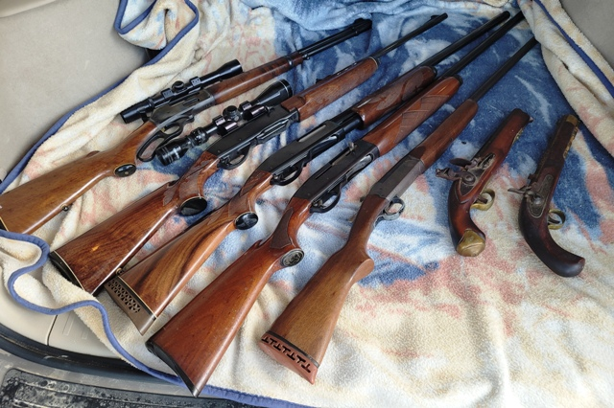

Yard, Shop, & Outdoor
16’ Osageian Canoe
Insulated Doghouse
Dog beds small & large
Dog Crates/Kennels, Med. & Large
Chain link Kennel approx.. 8’X13’
Craftsman Router in case
Craftsman 10” Table saw
Craftsman belt sander
B&D Orbital sander
Some Hand tools
Bench Grinder
Pipe Clamps
5’ Aluminum Ladder
Lot lumber
Ladder Stand
Lot T Posts
Old Style Bale Spike (attach to loader)
Rhino 3 pt Auger 12” bit
Patio Table w/2 chairs
8’ Picnic table
Yard Cart
Wheelbarrow (needs handles)
Plastic tubs
Wooden Wardrobe & Shelf (lockable)
Tripod Cable Pulley System
Troybilt Pressure Washer
Craftsman Self Propelled Mower w/B&S 163cc
DR Walk behind String Trimmer
Electric Sprayer 3pt Carryall
ATV Mount Electric Sprayer
Hunting & Fishing Gear
Deep Sea Fishing Rigs
Fly Tying Equipment in Case
Propane burner
Homelite SXL Chainsaw
Kerosene Heater
Coleman Camp Stove
Trailer Dolly
Army Cots
Some Handle tools
Old Sickle Mower
80” 3 pt. Cultivator
10’ Pull type brush hog
2 Bottom Disc Plow

Ford 5000 Tractor, w/Bush Hog Loader, 6’ Bucket, “shows” 89 hrs.
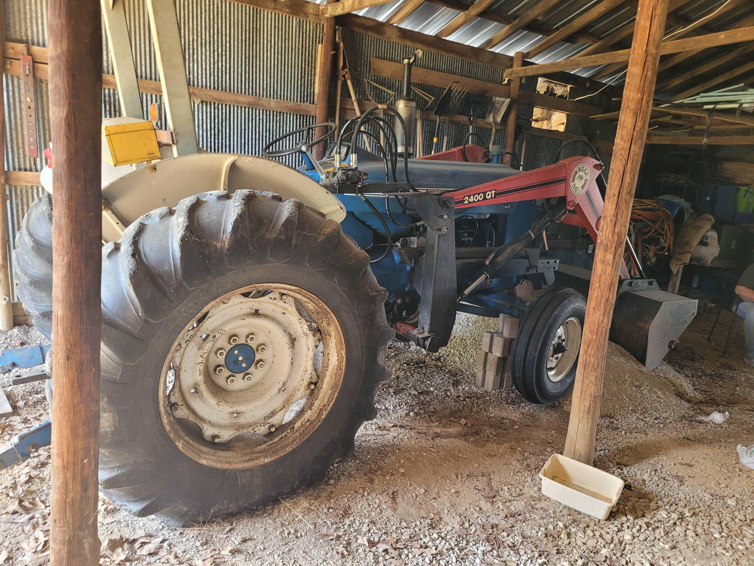

Many more items too numerous to mention

Owner: Seay Estate
Sale Conducted by
WARDEN AUCTION & MORE
(573) 528-0729
Ed Warden – Auctioneer, Broker
www.wardenauction.com

