BARBER SHOP LIQUIDATION ONLINE ONLY AUCTION
Bidding starts Dec 4th & will end Dec 19th
Preview/Inspection date is: Saturday, 14 Dec 2019 between 1:00pm-3:30pm
Winning bidders will pick up items on Monday afternoon, Dec 23rd.

Location: 240 Marshall Dr, Suite 6, Hidden Valley Plaza, Saint Robert, MO
Due to retirement, we are selling the fixtures, supplies and some of the memorabilia from Major Cuts St Robert along with other items useful to anyone. Hair care supplies; barber/beautician chairs; waiting area chairs; mirrors; back bars with sinks; Commercial floor buffer; models of military equipment; vacuum system and MORE!
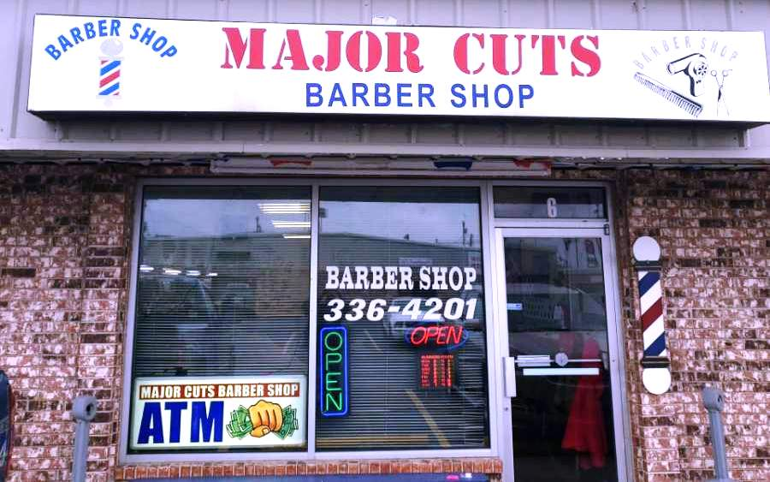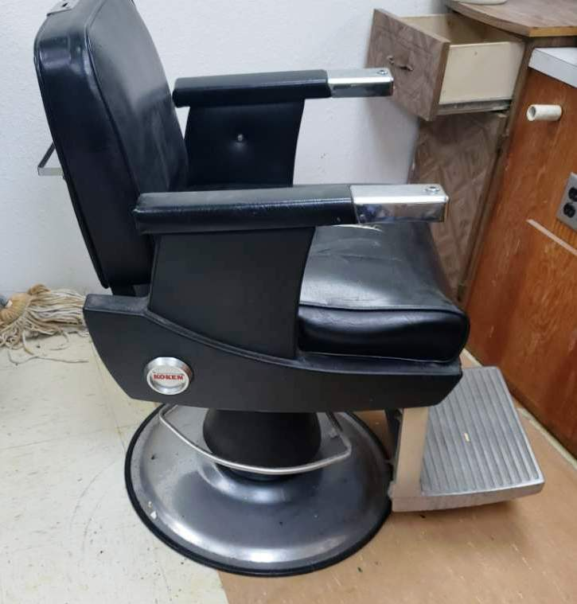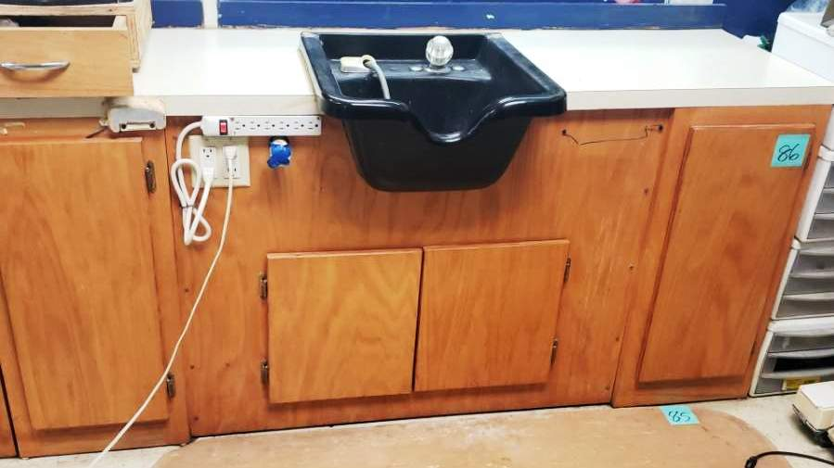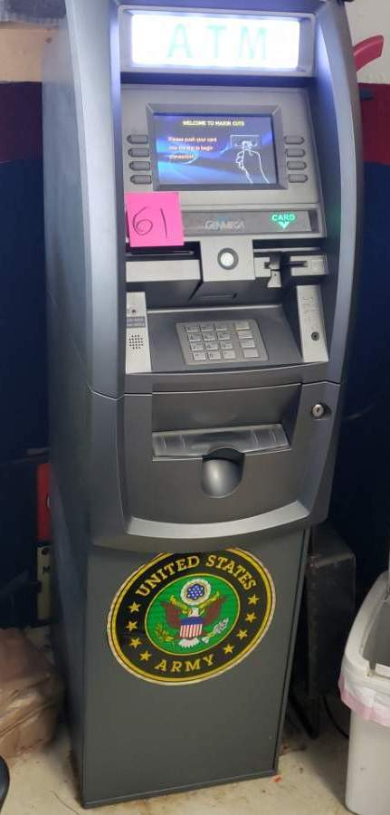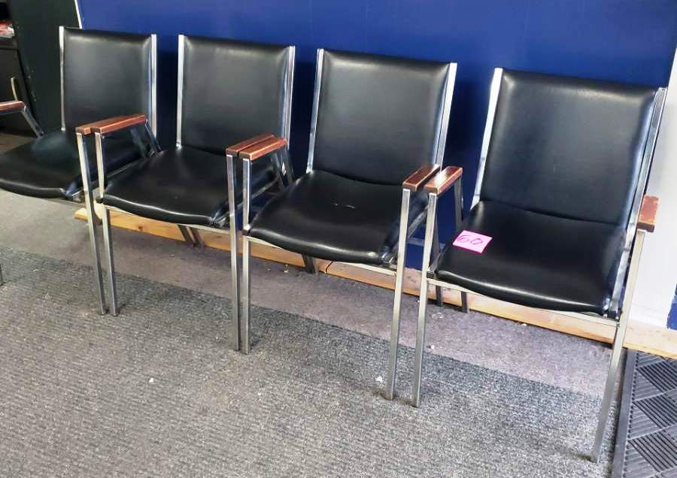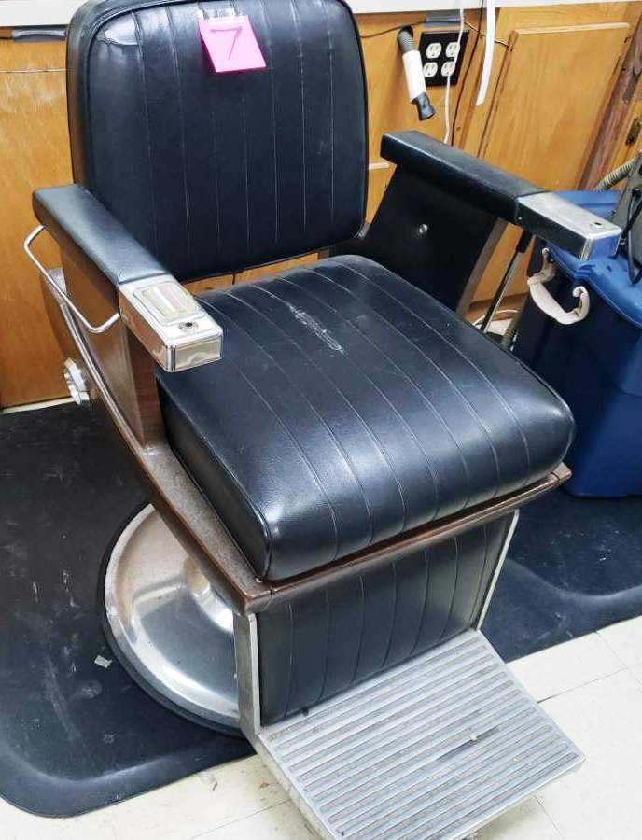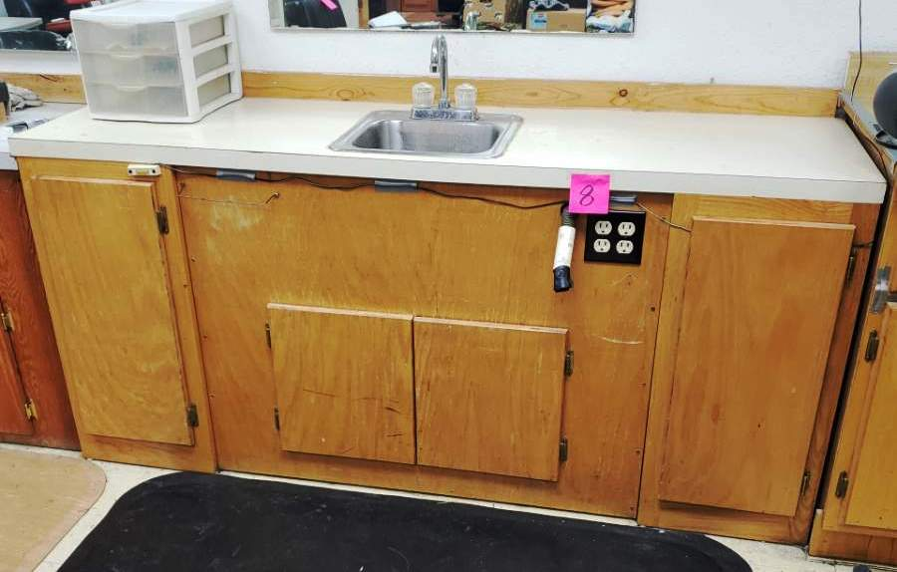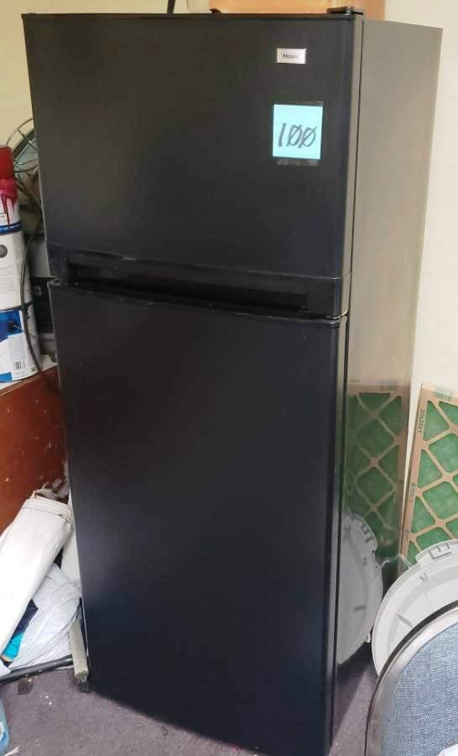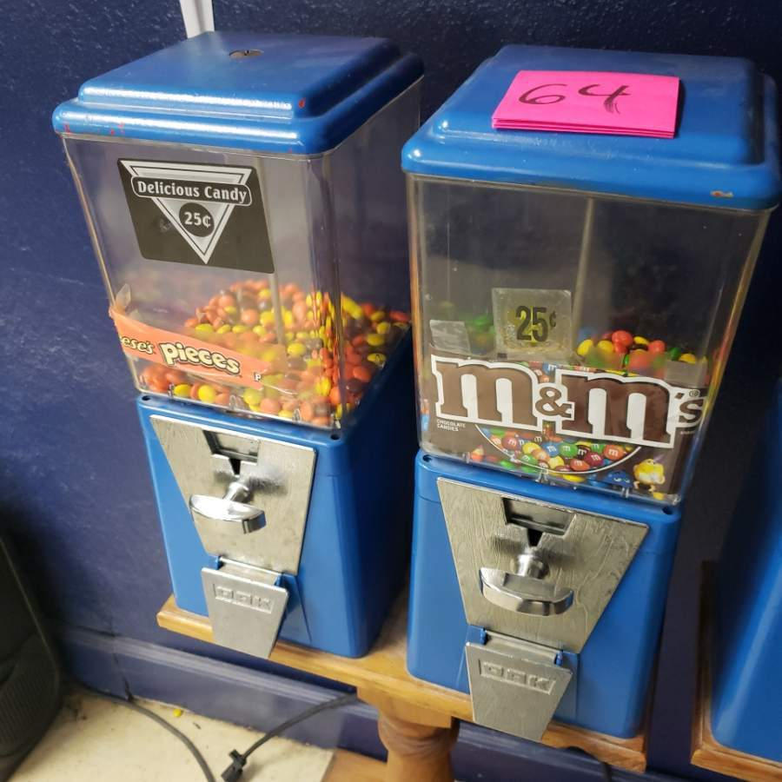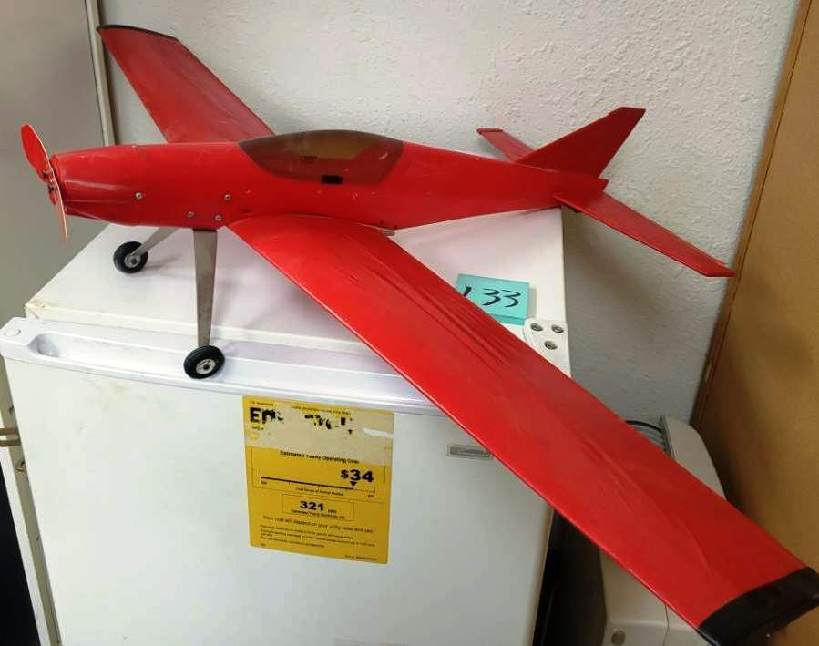
All terms, conditions, details and photos are found at
www.wardenauction.bid or www.wardenauction.com & follow the links.

Sale Conducted by
WARDEN AUCTION & MORE
Ed Warden – Auctioneer/Broker
(573) 336-2367 or (573) 528-0729

