ONLINE ONLY AUCTION
Bidding starts Nov 4th & will end Nov 14th
Preview/Inspection date is: Monday, 11 Nov 2019 between 1:30pm-4:00pm
Winning bidders will pick up items on Sunday afternoon, Nov 17th.

Location: 18299 Deer Run Lane, Saint James, Missouri 65559
Selling: Complete Household Liquidation. Quality very clean home furnishings & decor, Washer/Dryer, Ethan Allen furniture, and MORE!
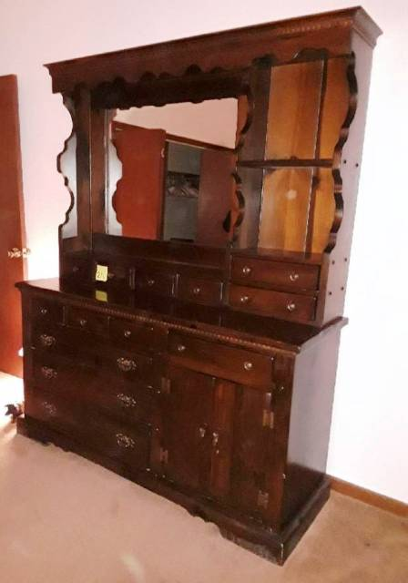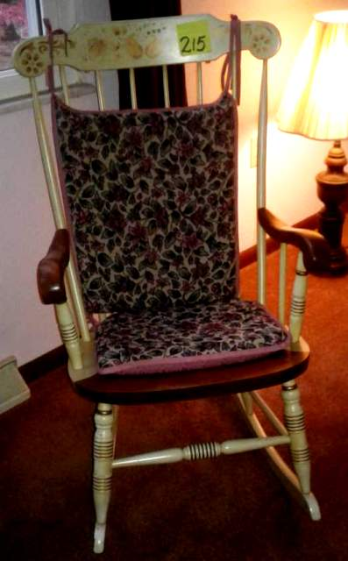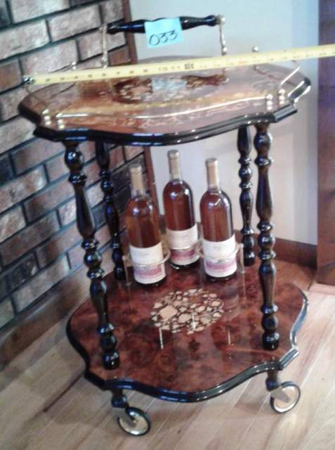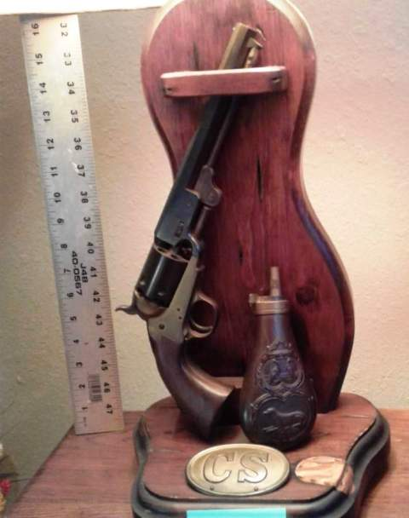
All terms, conditions, details and photos are found at
www.wardenauction.bid or www.wardenauction.com & follow the links.
Owner: Harold & Shirley Wright Trust
Sale Conducted by
WARDEN AUCTION & MORE
Ed Warden – Auctioneer/Broker
(573) 336-2367 or (573) 528-0729

