Serenity On Fifth
Client Intake Form

Full Name: __________________________ DOB: __________________
Address: _________________________________________________________
City: _________________ State: ________ Zip: ___________________
Phone #: _____________________ Email: ____________________________
Occupation: _________________________
- All legalities and ethical codes shall be abided by in accordance with the RULES AND REGULATIONS of the NORTH CAROLINA BOARD of MASSAGE & BODYWORK THERAPY (Standards of Professional Conduct- Section .0500, .0505); If the client is under the age of 18, a Parent or Guardian must give informed, and written, consent and accompany the minor during the session(s).

Emergency Contact: __________________ Phone #________________
Relationship: _________________________
Physician: __________________________ Phone: _______________________

How did you hear about Serenity on Fifth? ________________________

Medical History
Health Conditions: __________________________________________________________________
Medications Being Taken: __________________________________________________________________
Please indicate any of the following conditions that you currently have:
- Headaches ○ Varicose Veins
- Cancer ○ Diabetes
- Heart/Circulation Problems ○ Sprains/Strains
- Major Accident ○ Arthritis/Tendonitis
- Neck/ Back Injuries ○ Abnormal Skin Condition
- Numbness ○ High/Low Blood Pressure
- Allergies ○ Blood Clots
- TMJ ○ Recent Injuries
- Joint Surgery
- Auto-Immune Disorders (AIDS/Hepatitis/Lupus/Etc.)

Explain Any Conditions You Have Marked Above:
________________________________________________________________________________________________________________________________________________________________________________________________________________________________________________________________________________________________________________________________________________________________________________________________________________________________________________________________________________________________________________________________________________
Atmosphere of Session(s):
* Aside from necessary vocalizations for treatment and/or aftercare

Ambient Music:
- Personal Playlist
- Spa Playlist
- Both
- Neither
Ambient Lighting:
- Dim
- Medium
- High
Conversations:
- No Conversation
- Minimal Conversation
- Light Conversation

Preferred and Non-Preferred Scents:
________________________________________________________________________________________________________________________________________________________________________________________________________________________________________________________________________
Please indicate in the diagram the most problematic areas in need of marginal focus:
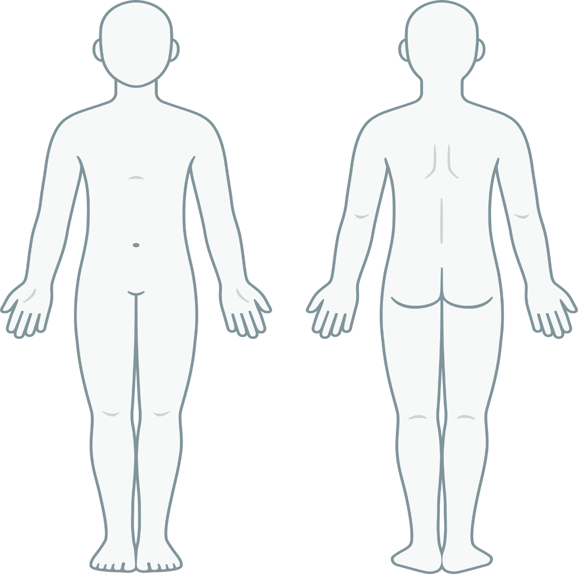

Parent/Guardian Signature:
_____________________________________________ Date: _______________
Client Signature: _______________________________ Date: _______________

