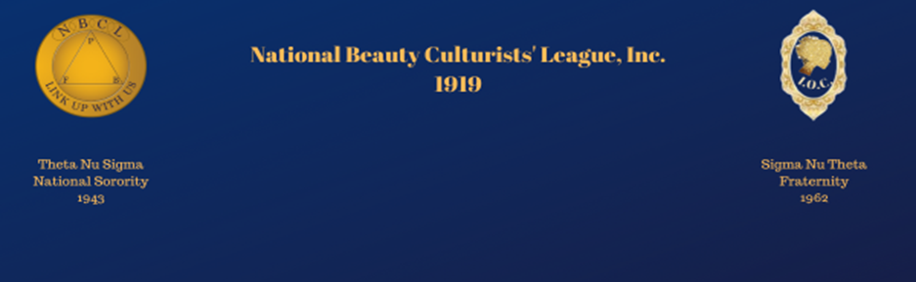[Date]

[Merchant’s Name]
[Merchant’s Business Name]
[Merchant’s Address]
Subject: Partnering for the Future: Scholarship Sponsorship Opportunity
Dear Sponsor,
I hope this letter finds you well. I am reaching out on behalf of the National Beauty Culturists’ League (NBCL), an esteemed organization dedicated to advancing the profession of Cosmetology through professional training and educational opportunities for future generations of Beauty Professionals, Barbers, Cosmetologists, Students, Nail Technicians, Makeup Artists, and more.
As part of our ongoing commitment to excellence in beauty education, we are launching a scholarship program to empower aspiring professionals by removing financial barriers to their training and certification. We firmly believe that education and opportunity are the cornerstones of success, and with support from esteemed businesses like yours, we can cultivate the next generation of talent in the beauty industry.
We invite [Merchant’s Business Name] to join us in this mission by becoming a sponsorship partner. Your contribution will directly fund scholarships for talented individuals who may otherwise struggle to pursue their dreams in cosmetology. As a valued supporter, your business will be recognized in our promotional materials, event programs, and on our official website, showcasing your dedication to fostering excellence in the beauty industry.
Would you be open to discussing how [Merchant’s Business Name] can participate in this life-changing initiative? Whether through a monetary donation, product contributions, or collaborative events, your involvement will make a meaningful impact on the careers of future beauty professionals.
We would be honored to speak further about this opportunity at your convenience. Please feel free to contact me at pbriggs502@gmail, and I would be happy to provide more details.
Thank you for considering this partnership. We look forward to the possibility of working together to shape the future of the beauty industry.
Warmest regards,
National Beauty Culturists League

Please remit payment online or by personal check.
MAKE ALL CHECKS PAYABLE TO “NBCL” AND
MAIL TO:

Dr.. WIllie C Singleton
3358 North Milwaukee St
Denver, CO 80205
720-260-3734

Online “Scholarship Donation”:
https://www.nbcl.info/shop.html
1)Choose degree level
2)Check-out and pay

