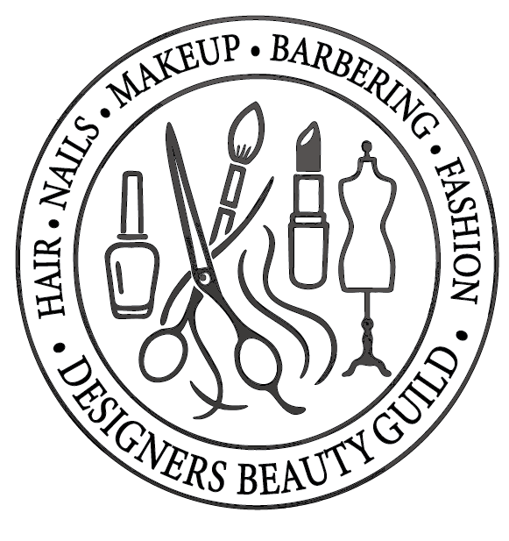

Designers Beauty Guild Administration and Membership Guide

Objectives:
- General Objectives: In the tradition of medieval and modern guilds for artists and craftsmen, the Guild aims to continually foster the growth and development of its members’ artistic and technical skills. It seeks to increase public appreciation for these talents and cultivate professional and fraternal relationships among hair design artists.
- Specific Goals: The Guild's mission is to enhance the professional performance of its members, particularly in the fields of hair styling, coloring, weaving, and design. It also seeks to support areas closely related to hair design, including collaboration with millinery or dress design, figure control, and salon atmosphere.
To achieve these goals, the Guild will conduct advanced workshops and clinics for members, facilitate information exchange, and encourage participation in demonstrations, professional meetings, and educational services.
Annual advanced courses will be offered to Guild members, further supporting their professional growth. Additionally, the Guild will function as a referral agency for individuals seeking skilled hair designers for demonstrations, instruction, or other professional services. Public relations efforts will also be pursued to raise awareness and appreciation for the specialized services Guild members provide.

Designers Beauty Guild Membership Application Form
Personal Information
- Full Name: ___________________________________________
- Address: ___________________________________________
- City, State, ZIP Code: ___________________________________________
- Phone Number: ___________________________________________
- Email Address: ___________________________________________
- Date of Birth: ___________________________________________
Professional Information
- Current Occupation: ___________________________________________
- Business Name (if applicable): ___________________________________________
- Business Address: ___________________________________________
- Years of Experience in the Beauty Industry: __________
- Specialization (Check all that apply):
  - ☐ Hair Styling
  - ☐ Barbering
  - ☐ Coloring
  - ☐ Weaving
  - ☐ Makeup Artistry
  - ☐ Nail Services
  - ☐ Esthetics
  - ☐ Other (Specify): ________________________
Education & Credentials
- Name of Beauty School Attended: ___________________________________________
- Year of Graduation: __________
- License/Certification Number: ___________________________________________
- Additional Certifications: ___________________________________________
Guild Membership Requirements
- ☐ I have completed advanced training beyond licensing requirements.
- ☐ I have at least three years of specialized experience in a beauty-related field.
- ☐ I am a current member of the National Beauty Culturists' League (if applicable).
- ☐ I have attached my portfolio and/or resume.
Membership Type (Select One):
- ☐ Standard Membership
- ☐ Student/Apprentice Membership
- ☐ Educator Membership
- ☐ Affiliate Membership
References (List two professional references)
- Name: ___________________________________________
Contact Info: ___________________________________________
Relationship: ___________________________________________
- Name: ___________________________________________
Contact Info: ___________________________________________
Relationship: ___________________________________________
Agreement & Signature
By signing this application, I certify that all the information provided is true and accurate. I agree to uphold the standards and ethics of the Designers Beauty Guild and participate in professional development activities.
Applicant Signature: ___________________________ Date: ______________

