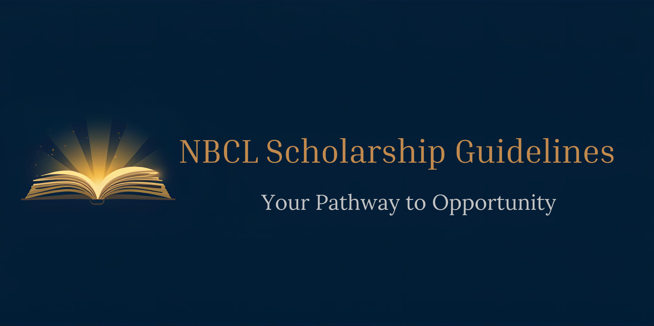
NBCLSM Institute of Cosmetology
Division of
National Beauty Culturist’s League Inc.

Student Application
Name__________________________________________
Address ________________________________________
City/State/Zip____________________________________
Telephone________________Cell____________________
Email __________________________________________
- I am a member of______ State (Beauty Association)
- I am a licensed:
Cosmetologist ___
Barber___
Manicurist___
Esthetician ___
Massage Therapist___
Natural Hair Stylist ___
Application Requirements:
Please use the following as a checklist for your application:
-Eligibility Criteria
- Field of Study – Must be pursuing a program in cosmetology, esthetics, barbering, nail technology, or a related beauty industry field.
- License Status – State Professional License must be current/valid.

