Director Trustees
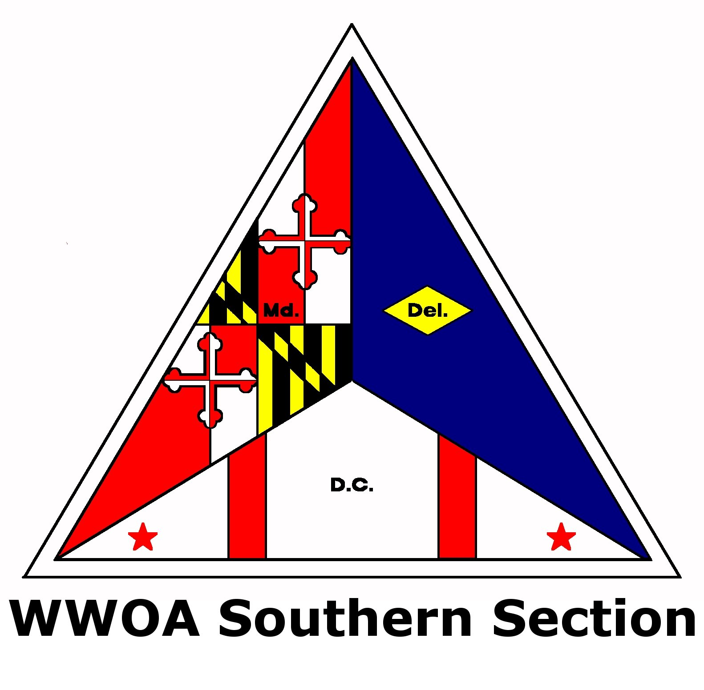
Tara Jones, WSSC Mike Emery, Calvert County
William A. Shreve, Jr., St. Mary’s County
Director-Elect George Bacon, Charles County
Tom Spalding, Retired
Past Director Treasurer
Jessy Cockrell, Charles County Danielle Phelps, Charles County
Secretary, Kristy McAndrew, Charles County
The WWOA Southern Section is holding a meeting with two training classes as indicated below on Wednesday, May 24, 2023, at the North East Community Center in Chesapeake Beach, MD.. The registration fee for WWOA members is $35 for training, morning refreshments and lunch. Non-member price is $60 and includes membership in WWOA through December 31, 2023. 50/50 tickets will be on sale to benefit the Southern Section. Please come out to support your Association and enhance your knowledge!
AGENDA
8:00 - 8:30 Registration (coffee, juice, donuts)
8:30 - 12:00 Chemical Treatment (Part 1) *.
TRE 6021-16-11: All WW; All IWW; All WT (Process), 7 Hours.
Class description: Most water and wastewater treatment plants now use chemicals for some of the processes. In water treatment, chemicals are used to adjust pH, aid in settling particulate matter, to enhance filtration, and to remove trace constituents. In wastewater treatment, chemicals can be used to remove phosphorus; they can enhance settling in primary and/or biological treatment; they can assist in odor control, sludge thickening, sludge dewatering, and sludge stabilization. In this class, students will learn about the various chemicals used, how they can be stored and handled safely, and how to calculate dosages. Ideas on costs and how to contract for the purchase of chemicals will be provided.
8:30 -12:00 Advanced Treatment Technologies for the 21st Century (Part 1) *
TRE 7046-21-7; All Operators (Process)
Class description: Today's technological advances have resulted in our ability to measure and report emerging contaminates and pathogens. Trace amounts of pharmaceuticals, organics, (PFAS) pathogenic microorganisms (Covid-19, freshwater flesh-eating Amoeba) and others have prompted operators and superintendents to explore treatment technologies available to best meet these potential challenges. This program explores applications of chemical oxidation, absorbance, absorbance, filtration, precipitation, and the combination of advanced technologies currently available; in-use as well as future treatment capabilities expected to meet these challenges. We will explore Chlorine Dioxide, Peracetic Acid, Fenton’s reaction, and combination with UV, Ozone, Advance Oxidation Process, and even the use and application of Nanotechnology to meet future treatment needs.
12:00 - 1:00 Lunch/Business Meeting
1:00 - 4:30 Chemical Treatment (Part 2) *
1:00 - 4:30 Advanced Treatment Technologies for the 21st (Part 2) *
4:30 Issue Class Certificates - Adjourn
*You must attend both sessions of the class to obtain your training certificate.
Register On-Line at www.wwoa.net (Credit Cards Only)
You must register no later than Friday, May 19, 2023.

