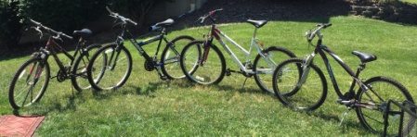

WHEELS FOR WORK
WE ARE COLLECTING
“GENTLY USED” OR NEW BICYCLES

LAST SUMMER WE HELPED A LOCAL MAN IN RECOVERY, LIVING IN A SOBER HOME OBTAIN A BICYCLE. HE WAS IN DESPERATE NEED OF TRANSPORTATION TO GET TO WORK.

IT BECAME SOMETHING MANY MORE WERE INTERESTED IN. WE COLLECTED A DOZEN OR MORE BICYCLES TO DONATE! A LOCAL HOMELESS SHELTER HAD A BIKE RACK WITH NO BIKES, IMAGINE THEIR SURPRISE WHEN WE FILLED THE BIKE RACK! UNFORTUNETLY WE HAVE MANY MORE IN NEED.

WE CAN ARRANGE FOR PICK UP OR MEET TO DROP OFF.
THANK YOU FOR ALL YOUR CONTINUED GENEROSITY AND SUPPORT.

CONTACT 610-657-2978 voicesforchange@yahoo.com

Voices for Change is a 501(c)(3) non-profit organization in the Lehigh Valley.
We exist to provide assistance to those in our community who suffer from substance use disorder. We provide support to help bridge the gap between inpatient treatment and aftercare. We help support those in recovery to transform their lives so they can fulfill their dreams and goals. We help break through the barriers of shame and stigma.

