**Adult T-Shirt (Navy) Adult T-Shirt (Charcoal) Ladies T-Shirt (Navy) Ladies T-Shirt (Charcoal)**

Sizes S – 5X Sizes S – 5X Sizes XS – 4X Sizes XS – 4X

**$15 $15 $15 $15**

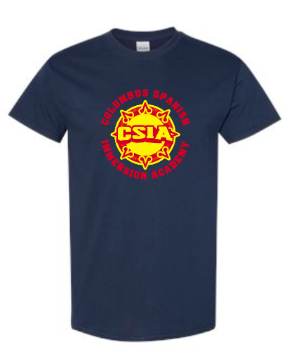 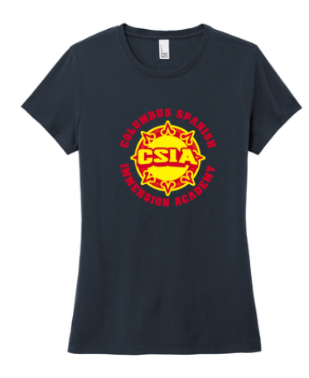 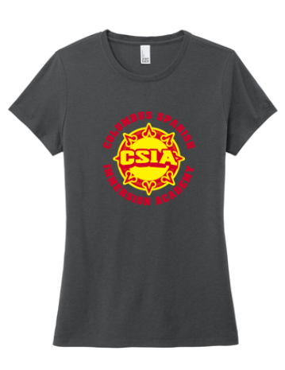

**Youth T-Shirt (Navy) Youth T-Shirt (Charcoal)**

Sizes XS – XL Sizes XS – XL

**$15 $15**

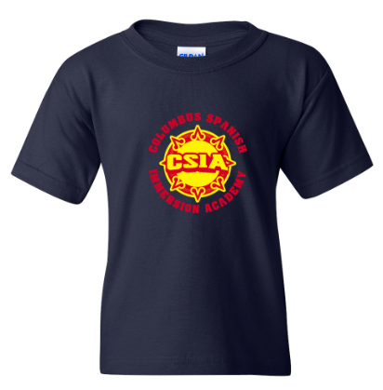 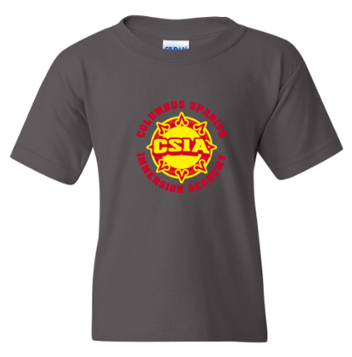

**Adult Hoodie (Navy) Adult Hoodie (Charcoal) Adult Crewneck (Navy) Adult Crewneck (Charcoal)**

Sizes S – 5X Sizes S – 5X Sizes S – 5X Sizes S – 5X

**$30 $30 $25 $25**

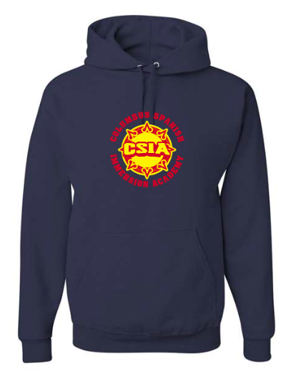 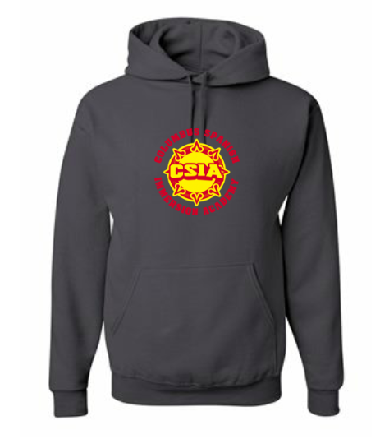

**Youth Hoodie (Navy) Youth Hoodie (Charcoal) Youth Crewneck (Navy) Youth Crewneck (Charcoal)**

Sizes S – XL Sizes S – XL Sizes S – XL Sizes S - XL

**$30 $30 $25 $25**

**Adult ¼ Zip (Navy) Adult ¼ Zip (Charcoal) Women’s ¼ Zip (Navy) Women’s ¼ Zip (Charcoal)**

Sizes S – 3X Sizes S – 3X Sizes XS – 2X Sizes XS – 2X

**$30 $30 $30 $30**

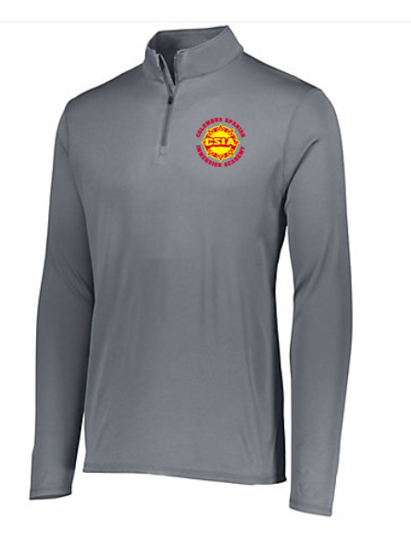 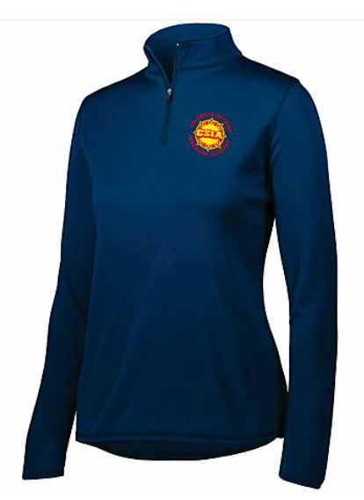 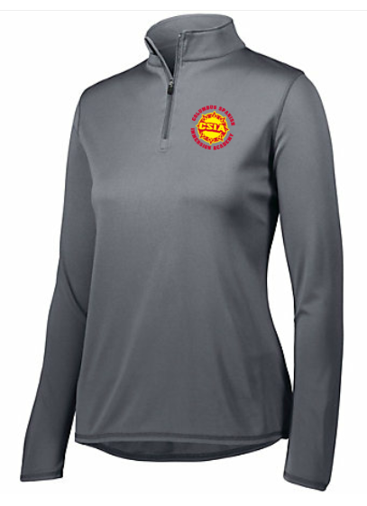

**Youth ¼ Zip (Navy) Youth ¼ Zip (Charcoal)**

Sizes S – XL Sizes S - XL

**$30 $30**

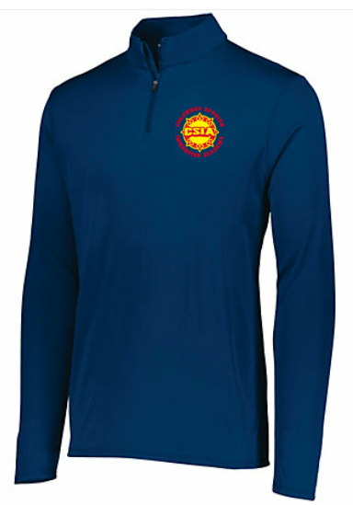

**Adult Polo (Navy) Adult Polo (Graphite) Women’s Polo (Navy)**

Sizes XS – 4X Sizes XS – 4X Sizes XS – 3X

**$25 $25 $25**

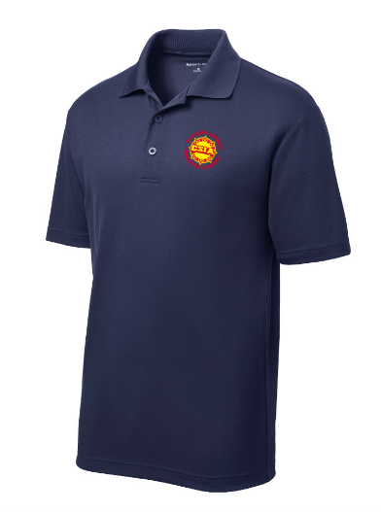 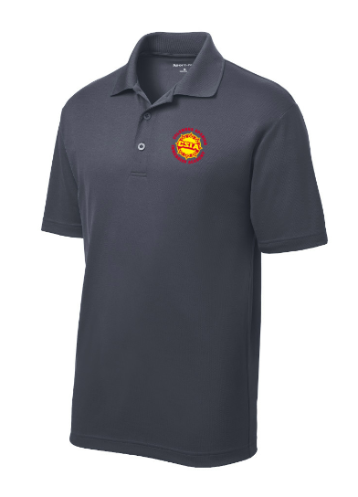

**Youth Polo (Navy) with Logo Youth Polo (Graphite) with Logo**

Sizes XS – XL Sizes XS – XL

**$20 $20**

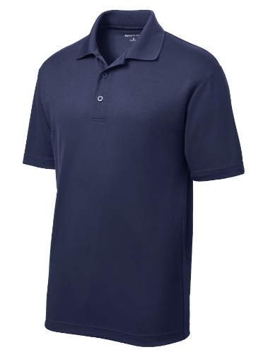

**Car Sticker**  **Cinch Backpack (Navy)**

**$6**  **$15**

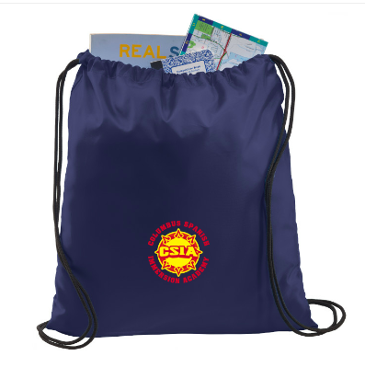

**Tote Bag (Navy)**   **Tote Bag (Natural)**

**$20 $20**

