Summer 2019 Wish list!

- Hand Sanitizer
- Disinfectant Wipes
- Kleenex
- Ziploc bags (Any Size)
- Brown paper bags
- Paper plates, cups and utensils
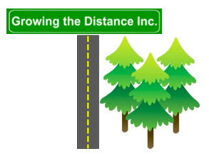
- Arts and Crafts supplies

