

100 University Drive, Amherst, MA 01002



***Solar Power on Farmland - Produce Two Crops***

***Co-location Solar Production: What is it?***

Co-location solar, or dual-use of land solar, consists of installing a set of solar panels on agricultural land in a way that allows the land to continue to be used for its primary purpose – the production of agricultural crops – while producing electrical power for the farm’s sustainability and financial benefit.

General scientific theory and recent tests at the University of Massachusetts Amherst regarding specific crops have demonstrated that partial sunlight during the growing process is either beneficial, neutral or minimally negative on those crops. However, each installation, for each farm requires thoughtful planning. The pictures below show two installations, developed by Hyperion Systems, LLC, in response to the production needs of each farm, for installing co-location solar.

***Installation at UMass Amherst Experiment Station, South Deerfield, MA***

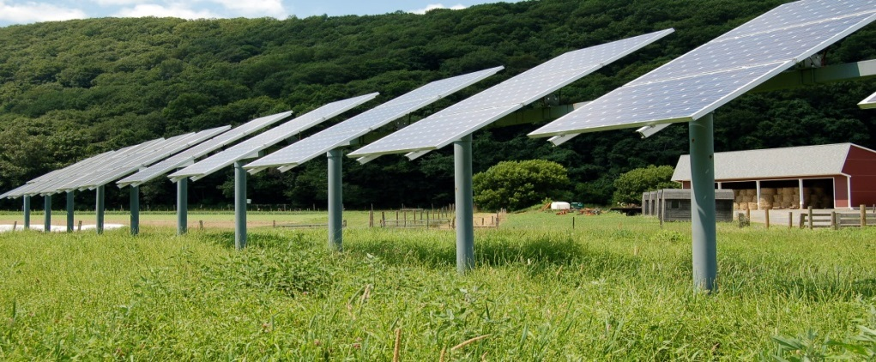

***Edwards Farm, Hadley, MA***

[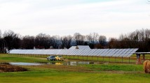](http://www.hyperionsystemsllc.com/wp-content/uploads/2011/11/Edwards11.jpg)

***Financial Analysis for Feasibility of Co-location Solar***

In order to decide whether a solar co-location project makes sense for your farm, the worksheet below outlines the issues and most important questions to be addressed before beginning a more detailed analysis. It is important to analyze financial options over a long period of time in order to make a sound decision.

***The Questions***

1. Is a co-location solar array financially feasible for my farm?
2. What would it cost to build and operate?
3. What are the total and annual revenues and benefits?
4. How would owning or leasing a co-location solar array affect my taxes?
5. Is a solar array compatible with my crops?
6. What are the greenhouse gas benefits? Would my farm be “greener”?

***Financial Benchmarks***

The eight calculations below provide a quick estimate of the feasibility of implementing a co-location solar project. These estimates are designed to give a potential project a quick overview and to lead into further detailed analysis using the *“Solar Co-Location Financial Analysis Spreadsheet”*,

Also, attached is a sample set of calculations for a 50 kW solar co-location project.

***Financial Feasibility***

1. ***Cost:*** There are two sets of costs. The capital costs of building the array and ongoing

Operating costs.

Estimate the cost to build the array by multiplying the size of the array by

$2.40 per watt.

Estimate annual expenses by assuming: 1) a loan payment @ 6%, and

2) maintenance costs (insurance, repair, replacement, etc.) by multiplying

The estimated installation cost by 0.05 for an annual cost.

1. ***Revenues:*** Revenues come in the form of solar incentives and

electricity savings,

a. Value of SMART Program Incentives: Assume

$0.30 for every kWh for 20 years,

1. Calculate the value of electricity savings

@ $0.089 for every kWh used.

***Estimated Total Annual Revenues***

1. ***Annual Cash Flow:*** Annual revenues minus expenses.
2. ***Payback Estimate****:* Investment divided by gross cash flows.
3. ***Return on Investment:***Net profit(benefits)/Initial capital investment
4. ***Internal Rate of Return:***Internal Rate of Return shows whether

an investment produces more revenue in the future – at a specific interest rate-

than the investment costs. Every farm has different overhead costs and

operating costs so the interest rate (the discount rate) of the future cash flows

needs to be calculated by each farm considering a co-location solar array.

The calculation is as follows: Net Present Value =

Investment + Future Cash Flows/(1+ Discount Rate)Time periods

1. ***Effect on Income Taxes***

Farm’s federal tax rate ______ Estimated Earnings _______

Taxes saved or incurred.

1. ***Suitability for crops***: List crops those planting, cultivation and harvesting

that will not be impacted by the presence of a fixed structure (poles with solar

panels above the poles in the ground).

1. ***Greenhouse Gas Savings Estimates: (To be completed)***

***Example of Financials for a 50 kW Co-location Solar Array in Massachusetts with SMART Program Incentives***

Project Size: 50 kW (nameplate rating)

58,273 watts of electricity produced annually (per NREL PVWatts calculator)

2 rows of panels 20 feet apart with crops between and/or underneath

(depending on the crop) requiring approximately ¼ acre. Hay @ $2,000 per acre here.)

Crops: Assume a hay crop valued at $2,000 per acre, per season, in this example.

***Financial Basics for Sample Project of 50 kW***

1. Costs

a. Total Investment (@ $2.30 per watt) $115,000

b. Annual cost of loan (total amount, 20 yrs @ 6% $9,887

c. Land required ¼ acre

d. Est. annual operating cost (0.5% of total cost) $575

Includes maintenance, equipment replacement

Funding, insurance.

***Estimated Total Annual Costs $10,462***

1. Revenues & Financial benefits

a. Value of SMART Program Incentives: Assume

$0.30 kWh for 20 years = $17,511

and value of electricity savings

@ $0.089 = $5,186 for a net benefit of $12,295

b. Crop retention (pasture @ $2,000 per acre) $500

***Estimated Total Annual Revenues $12,795***

1. Annual Cash Flow: Annual revenues minus expenses.  ***$2,333***
2. Payback Calculation: Investment divided by gross revenues

$115,000/$12,795 = **8.9 years**

1. Return On Investment (ROI) = Profit/ Investment =

$2,333/$115,000 = **2%**

1. Internal Rate of Return (Discount rate of 8%) =

NPV = - $115,000 + 20 years cash flow of $2,333 @ 8% = ***7%***

1. Effect on Income Taxes

Farm’s federal tax rate ______ Estimated Earnings _______

Taxes saved or incurred.

1. Suitability for crops: Pasture ***OK***
2. Greenhouse Gas Savings Estimate: ***To Be Completed***