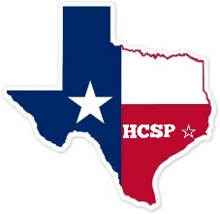

SAFEGUARD

**OFFICIAL NEWSLETTER OF THE HOUSTON COUNCIL OF SAFETY PROFESSIONALS**

P.O. BOX 5211 HOUSTON, TEXAS 77262-5211 VISIT OUR WEBSITE: [WWW.HCSP.INFO](http://www.hcsp.info/)

***“Promoting Transportation Safety through Driver Professionalism”***

HCSP Monthly Meeting

Friday, Nov. 08th, 2024 11:30am - 1:00pm

Battleground Golf Course

1600 Georgia Ave

Deer Park, TX. 77536

Guest Speaker:

**Blue Santa – Georgia Davis**

* **November is HCSP’s Veteran’s Appreciation Month!**
* **November guest speaker: Georgia Davis - Blue Santa**
* **Don’t forget to bring presents to November’s council meeting for BLUE SANTA!**
* **Joe Atkinson Award nominations due by December 13th, award presented in January**
* **December guest speaker – Jeff Langloss FMCSA**

**Enjoy the benefits of a HCSP membership – Now Accepting Dues**

**Bring a Guest & Door Prizes!!**