SURVEY AND VALUATION REPORT
FOR ROBERTS 38FT 2003 SAILING VESSEL
“ ZESTER ”

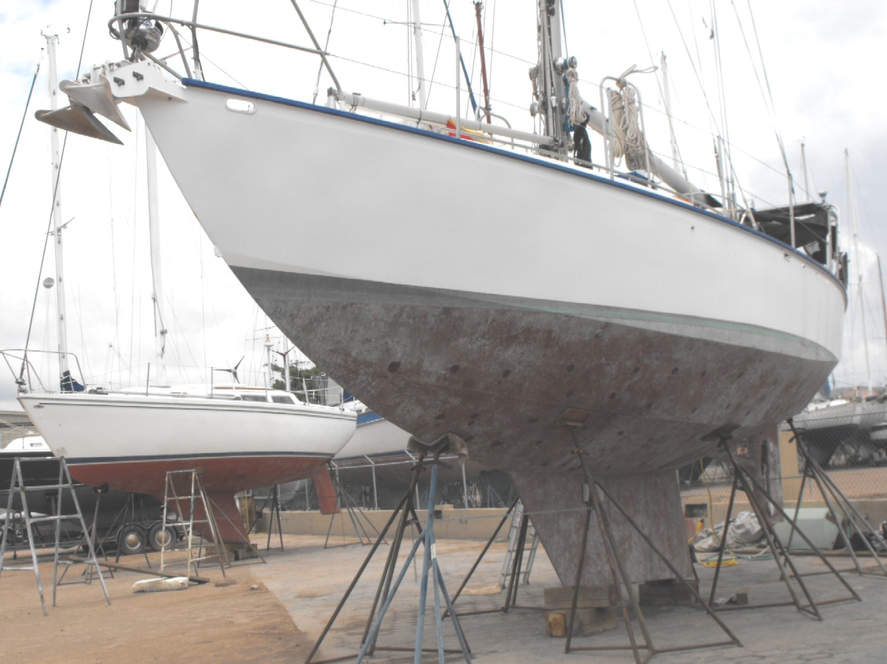

CECIL M. LANGE, AMS
MARINE SURVEYOR AND CONSULTANT
MEMBER- SCIETY OF ACCREDITED MARINE SURVEYORS
VHF Channel 22
Tel: 011-52-612-122-7066
Cell: 044-612-131-7459
Morelos #915 esq. Josefa O. de Dominguez
La Paz, B.C.S., México 23000
Email: cecillange1925@yahoo.com

SUMMARY
In accordance with the request for a marine survey of this vessel for the purpose of evaluating its present condition and estimating its market value and replacement cost, I hereby submit my conclusions based on the following report. The subject vessel was personally inspected and found to be a well-constructed, appointed and comfortable vessel.
Subject to corrections of the Requirements and Recommendations listed in this report, and predicated on the assumption that engines and machinery are in working order, the vessel is considered to be “fit for its intended use” of recreational coastal and offshore cruising OR sport fishing and coastal cruising.

SCOPE OF SURVEY
Constraints placed on Surveyor: Unless otherwise noted, all items inspected by the surveyor (such as, but not limited to, seacocks, thru-hull fittings, and hoses) is limited to that which is readily and visibly accessible.
Ships Papers Onboard: Yes
Engine(s) Run: No
Sea Trial: No
Special Test Meters Used during Survey: Altra sound
NOTE: Use of asterisks (*) in the body of the report indicate that a finding is listed in the “Recommendations” or “Requirements” Section pertaining to that item.
THE MANDATORY STANDARDS PROJULGATED BY THE UNITED STATES COAST GUARD (USCG), UNDER THE AUTHORITY OF TITLE 46 UNITED STATES CODE (USC) TITLE 33, AND TITLE 46, CODE OF FEDERAL REGULATIONS (CFR), AND THE VOLUNTARY STANDARDS AND RECOMMENDED PRACTICES DEVELOPED BY THE AMERICAN BOAT AND YACHT COUNCIL (ABYC) AND THE NATIONAL FIRE PROTECTION ASSOCATION (NFPA) HAVE BEEN USED AS GUIDELINES IN THE CONDUCT OF THIS SURVEY.
The vessel was inspected “On the Hard” only. Engines were NOT run. The rigging was inspected by a qualified rigger who was contracted by the owner. An Ultra Sounding was done on the bottom plating.

VESSEL STATISTICS

NAME OF VESSEL ZESTER | DATE OF SURVEY August 14 2010
HOME PORT //////////////// | SURVEY REQUESTED BY Owner
MANUFACTURER’S NO.: CFLOOOO1E700 | OWNERS NAME Miller Adams
OFFICIAL NUMBER: 1142540 | OWNERS ADDRESS1626 /////////////
TYPE OF VESSEL Roberts Sailing vessel | INTENDED USE Recreational
YEAR BUILT: 2003 | INSPECTED AFLOAT: No
BUILDER: Lindberg Marine | INSPECTED HAULED: August 14 2010
VESSEL MODEL: Roberts 38 | Accommodations: Five plus
DESIGNER: Roberts | DISPLACEMENT 30,000 lbs
LOA 38 FT.3” | TONNAGE MEASUREMENTS
BEAM: 11 FT 3” | GROSS TONS: 12
DRAFT: 6 FT | NET TONS: 11
DESIGNED WATER LINE: NA | DEPTH : 5 ft 8 “

VALUATION
MARKET VALUE $ 73,000 00 REPLACEMENT COST $ 350,000 00

EQUIVELENT VALUES

Roberts 38 ft cutter steel 1980 $ 75,000 00 Australia Yacht World
Roberts 38 ft cutter steel 1982 $ 56,368 00 New Zealand Yacht World
Roberts 34 ft Spray steel 1995 $ 70,048 00 sale pending Yacht World

SYSTEMS, HULL, DECK, SUPERSTRUCTURE

HULL CONSTRUCTION AND CONDITION: | Steel 3/16” core 10  Longtitudinals 1 1/4 x 5/16 flat straps  Transverse frames 2 1/2 ”x 5/16” steel, good condition , no rust
KEEL DESIGN: | Long fin keel 6,500 lbs lead ballast
KEEL CONSTRUCTION AND CONDITION: | Steel , good condition
DECK CONSTRUCTION AND CONDITION: | Steel, 3/16” core 10, no rust
SUPERSTRUCTURE CONSTRUCTION AND CONDITION: | Steel 3/16” core10, no rust

Electrical – DC 12 volt
NO. OF BATTERIES: | Five Group 31, AGM 12 VOLT  Four house and one starting battery, new
BATTERY VENTILATION: | Satisfactory
TERMINALS CONDITION: | Clean
TERMINALS PROTECTED: | Yes
BATTERIES SECURED: | Yes
BATTERY CHARGING: | Engine alternator,, with Link 1000 battery monitor.  160 Amp Balmar run off a jack shaft, and a Freedom 10 , 1000 watt Heart inverter / charger 50 amp.
BATTERY SWITCH: | Two
WIRING TYPE/GRADE: | Marine grade wire, tinned.
CIRCUIT PROTECTION: | Breakers and fuses,

Electrical – AC 110 volt 35 amp
SHORE POWER CONNECTION: | 110 volt, 30 amp with 50 ft cord
WIRING TYPE/GRADE: | Marine grade copper
AC CIRCUIT PROTECTION: | Breakers
AC GALVANIC ISOLATOR: | Heart voltage mind transformer
INVERTER: | Freedom 10 -1000 watt inverter / charger.

Propulsion and Auxiliary Power
PROPULSION MANUFACTURER: | Sabb
MODEL: | Sabb 2GZ
RATED HORSEPOWER: | 22 hp
YEAR MANUFACTURERED: | Purchased in 1985
YEAR INSTALLED: | 2003
SERIAL NUMBER: | AO233
ENGINE HOURS: | 1,750 hrs
FUEL TYPE: | Diesel
ALARMS | Oil pres., water temp, bilge high water
FRESH water cooled by grid cooling system: | Yes
ENGINE MOUNTS CONDITION: | Good
DRIP PAN: | Built-in
FUEL RETURN: | Yes
EXHAUST CLEAR OF WOOD WORK: | Yes
EXHAUST MUFFLER MATERIAL: | Steel, exhaust hose, FRP, water-cooled with water lift muffler
TRANSMISSION REDUCTION GEAR: | SABB 2-1 reduction
PROPELLER SHAFT SIZE: | St Steel 1 1/4”
PROPELLER SHAFT LOG: | Bronze
PROPELLER SHAFT SEALS: | Sabb sealed with grease lubrication
PROPELLER: | Bronze 2 bladed feathering and variable pitch 22”-
PROPELLER POSITION: | Protected
BEARING CONDITION: | Good, Sabb sealed system
GENERATOR: | NO

Corrosion Control
BONDING: | Yes
ZINC SYSTEM: | Yes
ZINC CONDITION: | 75 % good
IMPRESSED CURRENT SYSTEM: | No
ANODE CONDITION: | N/A
GROUND PLATE: | No

Thru-hull Fittings, Seacocks and Hoses
THRU-HULL MATERIAL: | Steel welded to hull,
THRU-HULL CONDITION | Appear sound
SEACOCK MATERIAL: | Bronze ball valves
SEACOCK CONDITION: | Good condition, free to turn
WOOD EMERGENCY PLUGS: | Yes
HOSE TYPE: | Neoprene wire reinforced
HOSE CONDITION: | Appear sound
HOSES DOUBLE-CLAMPED: | Double clamped

Steering
HELM TYPE: | Wheel
STEERING METHOD: | Rack and pinion
EMERGENCY STEERING: | Tiller, autopilot, and Sail O Mat wind vane self steering
NO. OF STATIONS: | One
RUDDER: | Welded steel foil rudder skeg mounted
RUDDERING BEARINGS: | Good condition
RUDDER PACKING: | Sealed type with grease fitting from inside of vessel

Tankage
NUMBER OF FUEL TANKS: | One
FUEL TANK MATERIAL: | Painted black ion
FUEL TANK LOCATION: | Under cockpit sole
FUEL TOTAL CAPACITY: | 53 gallons
PROPERLY SECURED: | Yes
FILL PIPE MATERIAL: | Fuel hose
FILL PIPE SIZE: | 1-1/2”
FILL PIPE GROUNDED: | Yes
FILL PIPE TIGHT AT DECK FITTING: | Yes
VENT LINE: | Yes
OVERFLOW GOES OVERBOARD: | Yes
FUEL LINE SHUT-OFF: | Yes
WATER TANK MATERIAL: | St Steel
NUMBER OF WATER TANKS: | Four
WATER TOTAL CAPACITY: | 80 gallons
HOLDING TANK MATERIAL: | St Steel
NUMBER OF HOLDING TANKS: | One, 20 gallons

Electronics and Navigation
RADIOS: | VHF: ICOM IC M127  SSB ICOM M700 Automatic tuner
RADAR: | Furuno 7” LCD 1712 -2.2 KW.
GPS CHART PLOTTER: | Garmin 182 C
WIND AND SPEED | Ray Marine ST 60
DEPTH SOUNDER: | Ray Marine ST 60
SPEED INDICATOR: | GPS and Ray Marine ST 60
AUTOPILOT: | Simrad TP 30, tiller attached to wind vane
COMPASS: | Ritchie 6 “
SHIP’S CLOCK: | Yes
BAROMETER: | Yes
NAVIGATION LIGHTS: | International
HORN: | Yes canister
BELL: | Not seen

Sanitation
MARINE SANITATION DEVICE: | One manual Wilcox Crittenden, Skipper 1550
MSD SYSTEM VALVING: | Holding tank, deck pump out, overboard

SAFETY EQUIPMENT AND MANDATORY NOTICES
BILGE PUMPS: | Electric automatic Rule 2000. Center, a manual Whale Gulper 220 portable and a Bosworth guzzler, located in bilge center..
PERSONAL FLOTATION DEVICES: | 4 adult type II, 2 Type III.
THROWABLE DEVICES (TYPE IV): | Life sling and one 24” ring float
VISUAL DISTRESS SIGNALS, TYPE: | Out of date
EPIRB: | No
LIFE RAFT: | Givens 6 man , (needs servicing)
FIRE EXTINGUISHERS: | Two B2 SIZE1 POWDER, 1 ADC powder B2 , size ii  Located forward, main salon, and galley.
AUTOMATIC FIRE SUPRESSION SYSTEM: | Fire boy in engine room
LIFE LINES: | St Steel stanchions and hand rails
PULPITS: | St Steel
OIL DISCHARGE PLAQUE: | Yes
WASTE MANAGEMENT PLAQUE: | Yes
WASTE MANAGEMENT WRITTEN PLAN: | Not required

GROUND TACKLE
ANCHORS: | CQR 45 LBS WITH 300 FT ht 5/16” chain  CQR 35 LBS WITH 25 ft chain and 150 ft 7/8 “ Nylon rode, Danforth 22 lbs, with chain and rode
ANCHOR WINDLASS: | Muir Hercules manual windlass

SPARS AND RIGGING
MAST AND BOOM: | Aluminum
BOOM VANG: | Hard,
STANDING RIGGING: | 1x19 St Steel
RUNNING RIGGING: | Dacron
ROLLER FURLING: | Hood Sea Furl 5.
WINCHES: ANDERSON | Two # 46 St, Two # 52 St, 6 # 40 St, 1 # 28 St  - Rope clutches  Harkin traveler and car
CHAINPLATES: | Steel welded to hull
POLE: | Two whisker poles
SAIL INVENTORY AND CONDITION: | Main, Yankee, Jib, storm jib, 130/%genoa. All reported in good condition

GALLEY AND INTERIOR
STOVE TYPE: | Propane Force 10 three burner stove with oven
STOVE WOODWORK PROTECTED: | Yes
STOVE FUEL CONNECTION METHOD:  FUEL CONECTION  FUEL LOCATION | Propane  Propane hose with regulator ,( no gage), with sniffer  In designated locker , vented
REFRIGERATION: | Built in with Glacia Bay II compressor and cold plate
AIR CONDITIONING: | No
HOT WATER TANK: | 6 gallon, engine and diesel heater heated
OTHER EQUIPMENT: | Wabasco diesel heating system

ADDITIONAL EQUIPMENT
WATER MAKER: | H RO system, 500 GPD
DINGHY: | Avon Red crest 9 ft
OUTBOARD MOTOR: | 8 hp outboard motor
ENTERTAINMENT SYSTEM: | Sony AM / FM Tape player with a Sony 10 disk changer  TV Philips 10 ‘ AC-DC , plus speakers
OTHER: Fenders 5  Dock lines 6  Many spares | Two St Steel swivel boarding ladders  Sail O Mat Wind vane  Solar Cell 75 watt

HULL BELOW THE WATERLINE
The hull below the waterline was inspected and sounded with an ultrasound, a minimum of wastage was detected, no rust , all through hull fitting appear sound, the rudder bearings are sealed and lubricated from above, the shaft bearings are a sealed Sabb unit also lubricated from the inside, all in good condition.
HULL ABOVE THE WATERLINE
The hull above the waterline including cockpit, decks, and superstructure are in good condition including the paint work, no rust, several small arrears of stick on non skid need repairs.
MECHANICAL
The steering is rack and pinion and is in good condition, both the rudder and shaft seals are sealed units in good condition. The motor was not run due to injector pump problems, sea cocks were activated and free to turn, hoses are in good condition and are double clamped, the bilge pump was activated. Both the engine and head anti siphon valves need servicing, no oil ore water was found in the bilge.
FORDECK
The foredeck consists of a double bow anchor roller with 2 anchors mounted ready to deploy, a manual windlass, cleats, St Steel stanchions and bow pulpit with double St Steel safety lines and an escape hatch 22x22 and two 24x14”.
COCKPIT
The cockpit has a seat aft with binnacle steering, engine controls, compass and instruments, a seat on both sides and a bridge deck, a wind vane mounted on the transom, stern pulpit, a dodger and 2 ladders mounted on each side.
RIGGING AND HARDWARE
All deck hardware is in good working condition, the rigging was inspected by a separate Yacht rigger, see riggers report.

ACCOMMODATIONS
Forward is a V berth with cabinets, draws and a hanging locker. Aft of the V berth on the port side is the bathroom that consists of a vanity with hand basin, cabinet with mirror, toilet and a shower. Aft of the bathroom is the main salon is a U shaped settee with a drop leaf table, opposite is a settee with storage under, behind the settees are cabinets and shelves above.
GALLEY
The galley is aft of the main salon , is U shaped with a stove, refrigeration, sink and cabinets, under the center counter top is the engine, opposite on the starboard side is electronics and a chart table with a quarter berth aft, center is the companion way leading to the cockpit.

SURVEYOR’S COMMENTS
Zester is a steel built vessel, an Dakota Ultrasonic model MMX-6 ultra sound was used below the water line, almost zero wastage was noted, she is a well built vessel, no rust was observed she was well coated and painted from new with foam above the bilge area, She is well equipped with the best of equipment.

RECOMMENDATIONS

REQUIREMENTS RECOMENDATIONS
1 UPDATE FLARES 1 SERVICE LIFE RAFT

2 Install gage on propane regulator 2 Service fire extinguishers
3 Service engine and head anti siphon valves

SURVEYOR’S CERTIFICATION
I certify that I have made a personal inspection of the vessel that is the subject of this report, and to the best of my knowledge and belief:
Specifics were obtained from sources available at the time of inspection and are believed correct, but are not guaranteed to be accurate.
The report analyses, opinions, and conclusions are limited only by the reported assumptions and limiting conditions, and is my personal, unbiased professional analyses, opinions and conclusions.
Observations and findings are limited to that which is visibly accessible.
I have no present or prospective interest in the vessel that is the subject of this report, and I have no personal interest or bias with respect to the parties involved.
My compensation is not contingent of the reporting of a predetermined value or direction in value, or direction in value that favors the cause of the client, the amount of the value estimated, the attachment of a stipulate result, or the occurrence of a subsequent event.

Attending Surveyor ------------------------------------------------------------------------------------------------------------------------------------ Cecil M Lange, AMS # 937, Member—Society of Accredited Marine Surveyors

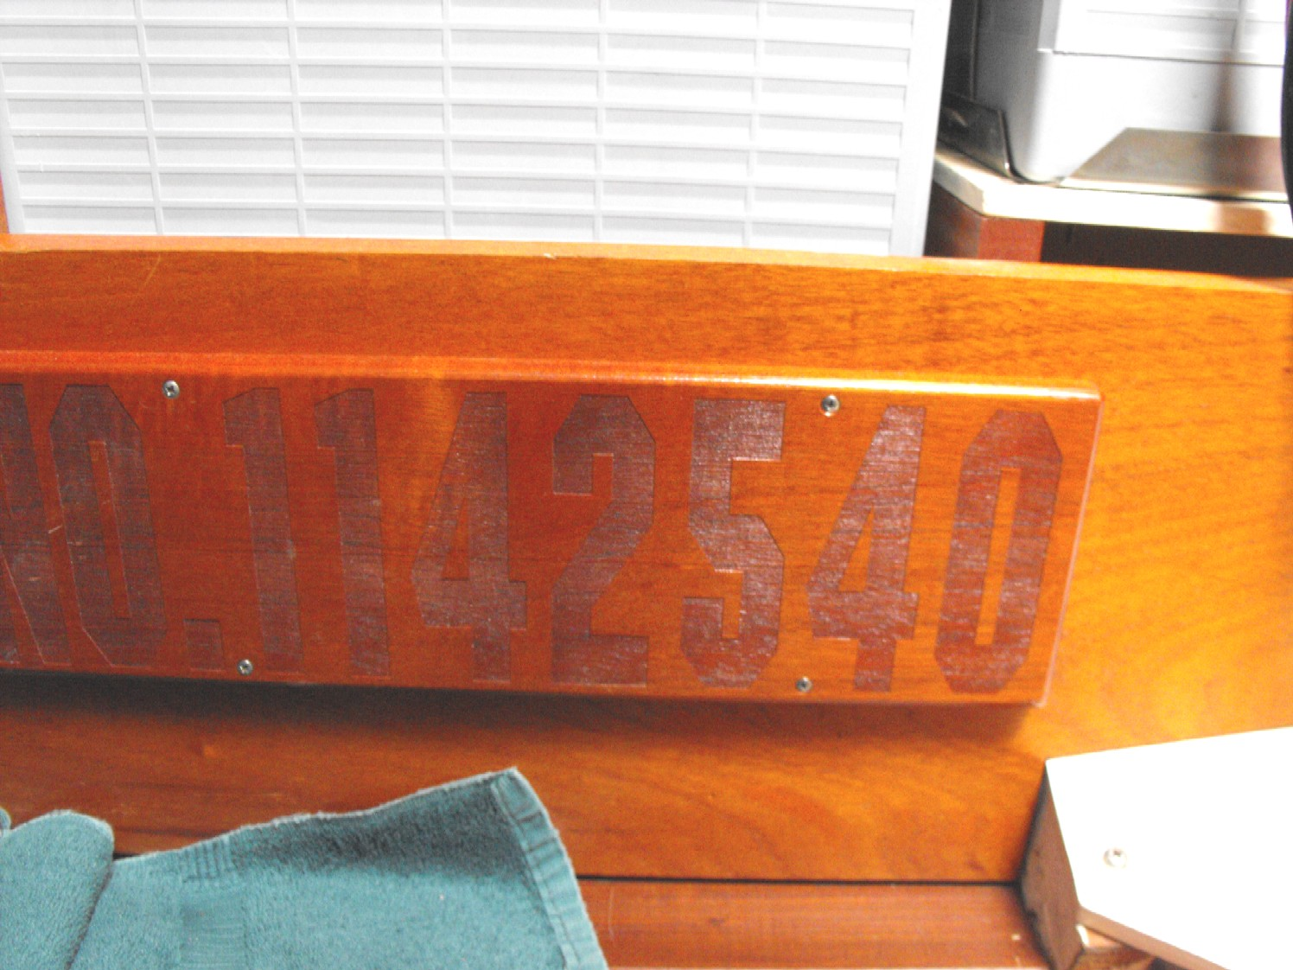
Official number

RELATED PHOTOGRAPHS
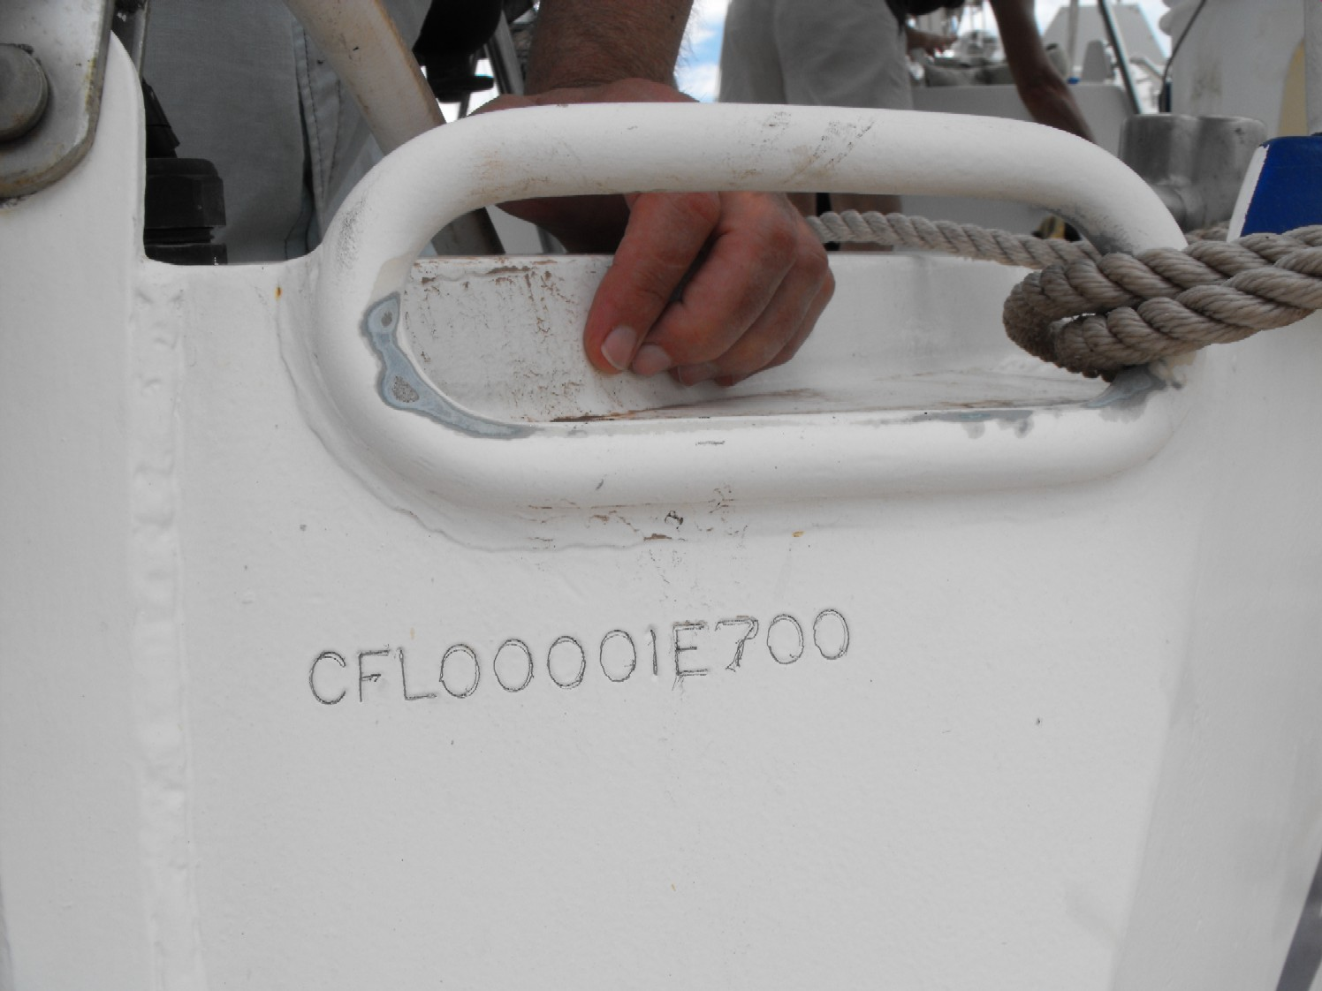
Hull number

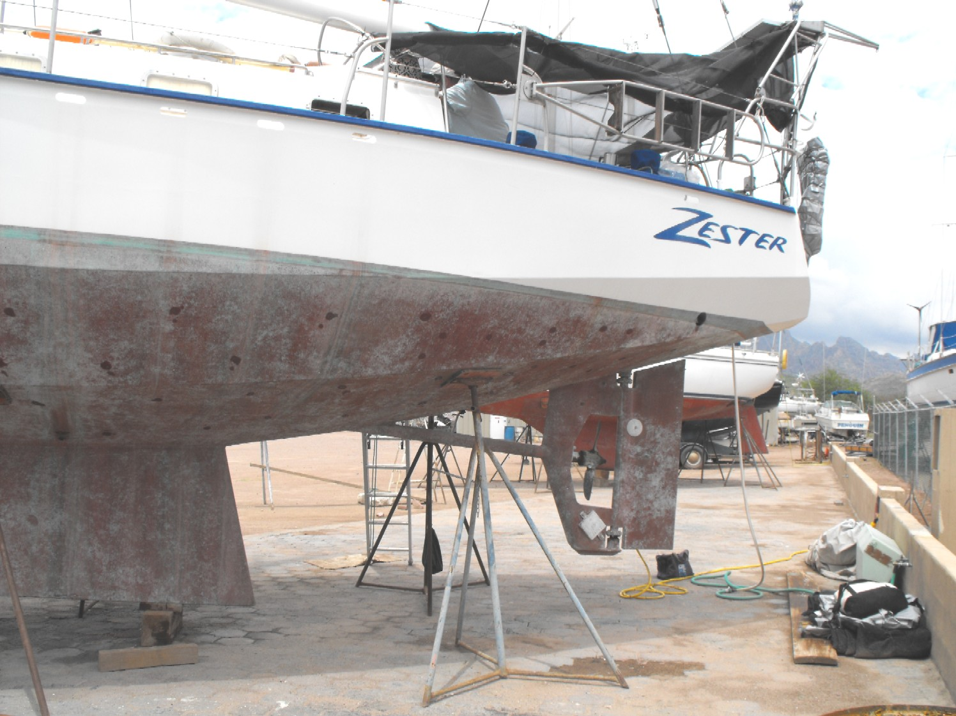
Out of the water

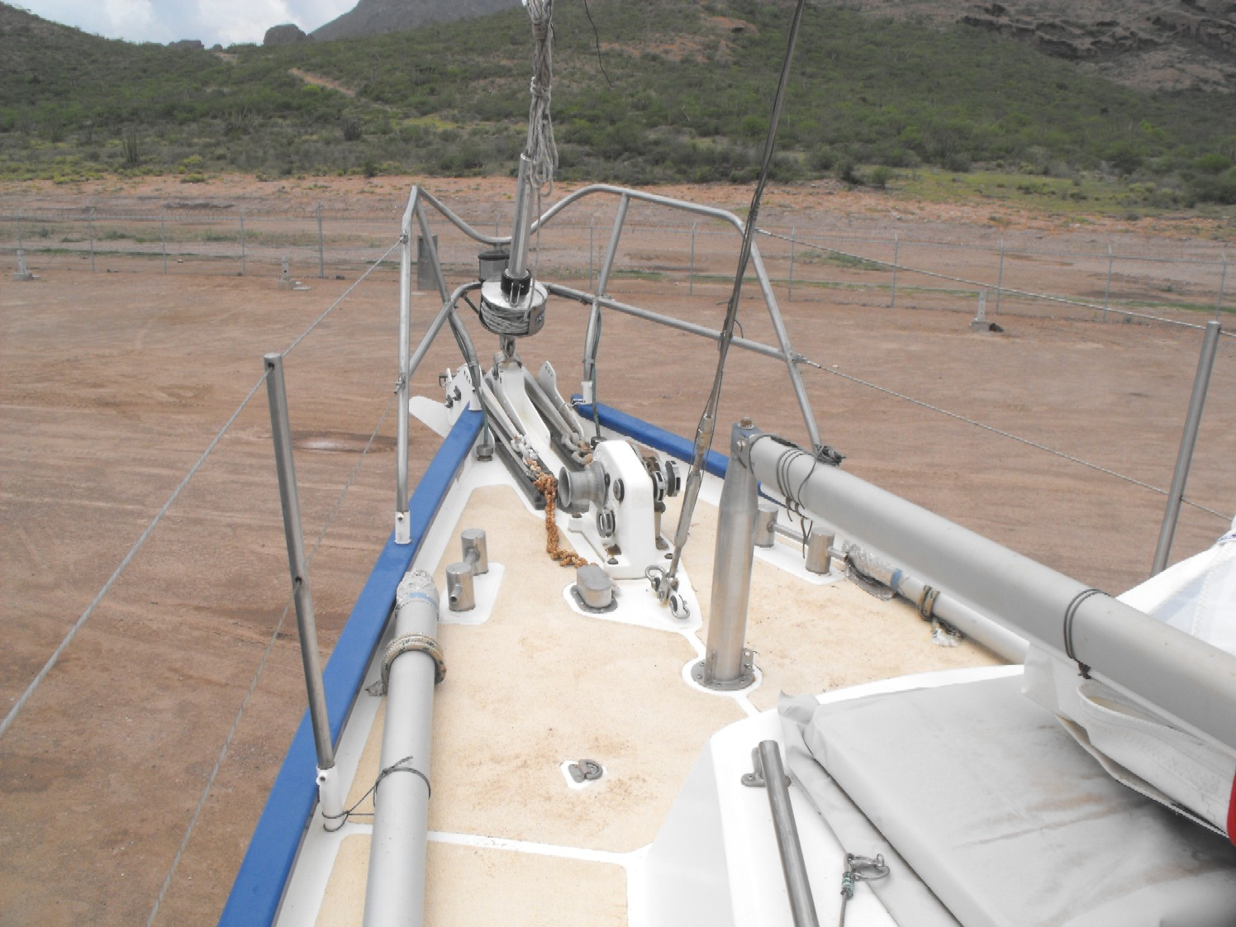
Foredeck
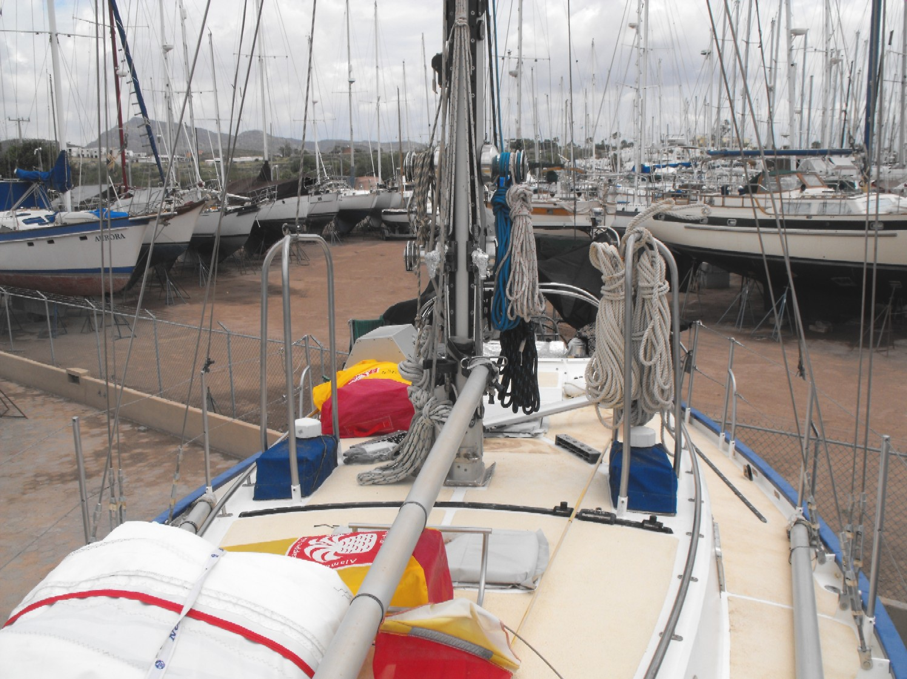
Facing aft

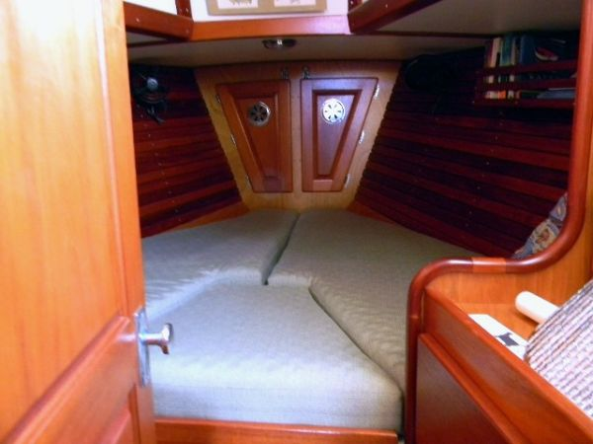
V berth
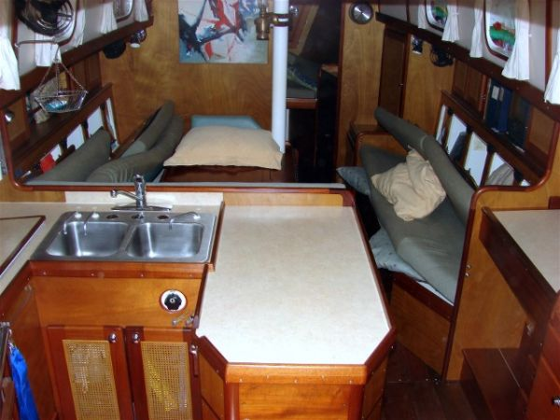
Galley

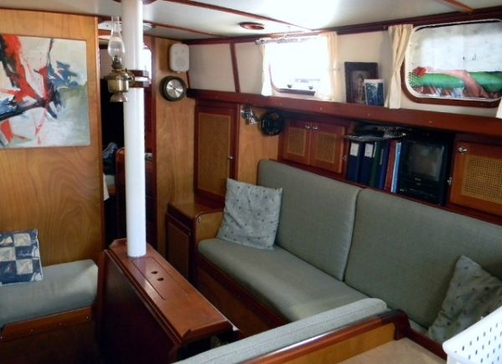
Main salon
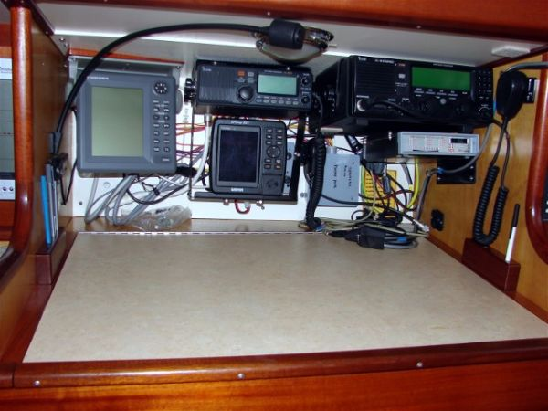
Nav station

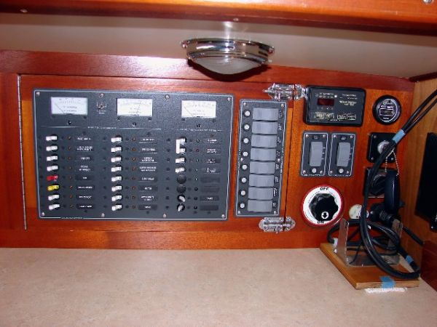
Electric panel
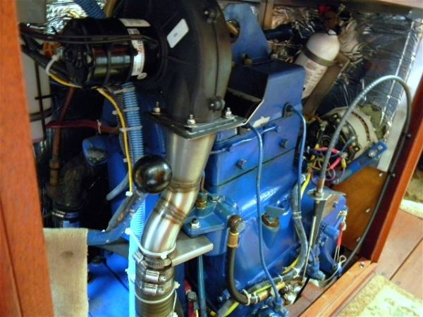
Sabb Diesel

