Particulars Form – Property Settlement Matters

COMPLETE THIS FORM
- Please ensure this form is completed and sent to JD at least seven (7) business days prior to the mediation date.
- Once JD receives Particulars from both parties, JD will share the documents between you.

Mediation date
Time
Length of Conference

Your name
& date of birth

Name of your lawyer / or Support Person
Other parent’s name
& date of birth

Parties’ details
 | Your details | Other parent’s details
Family Name
Given Names
Date of birth
Occupation
Gross weekly income | $ | $
Total weekly expenses | $ | $

Important Dates
When you started your relationship
When you started living together
When you married
(if applicable)
When you finally separated
When you divorced
(if applicable)

Children’s details
Child 1 |  | Child 2
Family name |  | Family name
Given name(s) |  | Given name(s)
Date of birth |  | Date of birth
Gender |  | Gender

Child 3 |  | Child 4
Family name |  | Family name
Given name(s) |  | Given name(s)
Date of birth |  | Date of birth
Gender |  | Gender

Child 5 |  | Child 6
Family name |  | Family name
Given name(s) |  | Given name(s)
Date of birth |  | Date of birth
Gender |  | Gender

Full & Frank Disclosure
- Speak with a family lawyer about your Disclosure obligations under the Family Law.
- Your lawyer can advise you about what you should be disclosing as part of these discussions.
- Please ensure you have access or copies of any necessary financial documentation to substantiate any items you are including in the Asset Pool.
- Please refer to the handout, ‘What do I need to bring for my property mediation’, for list of relevant documentation.
- Ideally, try to exchange any documentation prior to the mediation taking place. Also, where possible, try to agree on values of items included in your Asset Pool.
- If you have not been able / or cannot exchange documents and/or agree to respective values of items prior to the mediation taking place, this will take place during the mediation.

Schedule of Assets & Liabilities (Schedule)
- Please refer to the handout, ‘Joint Schedule of Assets and Liabilities (client preparation)’. You are welcome to add to the Schedule if you can. Otherwise, please provide your own Schedule of the Assets and Liabilities that are in your Asset Pool.
- If you are completing the Schedule that I have provided you, when you enter an amount for a Liability, note the value as a minus amount ie: if the credit card debt is $20,000, enter the value as “-20,000”.
For example:
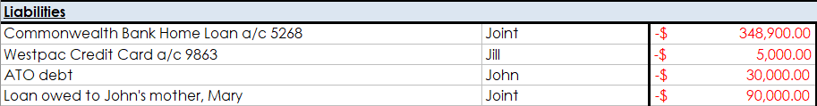

What “Contributions” do say have taken place?

What “Current & Future Needs” do you say are relevant?

What potential “scenarios” are you hoping to consider?

