Lessons from the World’s Top Performing Education Systems:
by Bruce & Karen McNeice

Studies of the world's top performing education system, show similarities with the Charlotte Mason philosophy, and some striking differences to the philosophy and outworking of the official standardised models of education in Australia, USA and UK. Since the year 2000, most OECD nations have participated in international testing of the academic standards of all 15/16 year old students at school, and these results have been compared across the various countries. These tests are called the 'Program for International Student Assessment' (PISA). During the past two and a half decades of PISA assessments, it has been found that nationally, reading and mathematics scores in Australia have declined significantly. In our 2016 edition of our Home-Education Guidebook, we reported a drop from 11th place to 15th place in the list of countries. The 2018 results showed Australia dropped further to 16th place for Reading, 17th place for science, and 29th place for Mathematics. Having a similar educational philosophy, the UK and USA are similarly performing poorly.

Between the year 2000 and 2015, students from Finland, on the other hand, had consistently ranked among the top three countries of the world in every subject area. However, interestingly, in the last nine years their scores have fallen since smartphone usage has increased, and they have been introducing more computer technology into their schools. Up until 2015, education officials from many countries had flocked to Finland to try to discover why the Finnish students had been so successful. The following is a list of distinguishing features of the Finnish education system prior to 2015:

- Although Finnish parents may utilise a preschool service, formal education of children was not compulsory until 7 years old (whereas Britain had compulsory education from age 3, various states in the US and Australia had been pushing for children to start schooling from age 5 or earlier with various preschool and 'headstart' programs.)
- Having more of an early intervention model, the Fins invested heavily into catching and remediating most learning difficulties and special needs by the third and fourth grade, rather than waiting to rectify the problems after they are more established.
- However, in Finland, rather than operating from a 'disability paradigm' (a child is learning disabled); they operated from what is known as a 'differentiated paradigm' (focusing on how each child learns differently utilising their different kinds of intelligences). It is a philosophy that believes every child can succeed and allows for the individual child's learning style. Such a belief will enable the provision of more relevant and engaging learning activities suited to the child's learning style. Most Finish children have had some special needs assistance in one area or another, so there is no stigma about “special education”. It is part of a 'learning strategy' rather than a 'problem that needs fixing'.
- In Finland, rather than a standardised curriculum approach, they have had a policy of decentralisation of control, giving more decision-making power to the teachers to work out the content, texts and methods that best suit the child.
- The parents also have a say in developing the objectives of the child's curriculum…
“in particular, the pupil's parents and guardians must be able to influence the definition of the curriculum's educational objectives. The pupils may also be involved in the curriculum development work.” (extract from the National Core Curriculum for Basic Education – Finland – 2004). As in our earlier discussion, this shows the ideal of a partnership between teachers, parents, and students.
- While the Finnish schools do not adhere to a completely ‘child-centred’ approach, the children have some say in what they wish to learn; and in the final two years of high school, the students are expected to design their complete course (within modular guidelines).
- The Finns have no standardised testing through Primary & early Secondary school. The teacher does ongoing regular assessing to help the child progress (what we call 'formative assessment'), but the only compulsory test is at the end of the student's 'Basic Education', at about 15-16 years of age.
- The parents and teachers can also opt to have the pupil “progress according to a [continuous] personal study program, rather than a grade-by-grade syllabus”.
- It is interesting that Australia prioritises the standardisation of content, knowledge, and testing of both teachers and students (the MySchool site compares schools and there are moves to compare teacher performance which develops a culture of blame and shame; the NAPLAN test compares student performance, ending with the same effect); whereas Finland prioritised the mentoring relationship between the teacher and student, to develop a culture of inquisitiveness. The difference in priority reflects the difference in what money is invested into, and differences in the education policies, all resulting in a very different performance outcome at the completion of a student’s education.
- Rather than a culture of testing/assessing performance (as in Australia), the Finns have focussed on coaching/mentoring and promoting a collegial culture of researching and inquisitiveness at every level from Principal to Students. Even the parents have been educated about education, as each time a child was born, the government sent the parents a small crib with baby-care products, a set of children's books plus guidelines to encourage parents to read to their children. The parents also played a role in contributing to the definition of the learning objectives of their child's curriculum.

Regarding the more recent decline in Finland’s results Ben Lawless comments…
“The countries with the biggest declines are rich western countries which have WAY more phones in their society. There is also an OECD graph from 2015 showing a correlation (causation?) between IT devices in a country and PISA decline.
Here:
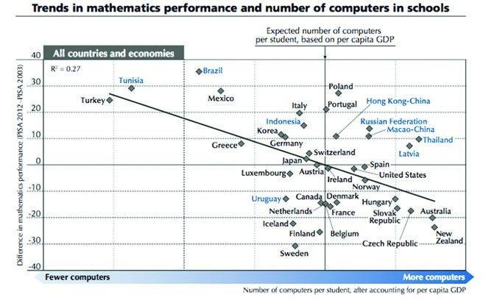
When one analyses these and other differences in the two systems, they boil down to a basic philosophical difference. Philosophical difference is of prime importance, because ideas have consequences, and great or poor ideas inevitably result in great or poor consequences.
Australia has been investing money, time and effort into standardisation, assessment of students and teachers, plus re-arranging the scope and sequence of topics and skills, thinking that a better national curriculum will raise the standard of education; whereas Finland (previously) had a 30-year (1980 to 2010) priority of investing into people (teachers and parents). When the Finnish government was concerned about academic standards, their analysis of the problem and worldwide search for strategies for improvement, led them to decentralise education and embark on a program of investing into families. Parents were trained to develop a habit of reading to their children from birth, and trained to be involved in decision-making about their children's education.
The old Finnish attitude of caring for people and the priority of relationships, was also shown in their strategy of allowing the teacher to keep the one group of children through several year levels if possible. The children developed such an enduring relationship with their teacher that they called them their 'School Mum or Dad' as distinct from their 'Home Mum and Dad'.
It is interesting that between 2011 and 2018 the Finish government cut education funding by a total of €1.5 billion. Training parents to develop a love of literature was no longer a priority, and as more and more technology was introduced into schools, digital entertainment increased in the home, and parents lost interest in reading, so too their PISA results have more recently been declining.
It is the foundational ideas that make the difference. The most fundamental presupposition affecting pedagogical practice is the understanding of the essential nature of the child. Charlotte Mason explained that “Anyone who wants to teach children needs to decide whether man [sic] is just physical, or something more. It can't be both ways, and even the most trivial detail of the school day will line up with one or the other of these two fundamental perspectives.” (Mason, 1918, in Ambleside Online, 2013)
If you believe that the child's mind is merely a 'tabula rasa' as Locke put it, i.e., a blank slate that must be filled with the right knowledge and understandings, then your 'educational reform' will focus on developing the knowledge content of the curriculum, the skills to process that information, and standardising the testing of what is learnt. Whereas if you believe in the value and respect of the personhood of the child (as well as that of the teacher and parent), then you will focus on ensuring there is a culture of valuing people and being more concerned with coaching and mentoring for personal growth, than keeping up with standardised testing.
A Charlotte Mason curriculum begins with the foundational belief that ‘children are born persons’ who interact with ideas. Their minds take in intellectual material that is relevant to them (like a living organism takes in food), and they interact with it to make their own connections. They are allowed to grow in their intellectual capacity at their own pace, so the actual scope and sequence of relevant knowledge may be very different for each student. A typical Charlotte Mason style assessment will not have the child do any multi-choice style testing of content facts that 'should' be memorised (except perhaps for appropriate memorisation eg., drilling the times-tables facts, or memorising spelling rules, poetry, lyrics, a Bible passage or famous quote, etc). Charlotte Mason believed that much of standardised testing merely tested what the child does not know; whereas she was more concerned with what the child does know; what he/she has absorbed and thought about. Because of this, the child is encouraged in the regular practice of narrating (telling back what they do remember of a story), and then discussing the topic, which leads on to written narrations and essays or creative presentations as culminating activities after a unit of study.
Hmmm... Which is better? More standardisation of curriculum?...Or coaching and mentoring, sharing your love of learning, and building a personal relationship with the student?
It’s something to think about.

