# [Freedom from the Law of the Booklist](https://centerforlit.wordpress.com/2015/03/26/freedom-from-the-law-of-the-booklist/)

[March 26, 2015](https://centerforlit.wordpress.com/2015/03/26/freedom-from-the-law-of-the-booklist/) / [missylandrews](https://centerforlit.wordpress.com/author/missylandrews/) / [9 Comments](https://centerforlit.wordpress.com/2015/03/26/freedom-from-the-law-of-the-booklist/#comments)

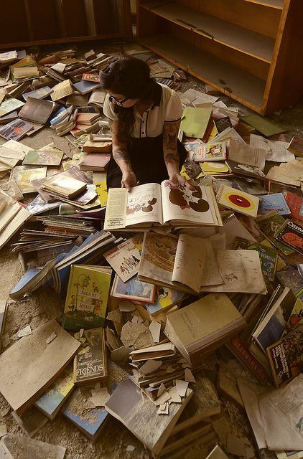

It was spring of my oldest son’s eighth grade year, and I, like homeschool moms all over the country, was planning for the fall. Except this time, my son would be starting high school. This time, it would “count.” Panic replaced my usual plenary excitement as I wondered what colleges would be looking for on high school transcripts and how I was going to prepare my homeschooler to convince them that he had mastered everything. I flew through reams of paper creating a plethora of booklists, each one longer and more ambitious than the previous, and frankly wore myself out with worry in the process.

In the midst of this confusion, my phone rang. To my surprise, I heard the voice of a favorite college professor on the line. After raving about the providential nature of his call, I asked him this question: If you were able to prepare a student to sit in your classroom, what would you have him read? He was very gracious and accommodating. He could give me the list right now, he said. Did I have a pencil? He suggested three books: The Bible, Milton’s Paradise Lost, and a little known book by Richard Mitchell called The Gift of Fire. I should read the last one first, he said. It would make everything clear.

One week later, I was halfway through Mitchell’s book, a philosophical treatise on education. In it, I discovered a liberating truth: Education is not a booklist! Education comes from the Latin root educere, which means “to lead out.” Out of what is the student led? Himself, of course! Education is the process by which an individual is led out of the narrow confines of his own mind in order to gain perspective on both himself and his world. By way of education, he learns to use his rational faculties, to assess his own thoughts and to know his own mind. He begins to watch himself thinking, and he becomes acquainted with the limits of his own knowledge in the face of the infinite and the larger world. In this way, education provides opportunities for the student to come to terms with his creature hood, thereby gaining humility.

Mitchell illustrates this truth by appealing to Socrates. He suggests that Socrates is notably one of the most educated men that ever lived, and yet, he argues, he read relatively few books. In fact, most of the books that would inevitably appear on current reading lists had yet to be written when Socrates lived. Even so, Socrates is still considered a highly educated man. This is because Socrates had a grasp of his own mind. He had learned how to think, and he thought all the time. As he asked universal questions and pondered logically sound answers, he better came to know his world and his place within it. Education, Mitchell argues, is not a booklist after all.

Education is not a booklist. This simple truth changed the way I approached planning my son’s high school career. Of course I still worked to choose books that were worthy and challenging, but I realized that a long and challenging booklist was ultimately not the measure of an education. This notion is quite different from current trends which view education as the accumulation and mastery of facts or the completion of ambitious booklists. What is the measure of an education, then?

Education in a Single Book

Like many, I can look back on a few pivotal books as landmarks in my own intellectual journey. These are books with which I connected at particular times, which challenged my ideas or illuminated important, universal truths. My encounter with these books was, for me, an education. Engaging with these works, I came to know both myself and my neighbors better.

I craft booklists for my students with these moments of insight in mind. While the lists themselves provide my kids with context in a literary and cultural tradition, cultural literacy itself is properly viewed as a species of education, perhaps even a vehicle of real education, rather than its equivalent.

The kind of self-sight available through good books simultaneously fosters humility and empathy. Humility comes as we discover our own finitude in the face of infinite knowledge. Empathy is achieved when we learn to accurately diagnose our own natures, making us more human (and hopefully more humane). This experience bears little resemblance to the “education is the perfect booklist” model, which sometimes produces the unfortunate side-effect of pride and self-importance.

The Law of the Booklist

When education is equated with a booklist, the booklist becomes a law; wherever we find the law, we can be sure to find death. (2 Cor. 3:7) Just as the “capital L” Law of God is beautiful and perfect, so is the “little l” law of the booklist. However, when we misuse the booklist to gain from it what it cannot deliver – identity, peace and life – we inevitably become miserable.

“The Law is our schoolmaster to bring us to Christ…” says the Apostle Paul. This is true regardless of where the law appears, even if that is within the throes of homeschooling. A beautiful, ambitious booklist can educate us, but not, perhaps, in the way we might expect. Far from fostering self-importance, a look into the “law of the booklist” reveals that we are finite creatures who will never know (or read) it all! As another educated man, King Solomon, told his son, “Of making many books there is no end; and much study wearies the body” (Ecc. 12:12). Try as we may, we will never master all there is to know about the world or even ourselves. We will never create or complete a perfect booklist. There will always be one more book we have not read, one more idea we have not encountered. If we make a booklist the measure of education, we set ourselves up for failure; the law of the booklist will inevitably shame us.

An Education in Grace

Re-examining the purpose of the booklist, I propose that its proper end is Christ. Identification with Him liberates me from the bondage of the law of performance and infuses my life with joy. Because of Jesus, I am freed from the bondage of the booklist. My identity and the identities of my children are safely rooted in the wisdom and work of Jesus, rather than in the superior mastery of knowledge or the achievement of cultural literacy. True education reveals the implications of this reality in every discipline of life; a beautiful booklist is merely a means to this end.

As you turn to the task of planning next year’s perfect booklist, remember two things: 1) Your identity and the identity of your child are rooted in Christ, and not in anything you do, and 2) Education is not a booklist. Education is the process of coming to know yourself and your relationship to the world around you. Choose books toward this end – books that confront your child with his creaturehood in all its weakness and glory, meanness and magnanimity, baseness and beauty. If you still don’t believe me, read three books: The Bible, Milton’s Paradise Lost, and Richard Mitchell’s The Gift of Fire. Start with the last; it will make everything else clear.